

**Polytechnic University of the Philippines**

**College of Engineering**

**Computer Engineering Department**

**CMPE 30174**

**Computer Networks and Security**

**MP-8 Perform Chapter 13 Activities**

**Tedie N. Villacuatro**

Submitted by

**BSCpE 3-3**

Course/Year/Section

**June 7, 2022**

Date Submitted

**Engr. Jake Binuya**

Submitted to

**Tedie N. Villacuatro**

**BSCOE 3-3**

1. **13.1.10 Packet Tracer - Configure a Wireless Network**
2. **Objectives**

·         Connect to a wireless router

·         Configure the wireless router

·         Connect a wired device to the wireless router

·         Connect a wireless device to the wireless router

·         Add an AP to the network to extend wireless coverage

·         Update default router settings

1. **Introduction**

In this activity, you will configure a wireless router and an access point to accept wireless clientsand route IP packets. Furthermore, you will also update some of the default settings.

1. **Instructions**
2. **Part 1: Connect to a Wireless Router**
3. **Step 1: Connect Admin to WR.**
4. a.     Connect **Admin** to **WR**using a straight-through Ethernet cable through the Ethernet ports. Select **Connections**, represented by a lightning bolt, from the bottom-left side of Packet Tracer. Click **Copper Straight-Through**, represented by a solid black line.
5. b.     When the cursor changes to connection mode, click **Admin** and choose **FastEthernet0**. Click **WR**and choose an available Ethernet port to connect the other end of the cable.
6. **WR** will act as a switch to the devices connected to the LAN and as a router to the internet. **Admin** is now connected to the LAN (**GigabitEthernet 1**). When Packet Tracer displays green triangles on both sides of the connection between **Admin**and **WR**, continue to the next step.
7. **Note**: If no green triangles are shown, make sure to enable **Show Link Lights**under **Options > Preferences**. You may also click **Fast Forward Time** just above the **Connections**selection box in the yellow bar.
8. 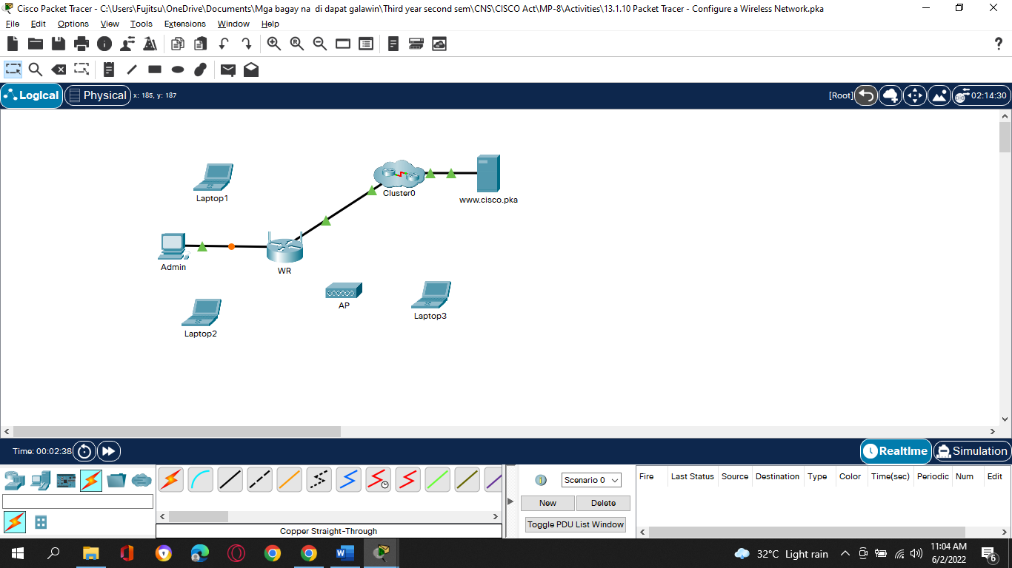
9. **Step 2: Configure Admin to use DHCP.**

To reach the **WR** management page, **Admin**must communicate on the network. A wireless router usually includes a DHCP server, and the DHCP server is usually enabled by default on the LAN. **Admin** will receive IP address information from the DHCP server on **WR**.

1. a.     Click **Admin**, and select the **Desktop** tab.
2. b.     Click **IP Configuration** and select **DHCP**.
3. 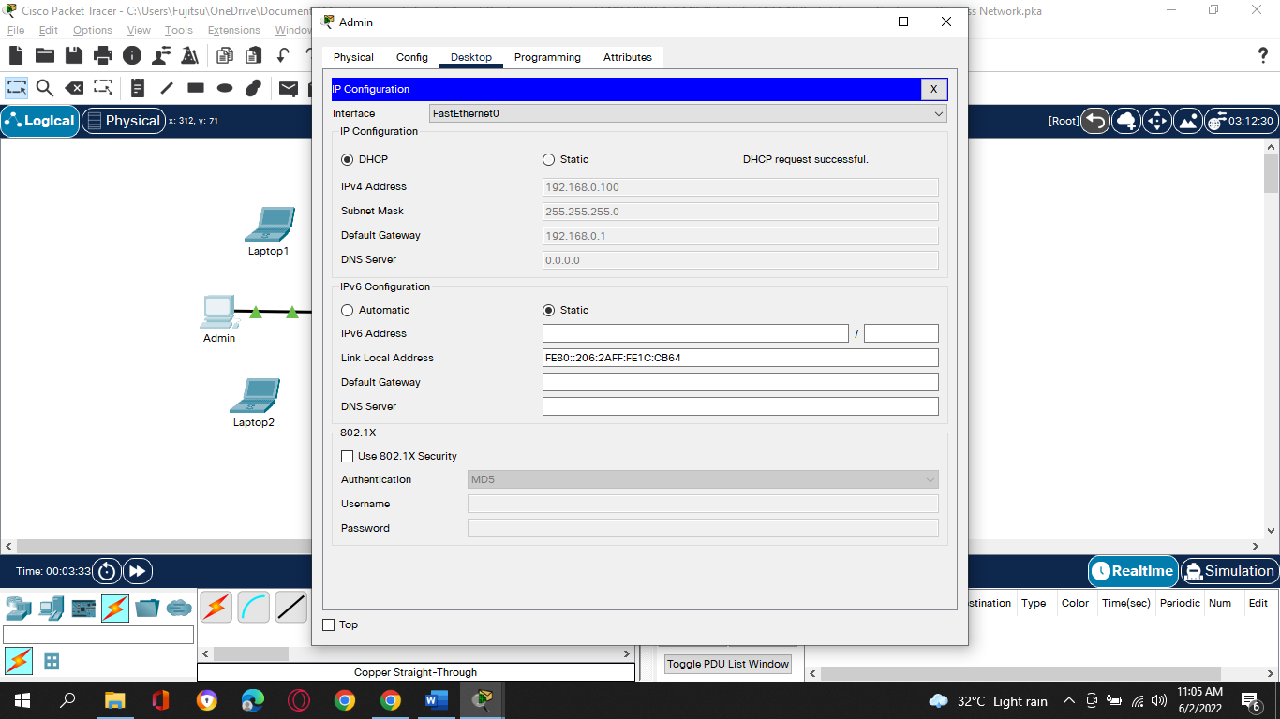

Questions:

1. What is the IP address of the computer? **192.168.0.100**
2. What is the subnet mask of the computer? **255.255.255.0**
3. What is the default gateway of the computer? **192.168.0.1**
4. c.     Close the **IP Configuration**window.

**Note**: Values can vary within the network range due to normal DHCP operation.

1. **Step 3: Connect to the WR Web Interface.**
2. a.     In the **Desktop** tab on **Admin**, choose **Web Browser**.
3. b.     Enter **192.168.0.1** in the URL field to open the web configuration page of the wireless router.
4. 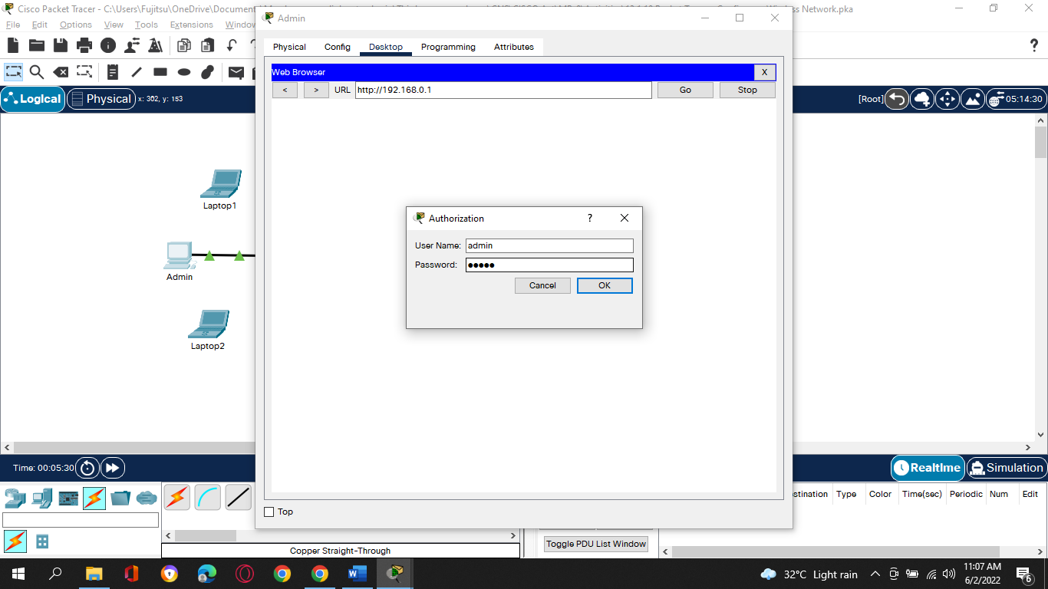
5. c.     Use **admin** for both the username and password.
6. 
7. d.     Under the Network Setup heading on the **Basic Setup** page, notice the IP address range for the DHCP server.
8. 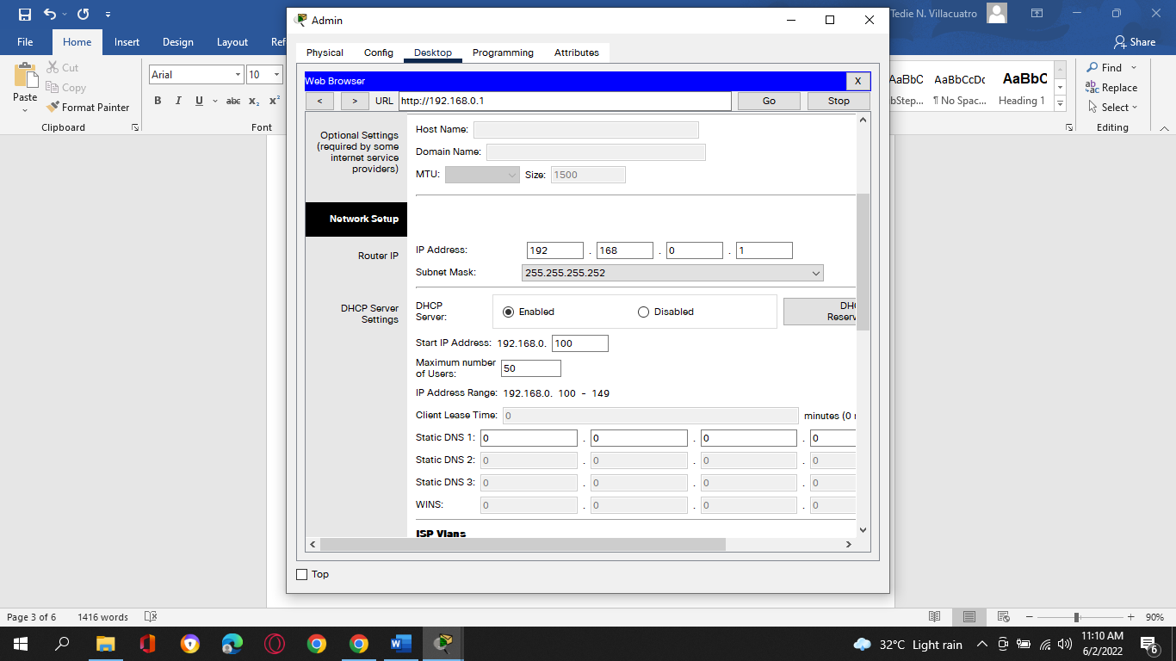

Question:

Is the IP address for **Admin** within this range? Is it expected? Explain your answer.

* **Yes. Admin has 192.168.0.100/24 which belongs to 192.168.0.0/24 and in the range of 192.168.0.100 to 192.168.0.149. It is expected because Admin acquired its IP information from WR via DHCP.**

1. **Step 4: Configure the Internet Port of WR.**

In this step, **WR** is configured to route the packets from the wireless clients to internet. You will configure the **Internet** port on **WR** to connect to the internet.

1. a.     Under the **Internet Setup**at the top of the **Basic Setup** page, change the Internet IP address method from **Automatic Configuration – DHCP**to **Static IP**.
2. b.     Type the IP address to be assigned to the Internet interface as follows:
3. **Internet IP Address**: 209.165.200.225
4. **Subnet Mask**: 255.255.255.252
5. **Default Gateway**: 209.165.200.226
6. **DNS Server**: 209.165.201.1
7. c.     Scroll down the page and click **Save Settings**.
8. **Note**: If you get a **Request Timeout** message, close the Admin window and wait for the orange lights to turn into green triangles. Click the fast forward button to make this happen faster. Then reconnect to **WR** from **Admin’s** browser using the process explained in Step 3.
9. 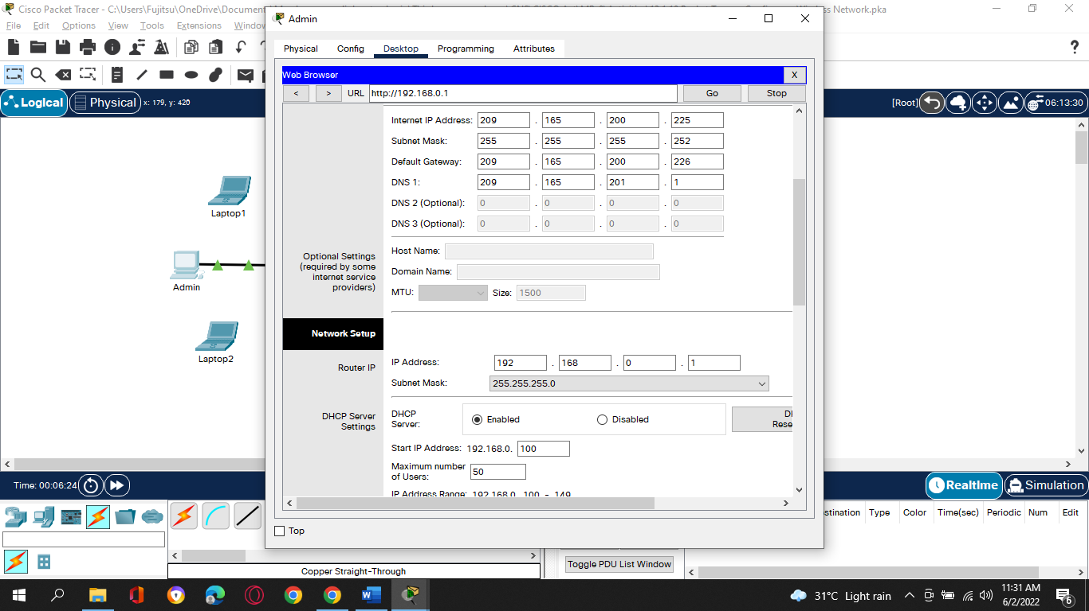
10. d.     To verify connectivity, open a new web browser and navigate to **www.cisco.pka** server.
11. **Note** It may take a few seconds for the network to converge. Click **Fast Forward Time**or **Alt+D** to speed up the process.
12. 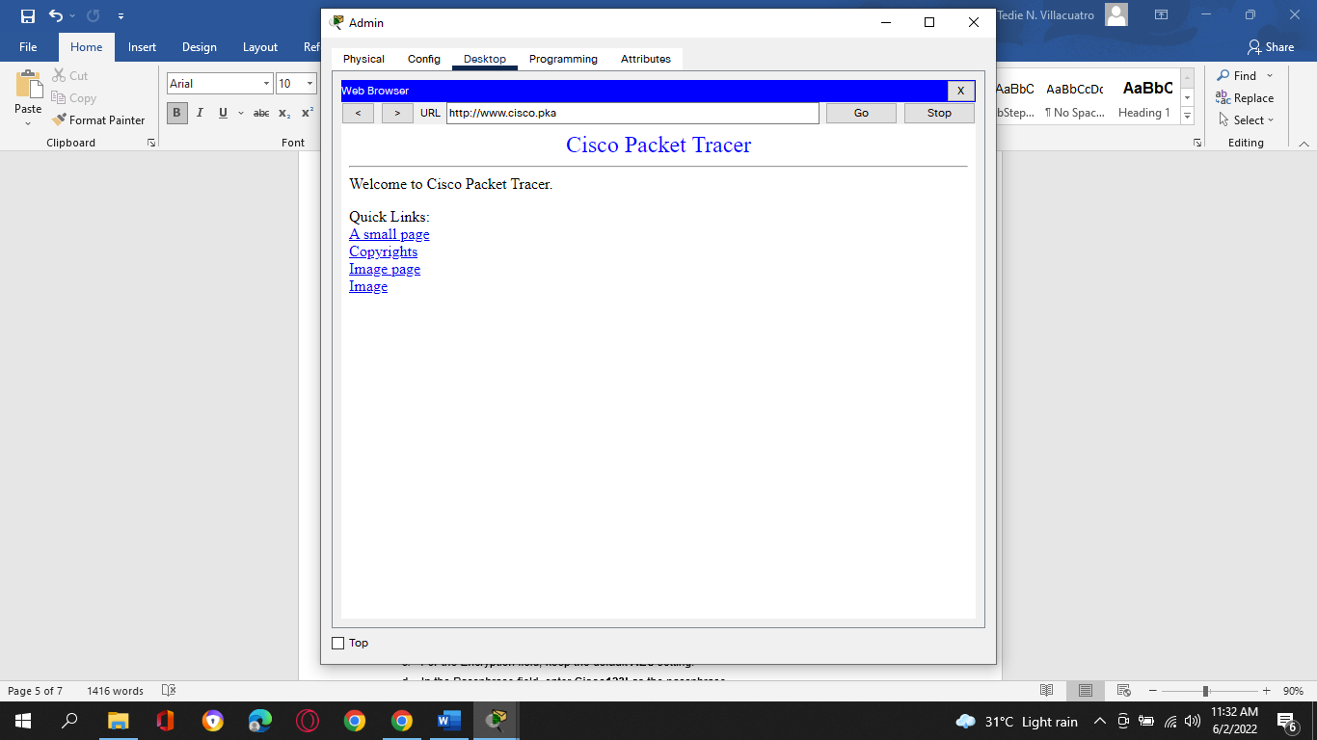
13. **Part 2: Configure the Wireless Settings**

In this activity, you will only configure the wireless settings for 2.4 GHz.

1. **Step 1: Configure the WR SSID.**
2. a.     Navigate to the **WR** GUI interface at **192.168.0.1** in a web browser on **Admin**.
3. b.     Navigate to **Wireless > Basic Wireless Settings**.
4. c.     Change **Network Name (SSID)** to **aCompany** for only 2.4 GHz. Notice that SSIDs are case-sensitive.
5. d.     Change the **Standard Channel** to **6 - 2.437GHz**.
6. e.     For this activity, disable both 5 GHz frequencies. Leave the rest of the settings unchanged.
7. f.      Scroll to the bottom of the window and click **Save Settings**.
8. **Step 2: Configure wireless security settings.**

In this step, you configure the wireless security settings using WPA2 security mode with encryption and passphrase.

1. a.     Navigate to **Wireless > Wireless Security**.
2. b.     Under the 2.4 GHz heading, select **WPA2 Personal** for the Security Mode.
3. c.     For the Encryption field, keep the default **AES**setting.
4. d.     In the Passphrase field, enter **Cisco123!** as the passphrase.
5. 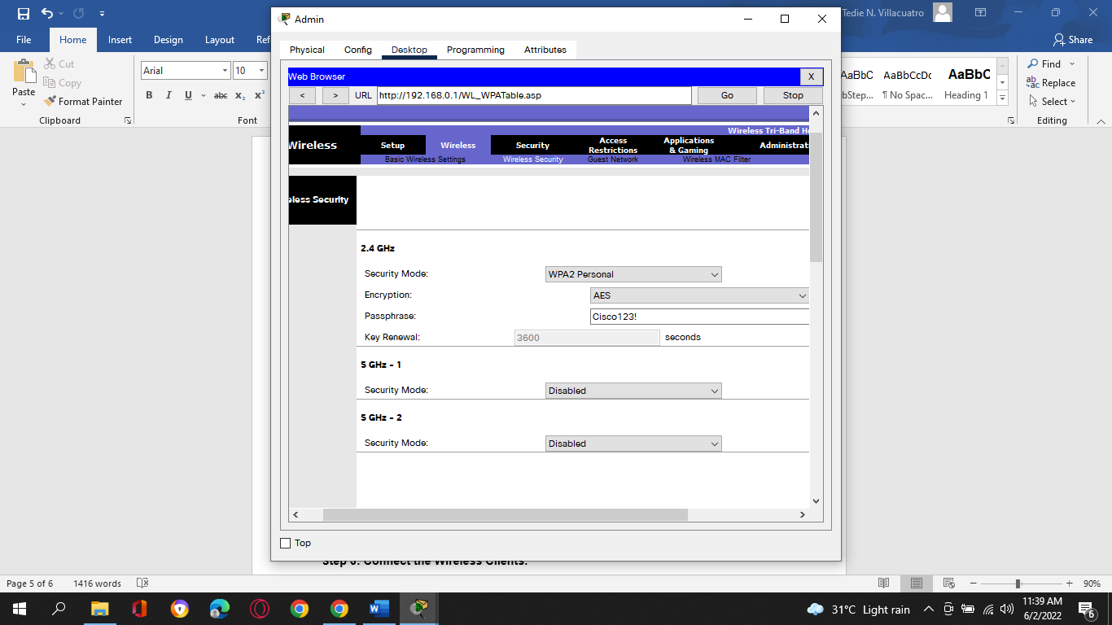
6. e.     Click **Save Settings**.

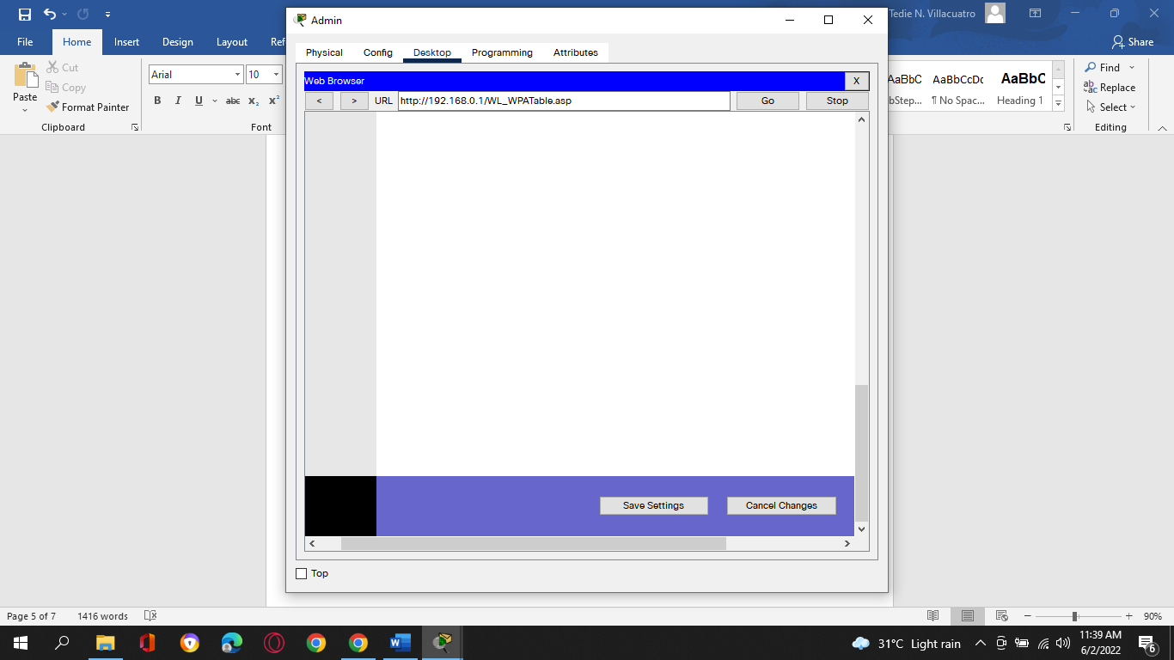

1. f.      Verify that the settings in the **Basic Wireless Settings**and **Wireless Security** pages are correct and saved.
2. **Step 3: Connect the Wireless Clients.**
3. a.     Open **Laptop1**. Select **Desktop** tab. Click **PC Wireless**.
4. b.     Select the **Connect**tab. Click **Refresh** as necessary. Select the Wireless Network Name **aCompany**.
5. 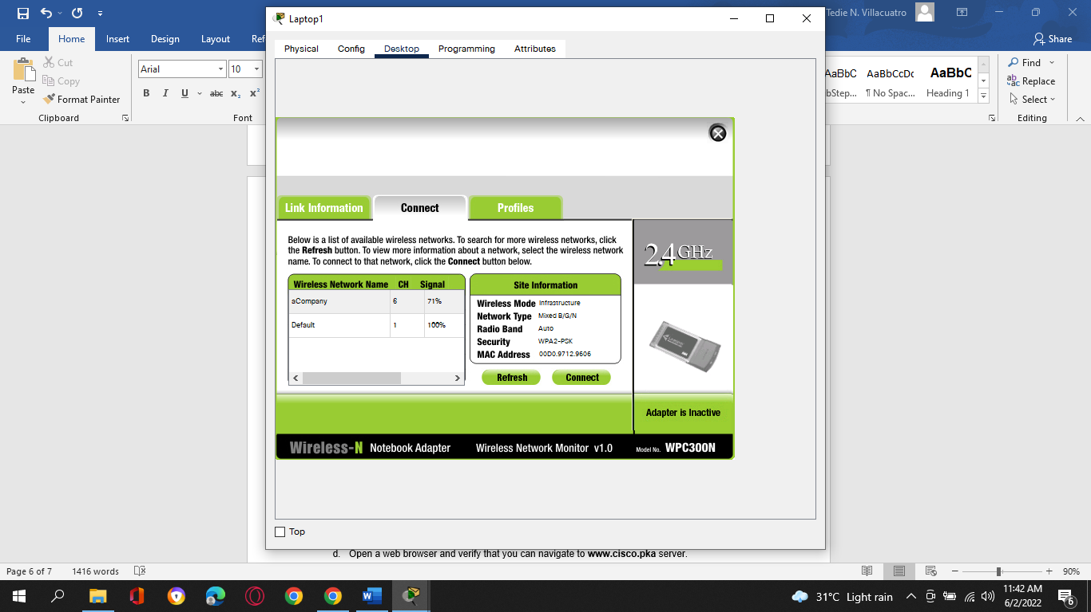
6. c.     Enter the passphrase configured in the previous step. Enter **Cisco123!** In the pre-shared key field and click **Connect**. Close the PC Wireless window.
7. 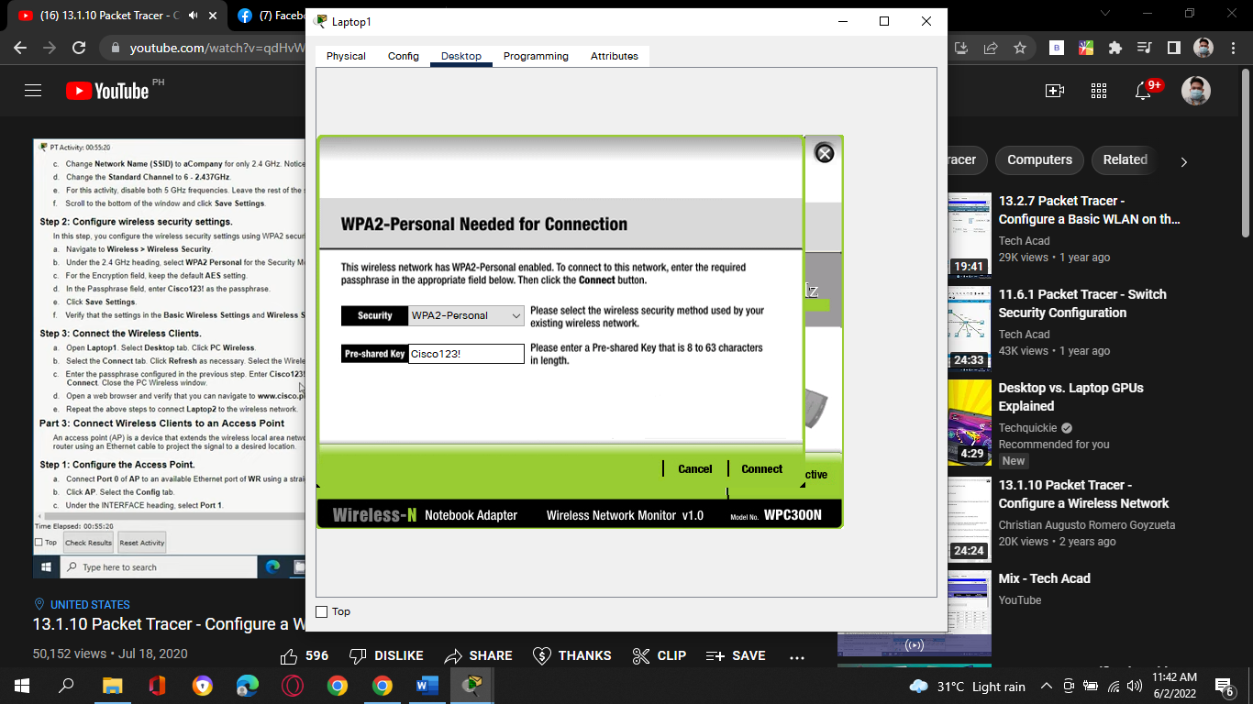
8. d.     Open a web browser and verify that you can navigate to**www.cisco.pka** server.
9. 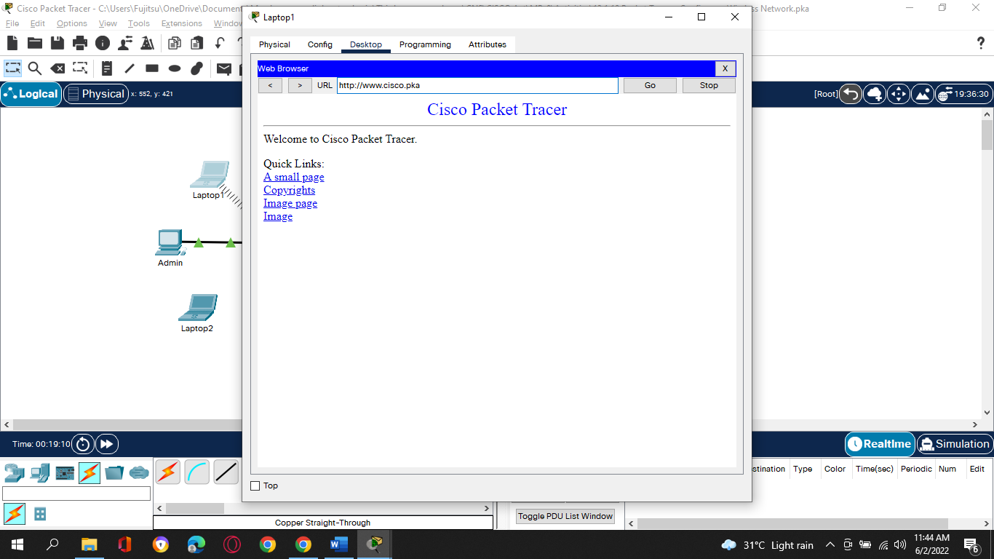
10. e.     Repeat the above steps to connect **Laptop2** to the wireless network.
11. 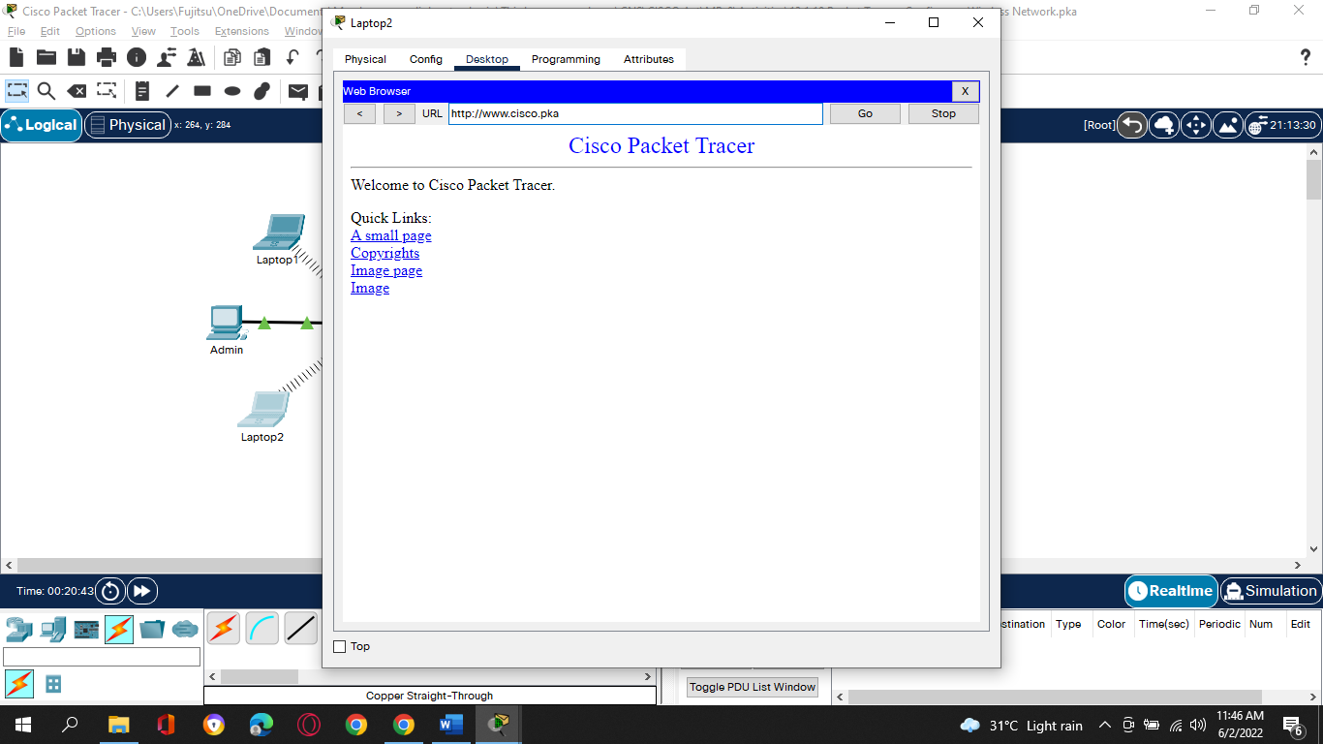
12. **Part 3: Connect Wireless Clients to an Access Point**

An access point (AP) is a device that extends the wireless local area network. An access point is connected to a wired router using an Ethernet cable to project the signal to a desired location.

1. **Step 1: Configure the Access Point.**
2. a.     Connect **Port 0** of **AP**to an available Ethernet port of **WR** using a straight-through Ethernet cable.
3. 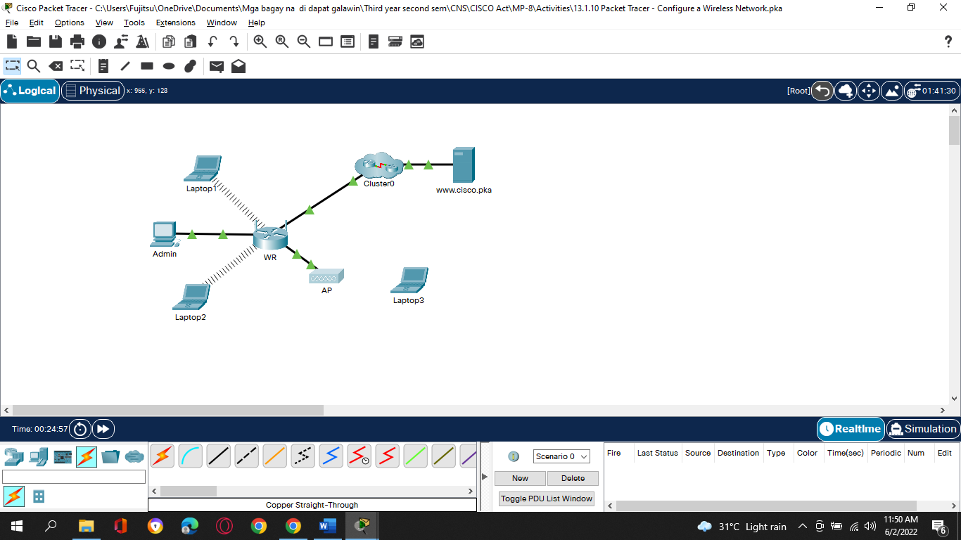
4. b.     Click **AP**. Select the **Config**tab.
5. c.     Under the INTERFACE heading, select **Port 1**.
6. d.     In the SSID field, enter **aCompany**.
7. e.     Select **WPA2-PSK**. Enter the passphrase **Cisco123!** In the Pass Phrase field.
8. f.      Keep **AES** as the default Encryption Type.
9. 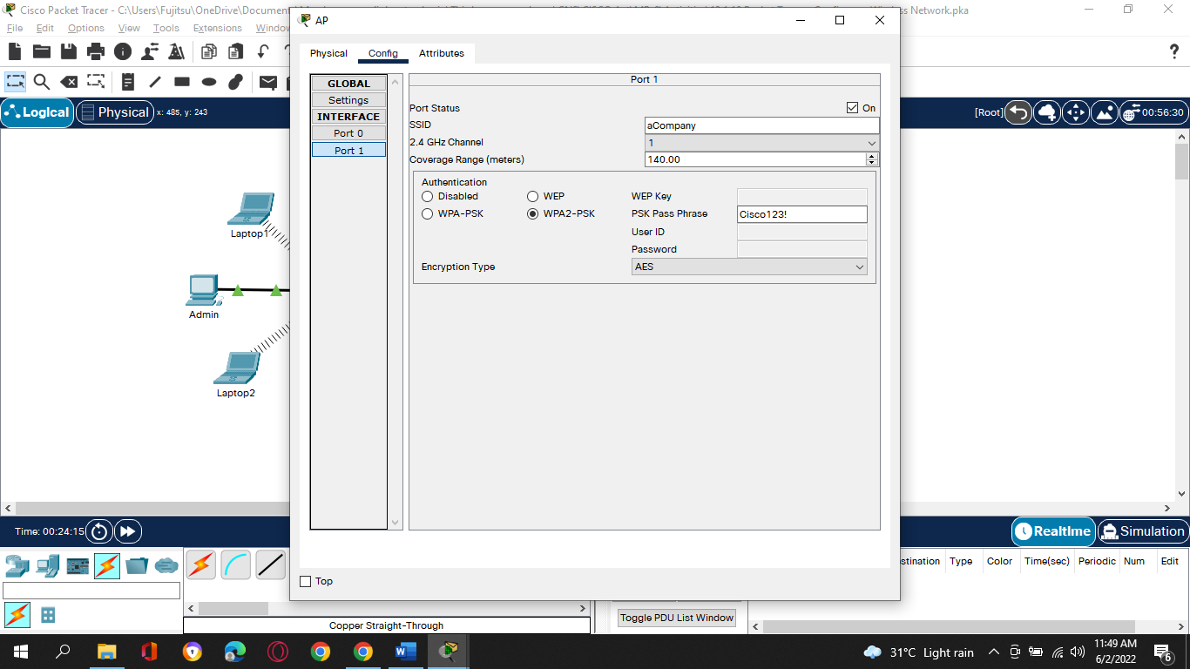
10. **Step 2: Connect the Wireless Clients.**
11. a.     Open **Laptop3**. Select **Desktop** tab. Click **PC Wireless**.
12. b.     Select the **Connect**tab. Click **Refresh** as necessary. Select the Wireless Network Name **aCompany** with the stronger signal (Channel 1) and click **Connect**.
13. 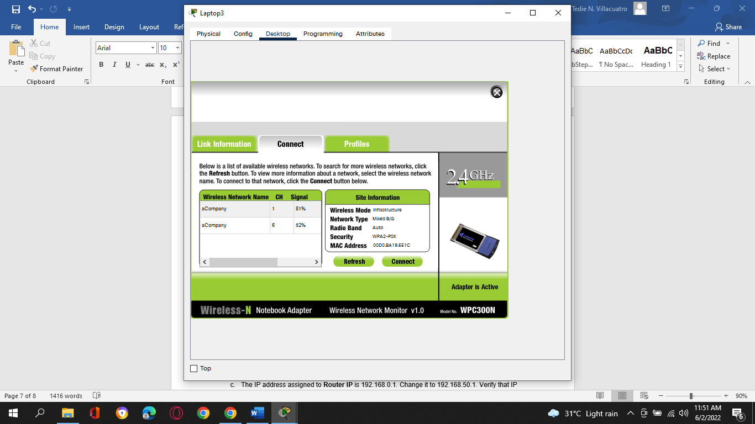
14. c.     Open a web browser and verify that you can navigate to **www.cisco.pka** server.
15. 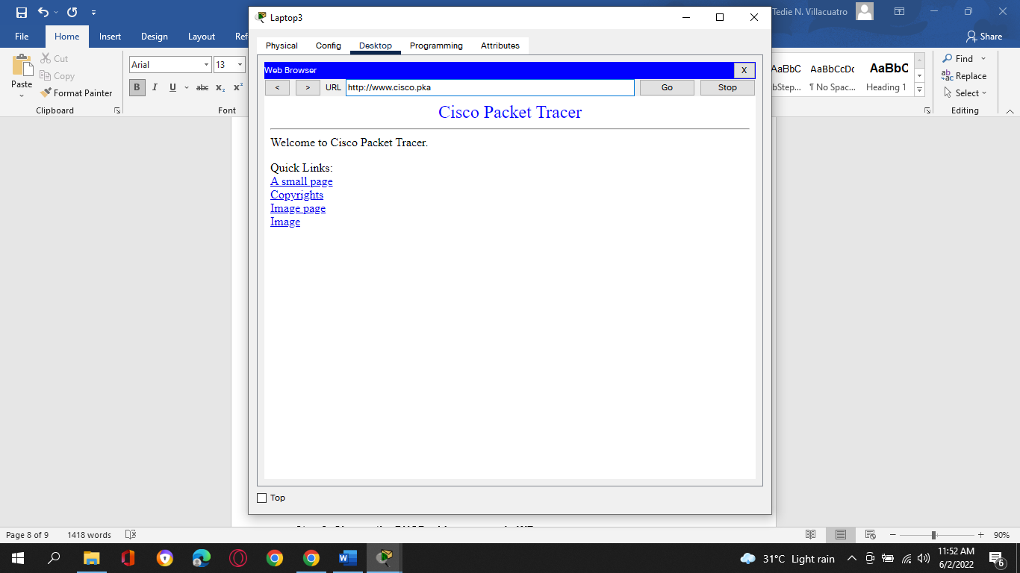
16. **Part 4: Other Administrative Tasks**
17. **Step 1: Change the WR Access Password.**
18. a.     On **Admin**, navigate to WR GUI interface at **192.168.0.1**.
19. b.     Navigate to **Administration > Management** and change the current **Router Password** to **cisco**.
20. c.     Scroll to the bottom of the window and click **Save Settings**.
21. d.     Use the username **admin** and the new password **cisco** when prompted to log in to the wireless router. Click **OK**to continue.
22. e.     Click **Continue** and move on to the next step.
23. **Step 2: Change the DHCP address range in WR.**

In this step, you will change the internal network address from 192.168.0.0/24 to 192.168.50.0/24. When the LAN network address changes, the IP addresses on the devices in the LAN and WLAN must be renewed to receive new IP addresses before the lease is timed out.

1. a.     Navigate to **Setup > Basic Setup**.
2. b.     Scroll down the page to **Network Setup**.
3. c.     The IP address assigned to **Router IP** is 192.168.0.1. Change it to 192.168.50.1. Verify that IP address still start at .100, and there are 50 available IP addresses in the DHCP pool.
4. d.     Add **209.165.201.1**as the DNS server with the DHCP settings.
5. e.     Scroll to the bottom of the window and click **Save Settings**. 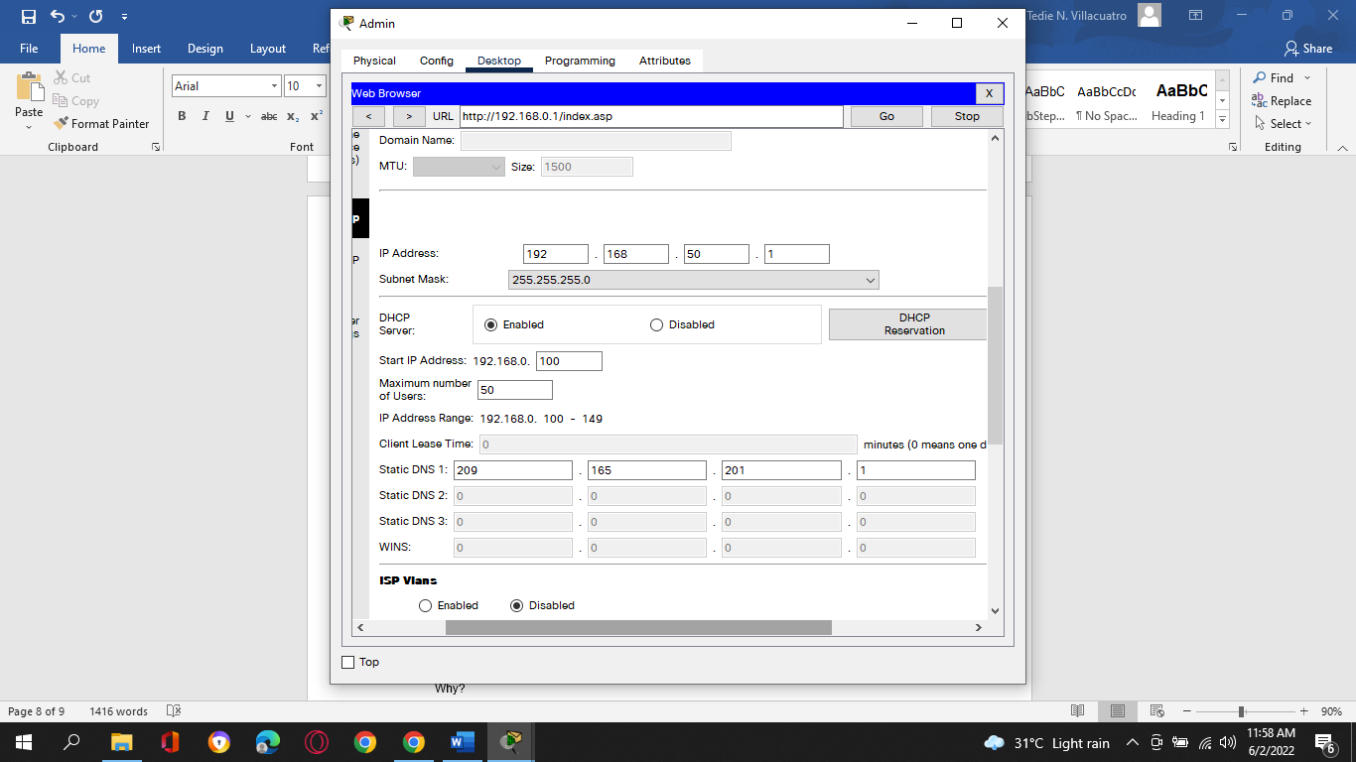
6. f.      Note that the DHCP range of addresses has been automatically updated to reflect the interface IP address change. The Web Browser will display a **Request Timeout** after a short time.

Question:

1. Why?

* **Because the Admin IP address is no longer within the same network as the router. The IP address of Admin is outside the new range of the DHCP server.**

1. g.     Close the **Admin**webbrowser.
2. h.     In **Admin Desktop**tab, click **Command Prompt**.
3. i.      Type **ipconfig /renew**to force **Admin**re-acquire its IP information via DHCP.

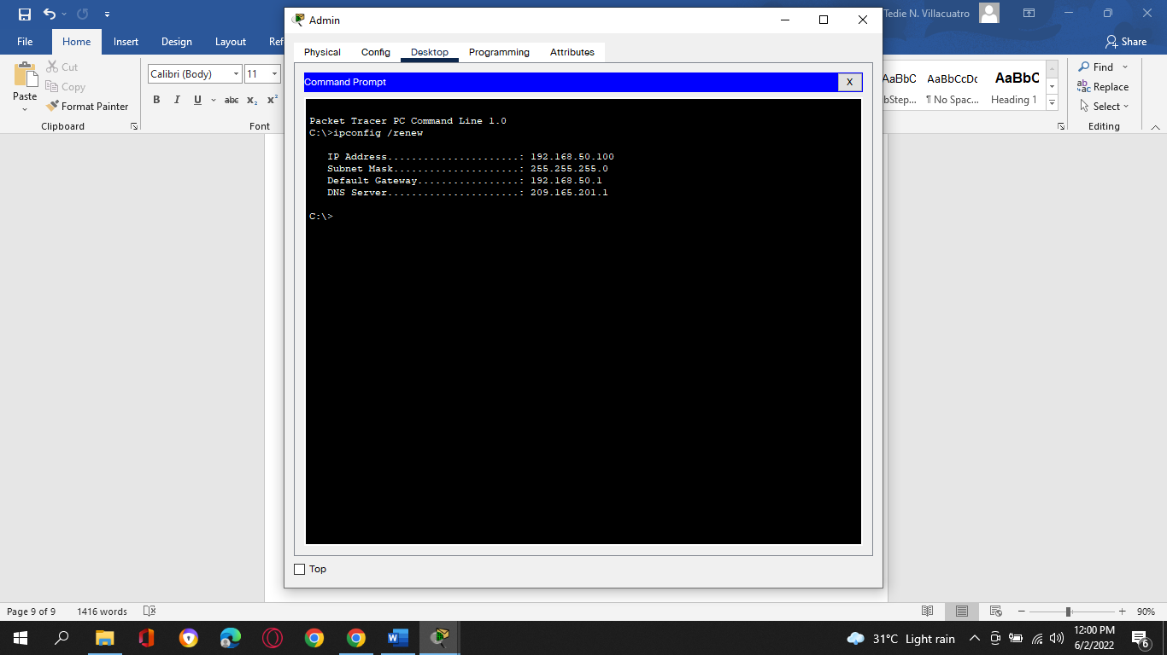

Question:

1. What is the new IP address information for **Admin**?

* **192.168.50.100**

1. j.      Verify that you can still navigate to **www.cisco.pka** server.
2. 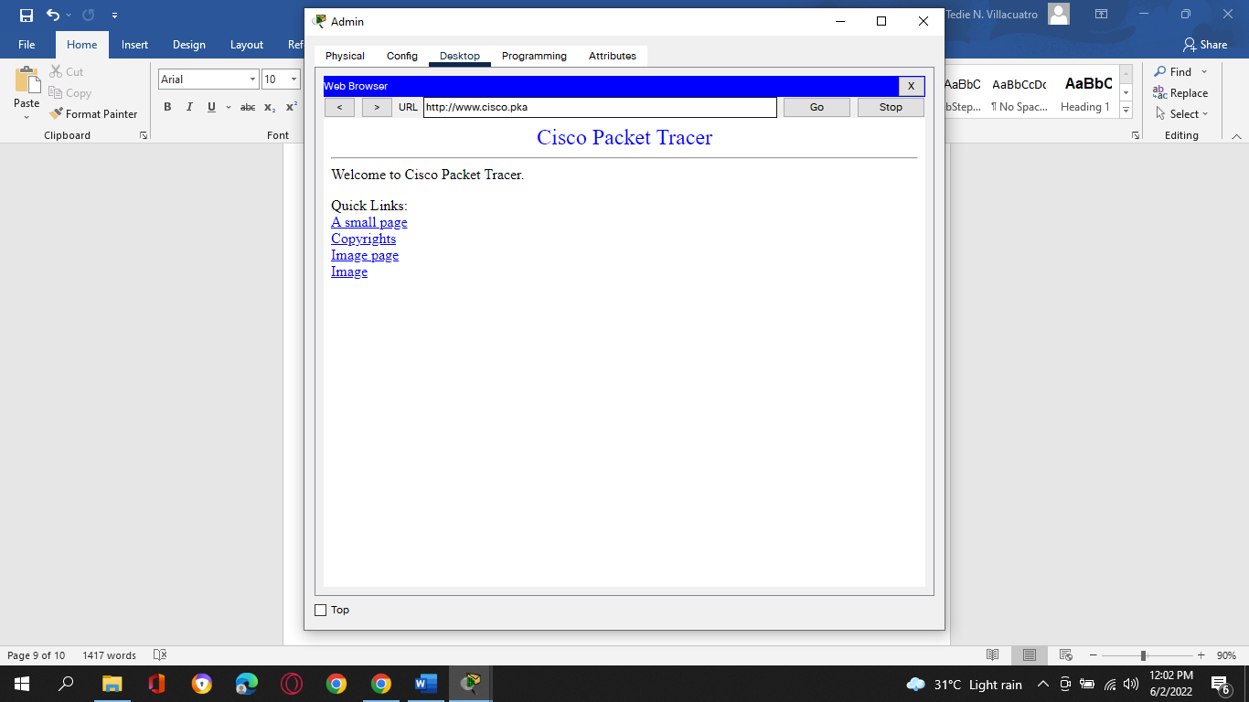
3. k.     Renew the IP address on other laptops to verify that you can still navigate to **www.cisco.pka** server.
4. l.      Notice that **Laptop1** connected to the **AP** instead of **WR**.

Question:

1. Why? **The AP had a better signal for Laptop1.**

**Configure a Wireless Network Activity Completion:**

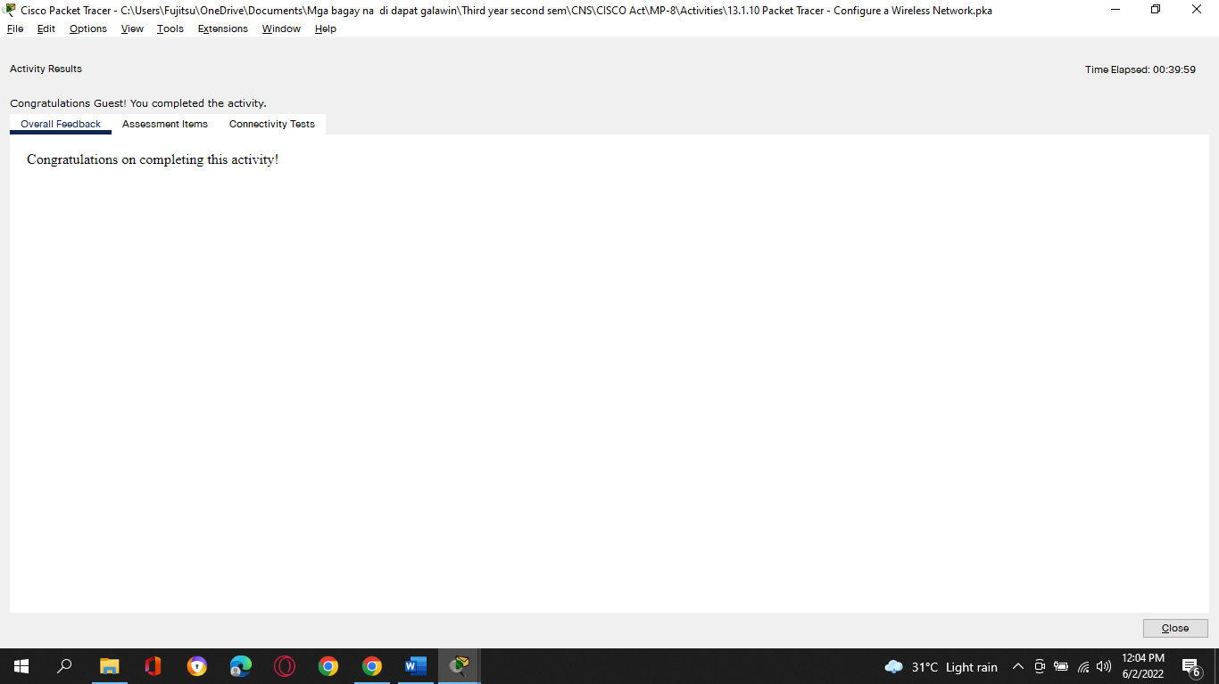

**Assessment Items:**

1. *End of Document*

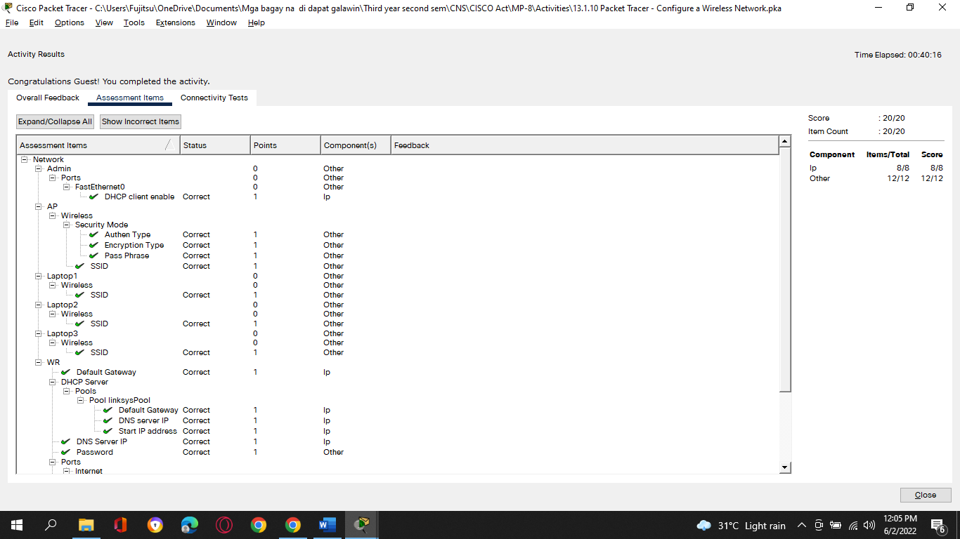

**Tedie N. Villacuatro**

**BSCOE 3-3**

**13.1.11 Lab – Configure a Wireless Network**

1. **Introduction**

In this lab, you will configure basic settings on a wireless router and connect a PC to router wirelessly.

1. **Recommended Equipment**
2. A Windows computer with wired and wireless network cards installed
3. Wireless router
4. Ethernet patch cable

**Note**: All wireless settings in this lab are for a 2.4 GHz wireless connection. Follow the same steps for setting up a 5 GHz wireless connection or when setting up both 2.4 GHz and 5 GHz connections.

**Instructions**

* 1. **Log into the Wireless Router**
     1. **Connect the computer to the router.**
        1. Ask the instructor for the following information that is used during the lab.

**Router Address Information:**

IP address: **192.168.46.1**

***Type your answers here.***

Subnet mask: **255.255.255.0**

***Type your answers here.***

Router name: **CMPE30174**

***Type your answers here.***

**DHCP Server Setting Information:**

Start IP address: **192.168.46.100**

***Type your answers here.***

Maximum number of users: **50**

***Type your answers here.***

**Default Router Access:**

Router Username / Password: **Username: admin / Password: p@55w0rd**

***Type your answers here.***

**Assigned SSID:**

Your Assigned SSID: **cisco2**

***Type your answers here.***

**Note**: Only use configurations assigned by the instructor.

* + - 1. Plug in the power for the wireless router. Boot the computer and log in as an administrator.
      2. Connect the computer to one of the **Ethernet** ports on the wireless router with an Ethernet patch cable.

**Note**: If this is the first time connecting to the lab router, follow these instructions to set a network location. This will be explained later in the course.

* + - 1. If prompted by the **Set Network Location** window, select **Public network**. Click **Close** to accept the network location Public.
      2. Open a command prompt and type **ipconfig** to determine the IP address of the default gateway, which should be the IP address of your wireless router. If it is necessary to renew the IP address, enter **ipconfig /all** at the prompt.

Question:

What is the default gateway for the computer? **192.168.46.1**

***Type your answers here.***

* + 1. **Log in to the router.**
       1. Open **Microsoft Edge** or other web browsers. Enter the IP address of your default gateway in the **Address** field, and then press **Enter**.
       2. In the **Windows Security** window, enter administrative user credentials provided by your instructor.

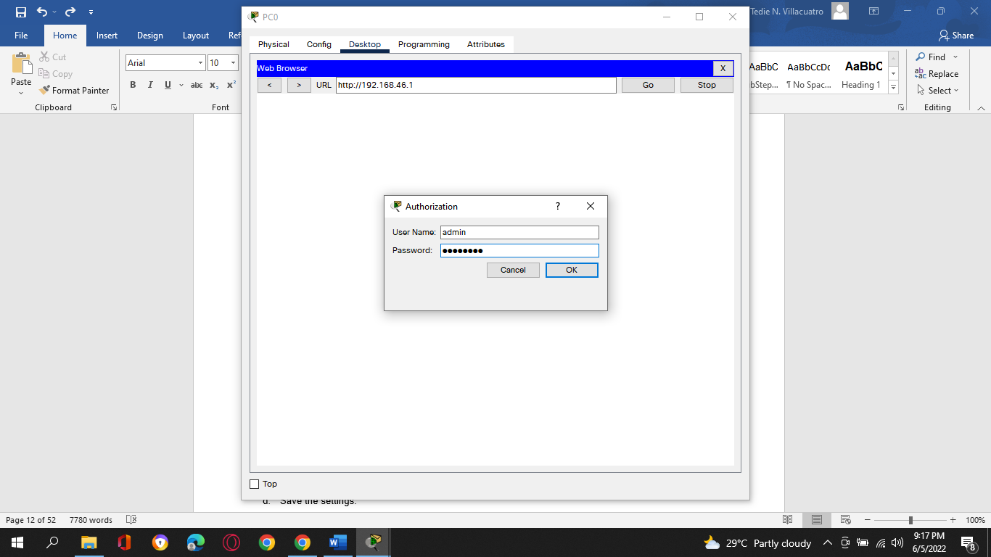

* 1. **Configure Basic Wireless Settings**

In this lab, you will not be configuring the wireless router to the internet. You will configure the SSID or network name and security in the wireless settings, configure DHCP settings, and set a new administrative password.

* + 1. **Configure SSID.**
       1. Locate the wireless settings. In the SSID or network name field, enter your assigned SSID.

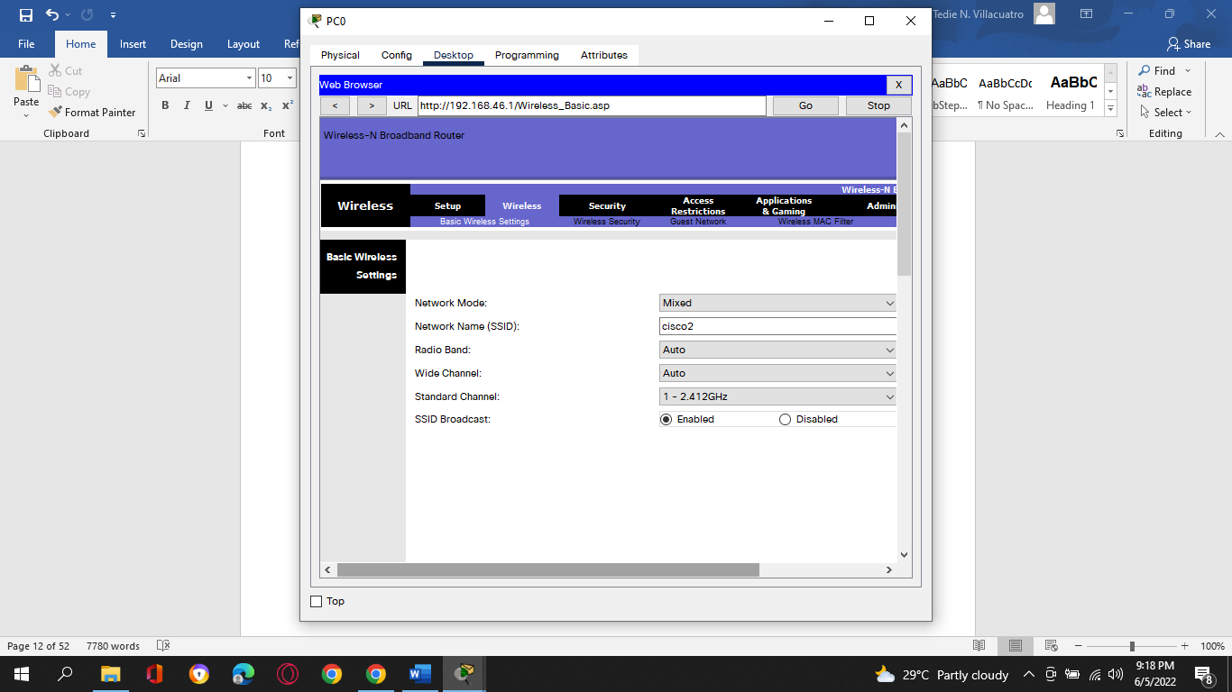

* + - 1. Save the settings.
    1. **Configure wireless security.**
       1. Locate the wireless security settings.
       2. Select WPA2 security option. Select AES cipher and personal if available.
       3. Enter a passphrase or password as assigned by your instructor or use **Cisco456!** as an example.

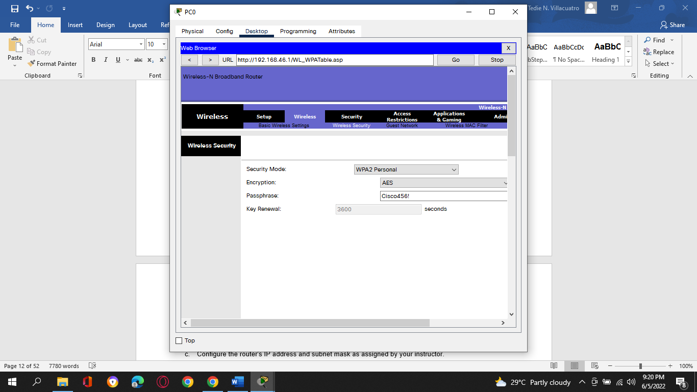

* + - 1. Save the settings.
    1. **Configure DHCP settings.**
       1. Locate the LAN settings.
       2. Configure router device name if available.
       3. Configure the router's IP address and subnet mask as assigned by your instructor.
       4. Verify that the wireless router is used as the DHCP server.
       5. Configure the LAN information for your assigned subnet. If possible, you may be providing the starting and end IP addresses or the maximum number of IP addresses available for connecting hosts wirelessly.

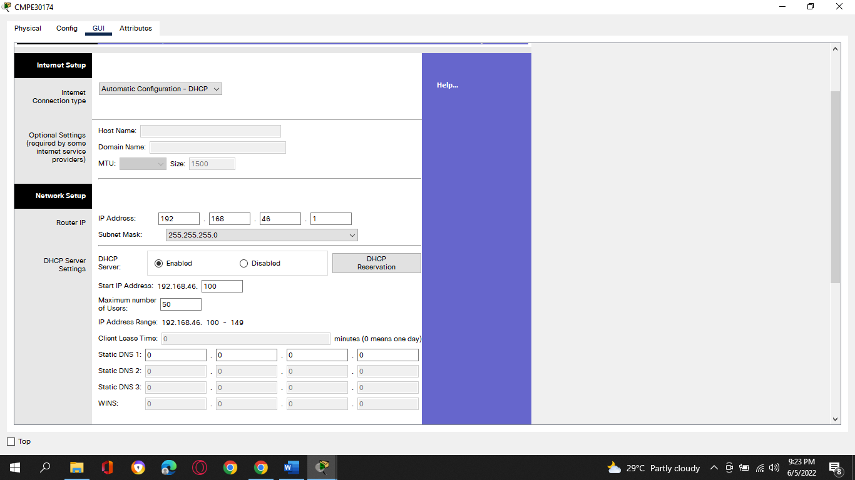

* + - 1. Save the settings.
      2. The router may need to reboot at this time. If necessary, reboot the router.
    1. **Change the default administrative password.**
       1. Locate the password settings for the administrative account.
       2. Provide the current password and the new password as assigned by your instructor or C**isco123!**.

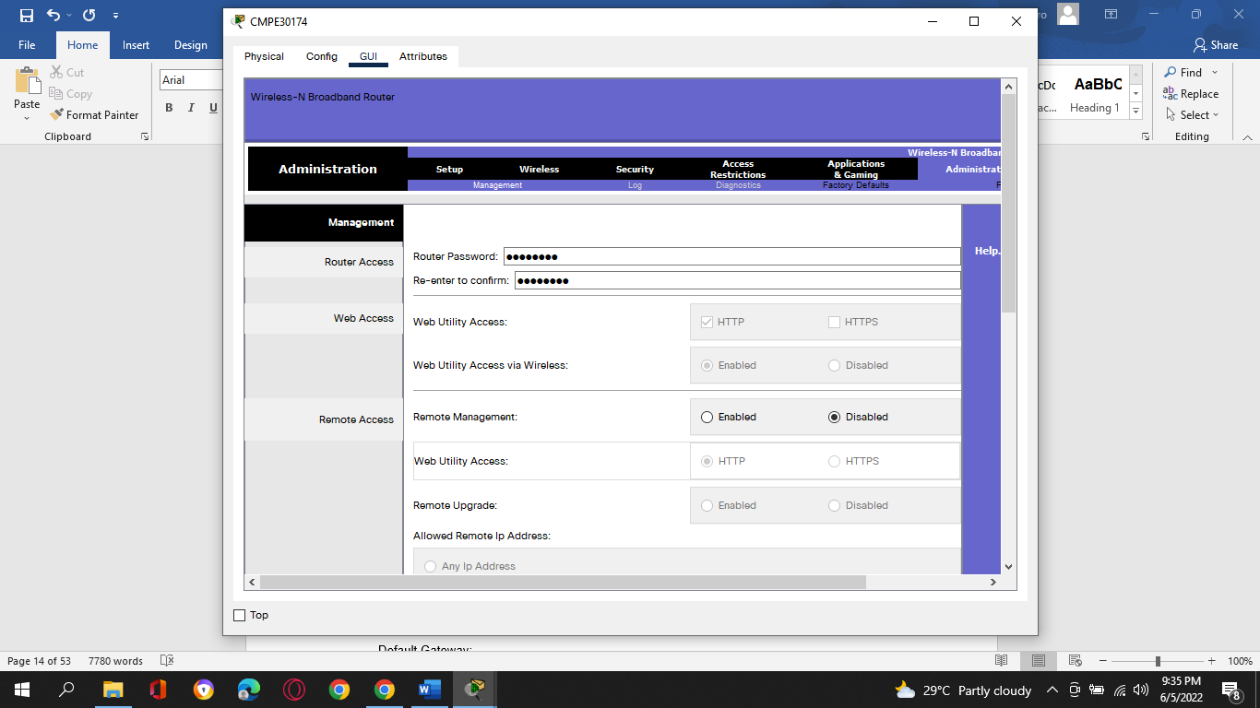

* + - 1. Save the settings.
      2. Log into the wireless using the new credentials: **admin** / **Cisco123!** or the credentials that were assigned to you.
      3. At this time, you can disconnect the Ethernet cable if desired.
  1. **Connect a Wireless Client**
     + 1. Click **Start**, enter **wireless**. Select **Change Wi-Fi Settings**.
       2. In Wi-Fi settings window, select **Show available networks**.
       3. Select the configured SSID that you configured in a previous step.
       4. Enter the password or passphrase configured in a previous step.
       5. Open a command prompt. Type **ipconfig** and record the following information.

**Computer IP information**:

IP address: **192.168.46.101**

Subnet mask**: 255.255.255.0**

Default Gateway: **192.168.46.1**

***Type your answers here.***

* 1. **Connect an Access Point (Optional)**

In this part, you will add a wireless access point (AP) to the network. An AP is connected directly to a wireless router using an Ethernet cable. The purpose of an AP is to extend the wireless LAN where the wireless users cannot reach the wireless router otherwise.

In this part, you may need to partner with another group with a wireless router that can be converted to an access point. Or your instructor may also provide an access point. Unless instructed to connect the wireless router the internet, you do not need to connect the Internet port of the wireless router to a cable or DSL connection.

**Note**: If you are converting a wireless router to an AP, please follow the instructions provided by your instructor or manufacturer's documentations.

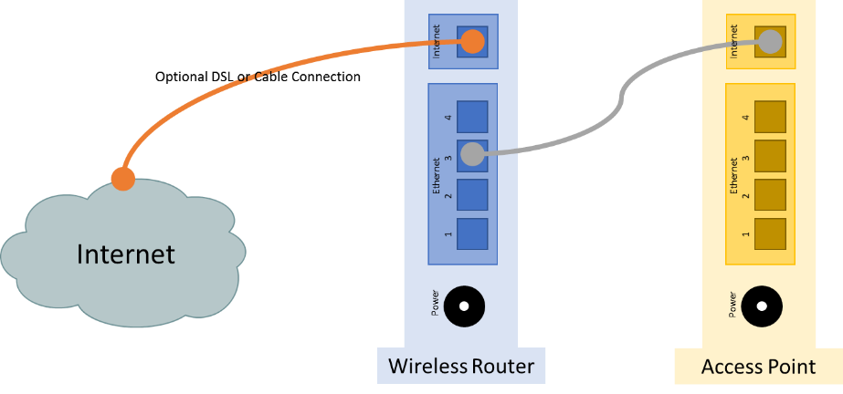

* + 1. **Connect the access point to the wireless network.**
       1. Connect the wireless router via the Ethernet port. Navigate to the wireless router using a web browser using the IP address of the default gateway and log in as the administrator.
       2. To prevent interference, navigate to the wireless settings. Change the wireless channel from the default channel 1 to channel 6 or 11 on the wireless router. Save the new settings.
       3. Connect the Internet port of the access point to one of LAN ports on the existing wireless router.
    2. **Configure access point wireless settings.**
       1. In the web page of the wireless router, navigate to the LAN settings to determine the IP address of the access point. The IP address of the access point can be listed in the address reservation table or DHCP client list.
       2. In another web browser, navigate to the IP address of the access point.
       3. In the access point settings, navigate to the wireless settings and configure the AP with the same wireless SSID and security options as the wireless router. For example, **ITE** as the SSID and WPA2 Personal AES with **Cisco456!** as the passphrase.

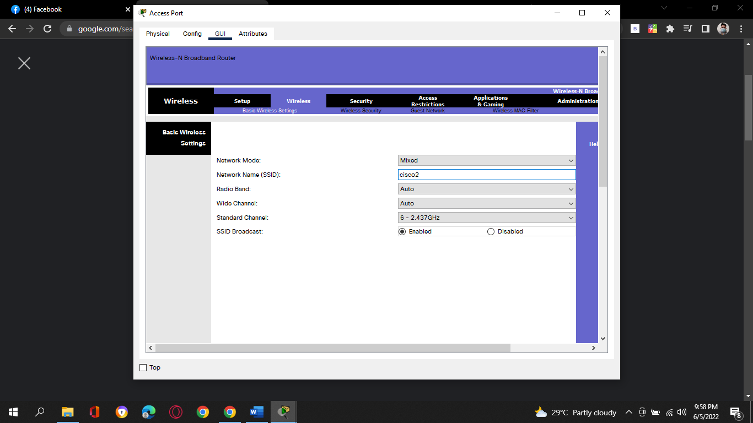

* + - 1. Verify that the wireless router and AP are not using the same wireless channels.
      2. Attempt to connect a wireless client to the wireless network.
    1. **Turn off wireless radio on the wireless router.**

After you have successfully connected to the wireless network, you will attempt to disable the wireless router radio, and a wireless client will attempt to connect to the wireless network through the AP.

Depending on the wireless router model, you maybe able to switch off the wireless radio using the on/off switch.

* + - 1. Navigate to the wireless router using a web browser. If necessary, connect to the wireless router using a wired Ethernet connection.
      2. Navigate to the wireless settings, turn off the wireless router radio if available. The option to enable wireless radio may be in the advanced wireless settings.
      3. Save the settings.
      4. Attempt to connect a wireless client to the AP.

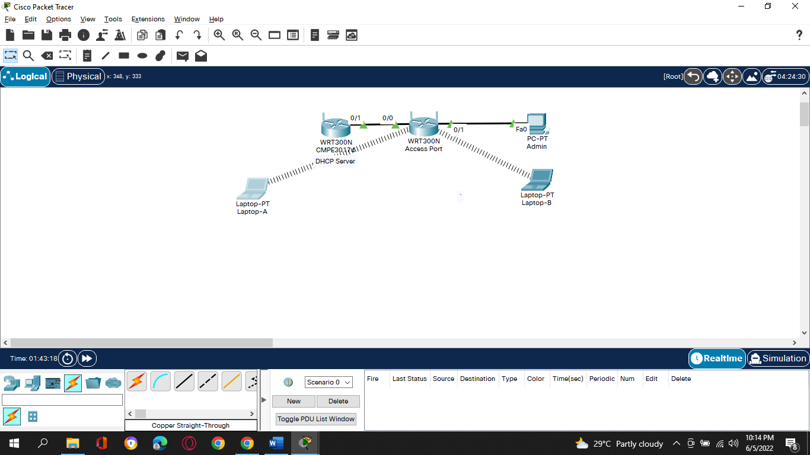

* 1. **Reset to the original configuration**

Unless stated otherwise by the instructor, restore the router back to factory default if the option is available.

**Note**: Some wireless models have a reset button to reset the router to its default factory settings.

* + - 1. Locate the Maintenance or System settings.
      2. Click the selection to revert to factory default settings.
      3. Provide your administrative credentials if prompted.
      4. Wait for your router to finish reboot before shutting down the wireless router.

1. *End of Document*

**Output Topology:**

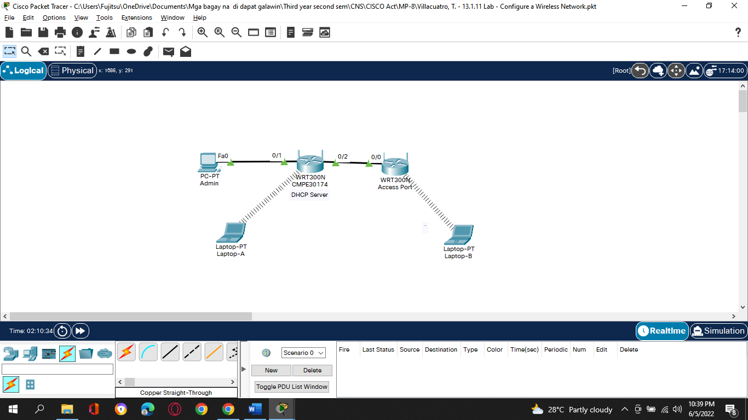

**Tedie N. Villacuatro**

**BSCOE 3-3**

1. **13.2.7 Packet Tracer - Configure a Basic WLAN on the WLC**
2. **Addressing Table**

| **Device** | **Interface** | **IP Address** |
| --- | --- | --- |
| R-1 | G/0/0 | 172.31.1.1/24 |
| 1. *R-1* | G0/0/1.5 | 192.168.5.1/24 |
| 1. *R-1* | G0/0/1.200 | 192.168.200.1/24 |
| SW-1 | VLAN 200 | 192.168.200.100/24 |
| LAP-1 | G0 | DHCP |
| WLC-1 | Management | 192.168.200.254/24 |
| Server | NIC | 172.31.1.254/24 |
| Admin PC | NIC | 192.168.200.200/24 |
| Wireless Host | Wireless NIC | DHCP |

1. **Objectives**
2. In this lab, you will explore some of the features of a wireless LAN controller. You will create a new WLAN on the controller and implement security on that LAN. Then you will configure a wireless host to connect to the new WLAN through an AP that is under the control of the WLC. Finally, you will verify connectivity.
3. ·         Connect to a wireless LAN controller GUI.
4. ·         Explain some of the information that is available on the WLC Monitor screen.
5. ·         Configure a WLAN on a wireless LAN controller.
6. ·         Implement security on a WLAN.
7. ·         Configure a wireless host to connect to a wireless LAN.
8. **Background / Scenario**
9. An organization is centralizing control of their wireless LAN by replacing their standalone access points with lightweight access points (LAP) and a wireless LAN controller (WLC). You will be leading this project and you want to become familiar with the WLC and any potential challenges that may occur during the project. You will configure a WLC by adding a new wireless network and securing it with WPA-2 PSK security. To test the configuration, you will connect a laptop to the WLAN and ping devices on the network.
10. **Instructions**
11. **Part 1: Monitor the WLC**
12. Wait until STP has converged on the network. You can click the Packet Tracer Fast Forward Time button to speed up the process. Continue when all link lights are green.

a.     Go the desktop of **Admin PC** and open a browser. Enter the management IP address of **WLC-1** from the addressing table into the address bar. You must specify the **HTTPS** protocol.

b.     Click **Login** and enter these credentials: User Name: **admin**, Password: **Cisco123**. After a short delay, you will see the WLC Monitor Summary screen.

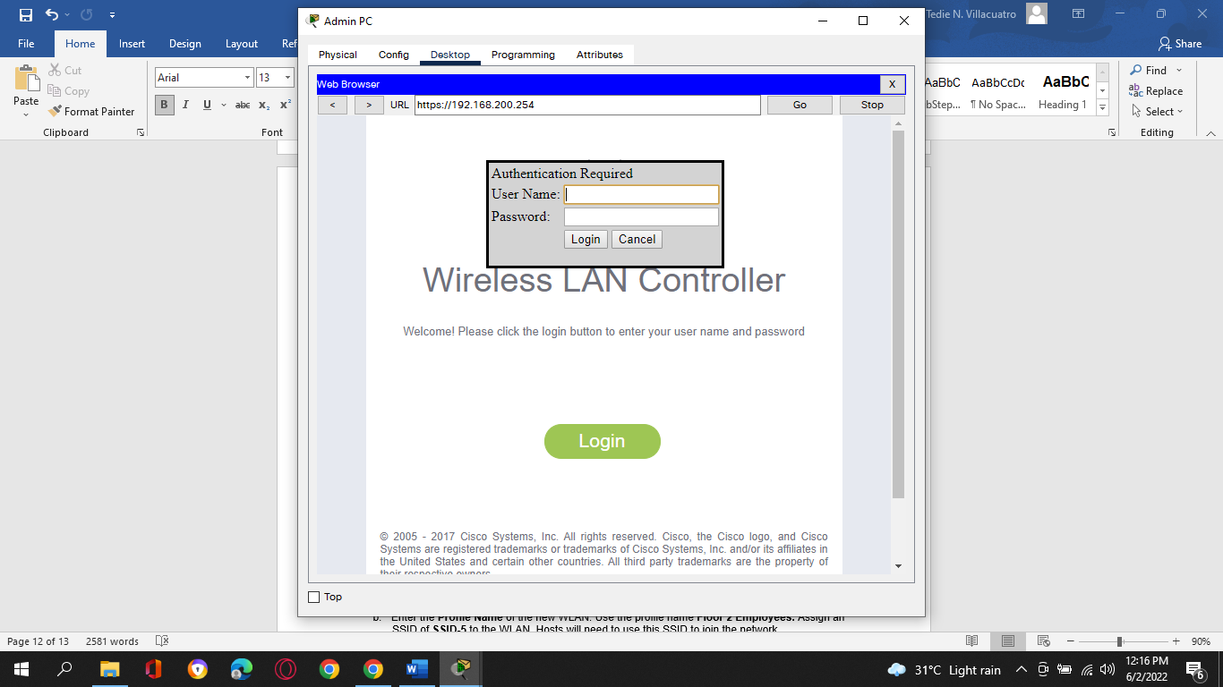

1. **Note:** Packet Tracer does not support the initial dashboard that has been demonstrated in this module.

c.     Scroll through the Monitor Summary screen.

What can be learned from this screen?

Is the WLC connected to an AP?

d.     Click Detail next to the All APs entry in the Access Point Summary section of the page. What information can you find about APs on the All APs screen?

1. **Part 2: Create a Wireless LAN**
2. Now you will create a new wireless LAN on the WLC. You will configure the settings that are required for hosts to join the WLAN.
3. **Step 1: Create and enable the WLAN.**
   * + 1. Click **WLANs** in the WLC menu bar. Locate the dropdown box in the upper right had corner of the WLANs screen. It will say **Create New**. Click **Go** to create a new WLAN.

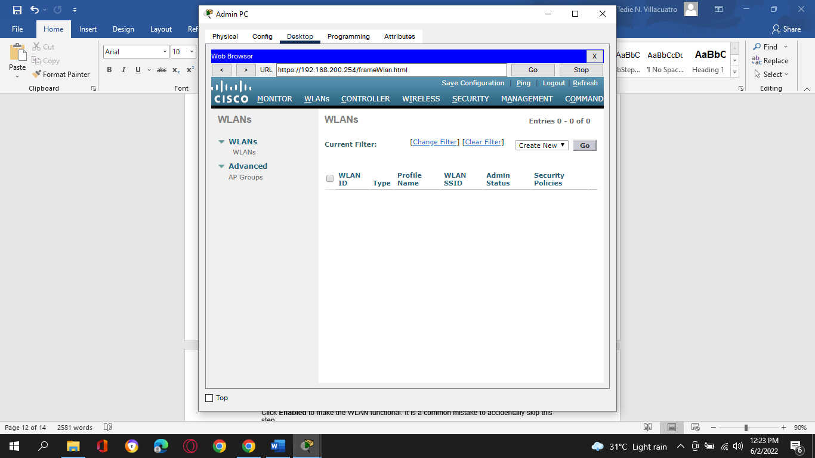

b.     Enter the **Profile Name** of the new WLAN. Use the profile name **Floor 2 Employees.** Assign an SSID of **SSID-5** to the WLAN. Hosts will need to use this SSID to join the network.

c.     Select the **ID** for the WLAN. This value is a label that will be used to identify the WLAN is other displays. Select a value of **5** to keep it consistent with the VLAN number and SSID. This is not a requirement but it helps with understanding the topology.

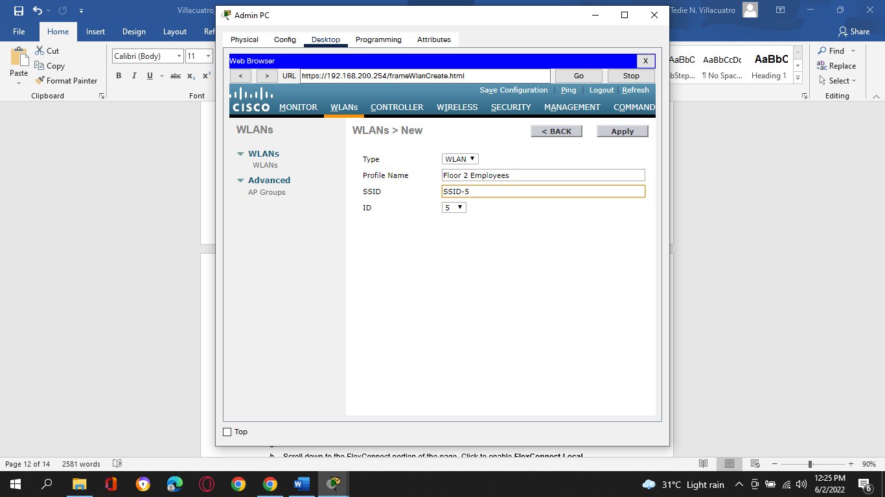

d.     Click **Apply** so that the settings go into effect.

e.     Now that the WLAN has been created, you can configure features of the network. Click **Enabled** to make the WLAN functional. It is a common mistake to accidentally skip this step.

f.      Choose the VLAN interface that will be used for the WLAN. The WLC will use this interface for user traffic on the network. Click the drop-down box for Interface/Interface Group (G). Select the **WLAN-5** interface. This interface was previously configured on the WLC for this activity.

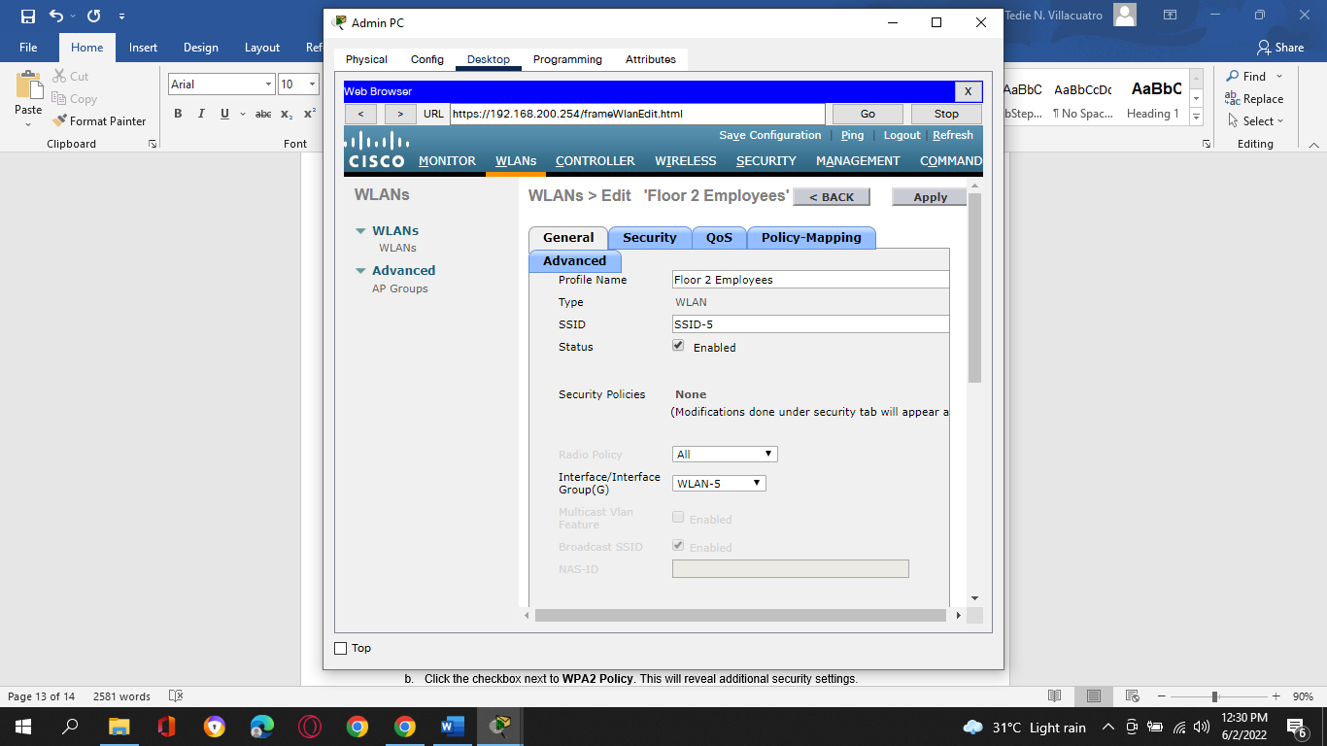

g.     Click the **Advanced** tab.

h.     Scroll down to the FlexConnect portion of the page. Click to enable **FlexConnect Local Switching** and **FlexConnect Local Auth**.

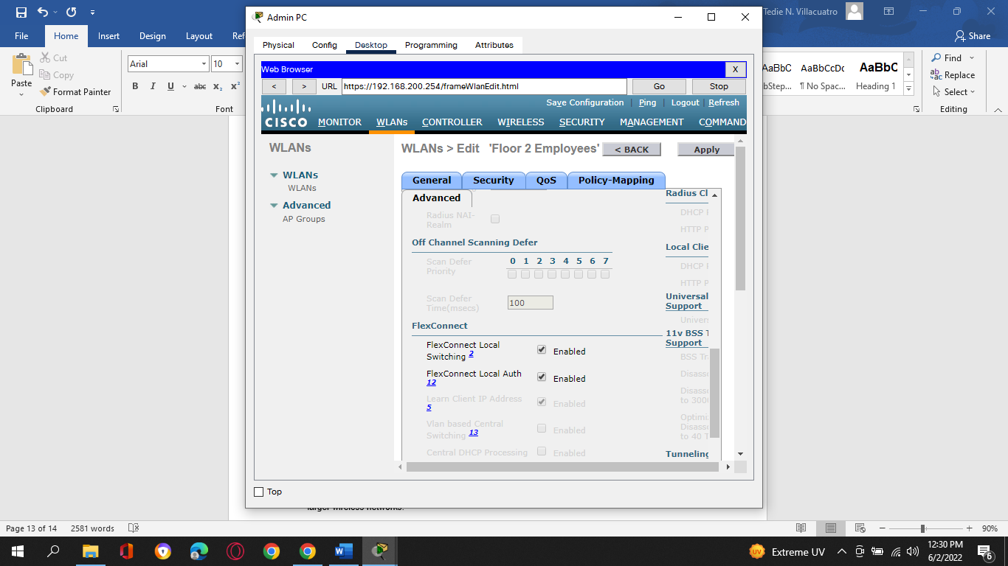

i.      Click **Apply** to enable the new WLAN. If you forget to do this, the WLAN will not operate.

1. **Step 2: Secure the WLAN.**
2. The new WLAN currently has no security in place. This WLAN will initially use WPA2-PSK security. In another activity, you will configure the WLAN to use WPA2-Enterprise, a much better solution for larger wireless networks.

a.     In the WLANs Edit screen for the Floor 2 Employees WLAN, click the **Security** tab. Under the **Layer 2** tab, select **WPA+WPA2** from the **Layer 2 Security** drop down box. This will reveal the WPA parameters.

b.     Click the checkbox next to **WPA2 Policy**. This will reveal additional security settings. Under **Authentication Key Management**, enable **PSK**.

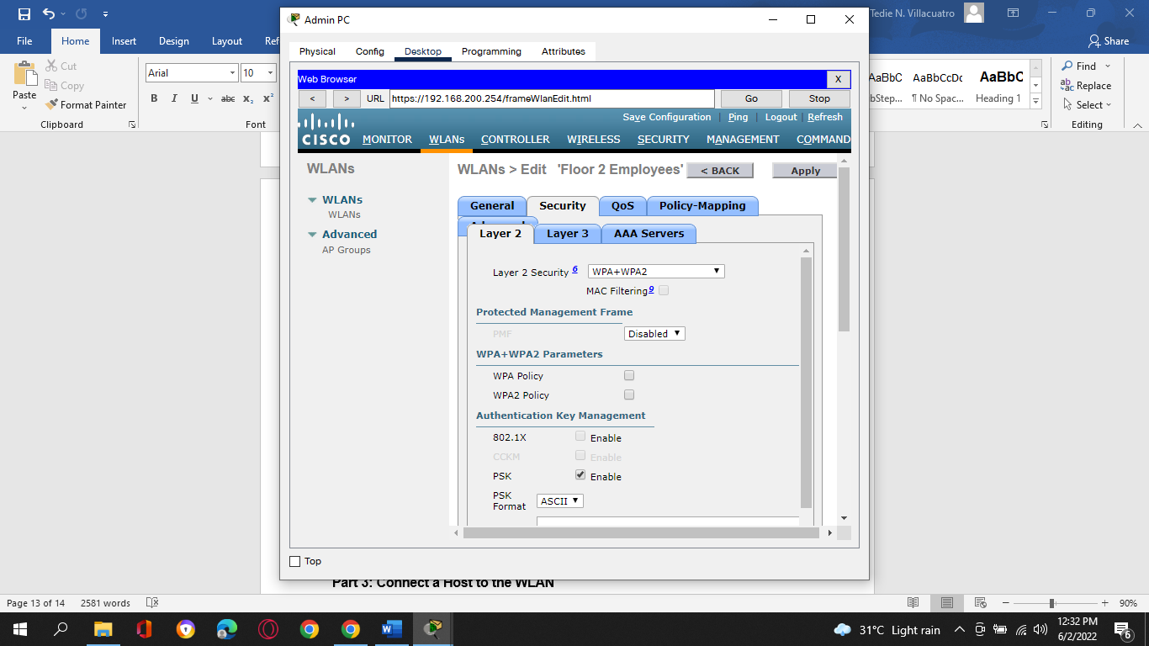

c.     Now you can enter the pre-shared key that will be used by hosts to join the WLAN. Use **Cisco123** as the passphrase.

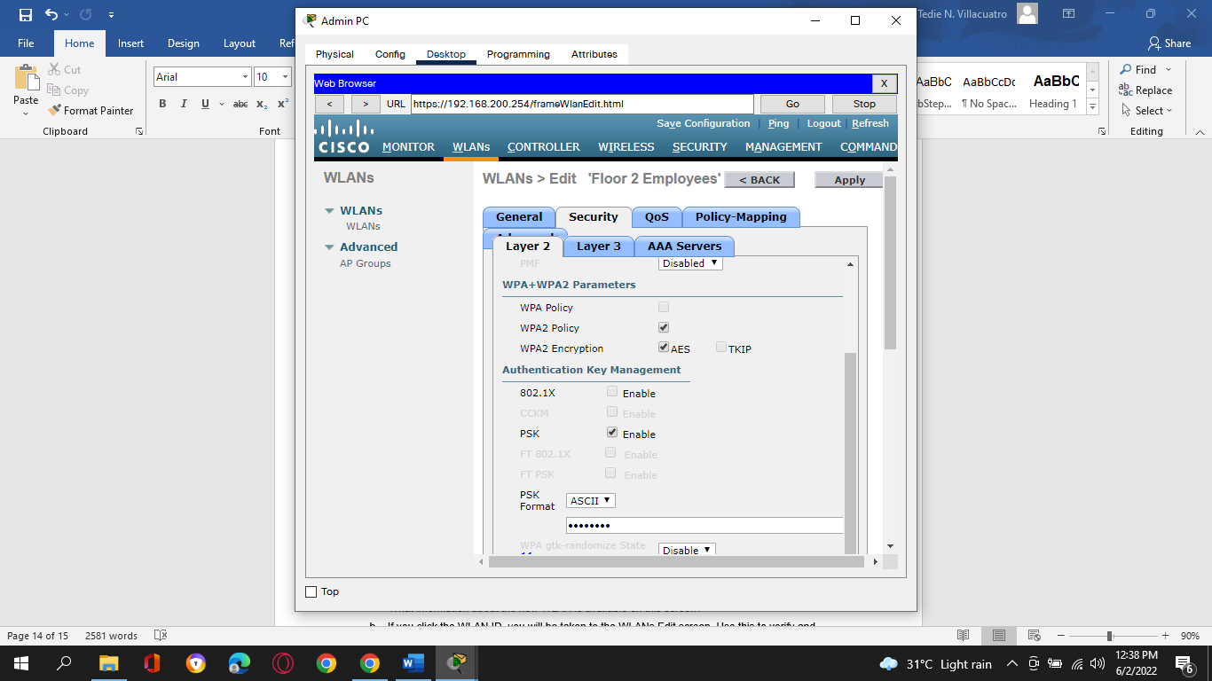

d.     Click **Apply** to save these settings.

1. **Note:** It is not a good practice to reuse passwords when configuring security. We have reused passwords in this activity to simplify configuration.
2. **Step 3: Verify the Settings**
   * + 1. After Applying the configuration, click **Back**. This will take you back to the WLANs screen.

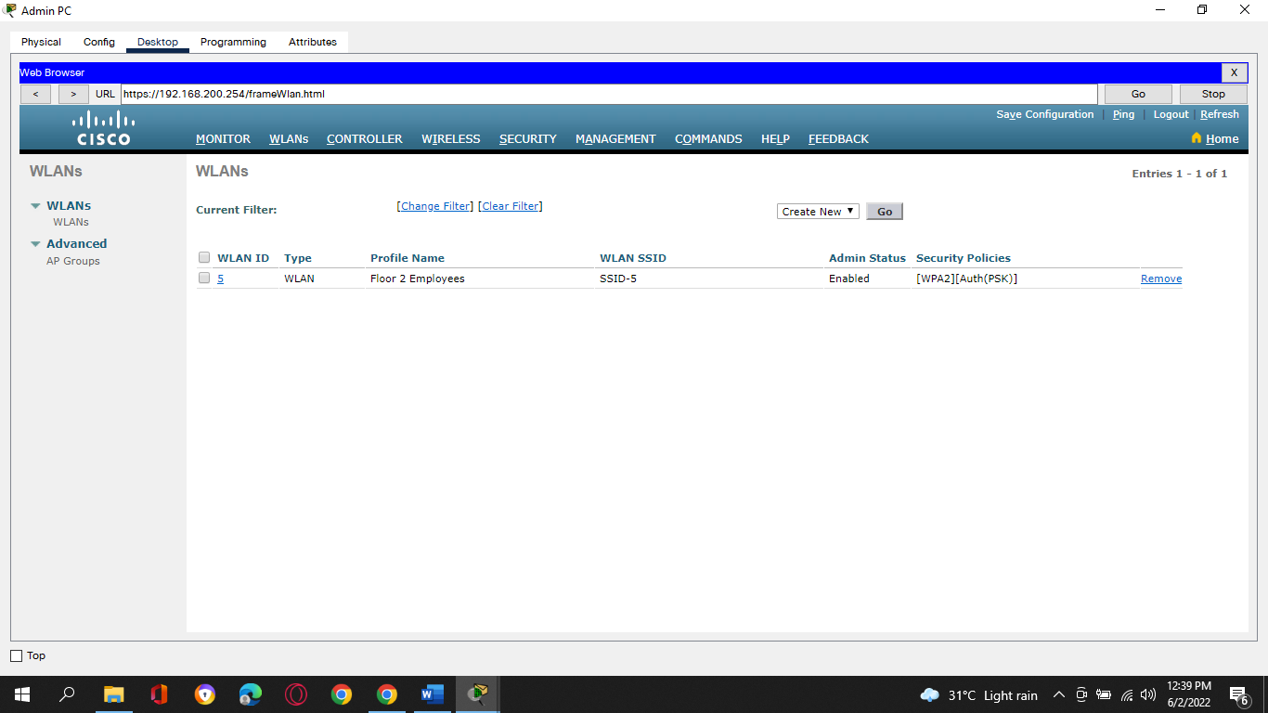

Question:

What information about the new WLAN is available on this screen?

b.     If you click the WLAN ID, you will be taken to the WLANs Edit screen. Use this to verify and change the details of the settings.

1. **Part 3: Connect a Host to the WLAN**
2. **Step 1: Connect to the network and verify connectivity.**

a.     Go to the desktop of **Wireless Host** and click the **PC Wireless** tile.

b.     Click the **Connect** tab. After a brief delay you should see the SSID for the WLAN appear in the table of wireless network names. Select the **SSID-5** network and click the **Connect**button.

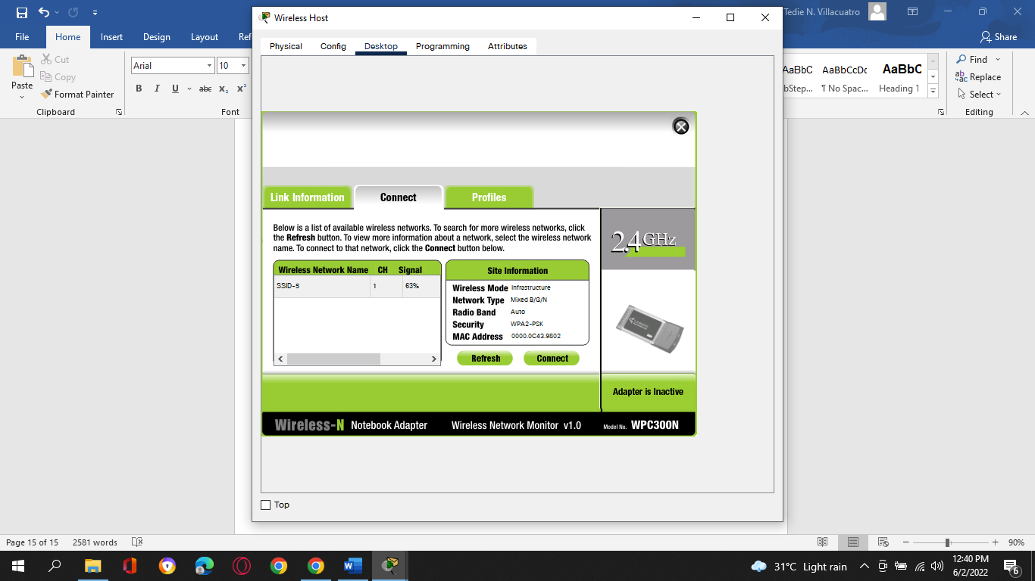

c.     Enter the pre-shared key that you configured for the WLAN and click **Connect**.

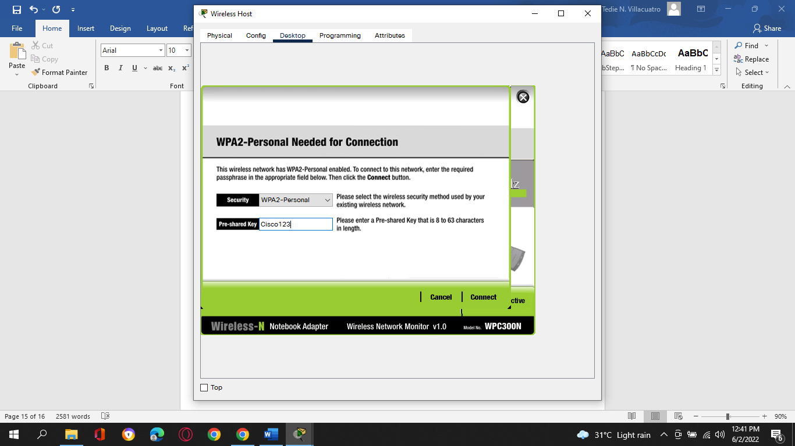

d.     Click the **Link Information** tab. You should see a message that confirms that you have successfully connected to the access point. You should also see a wireless wave in the topology showing the connection to LAP-1.

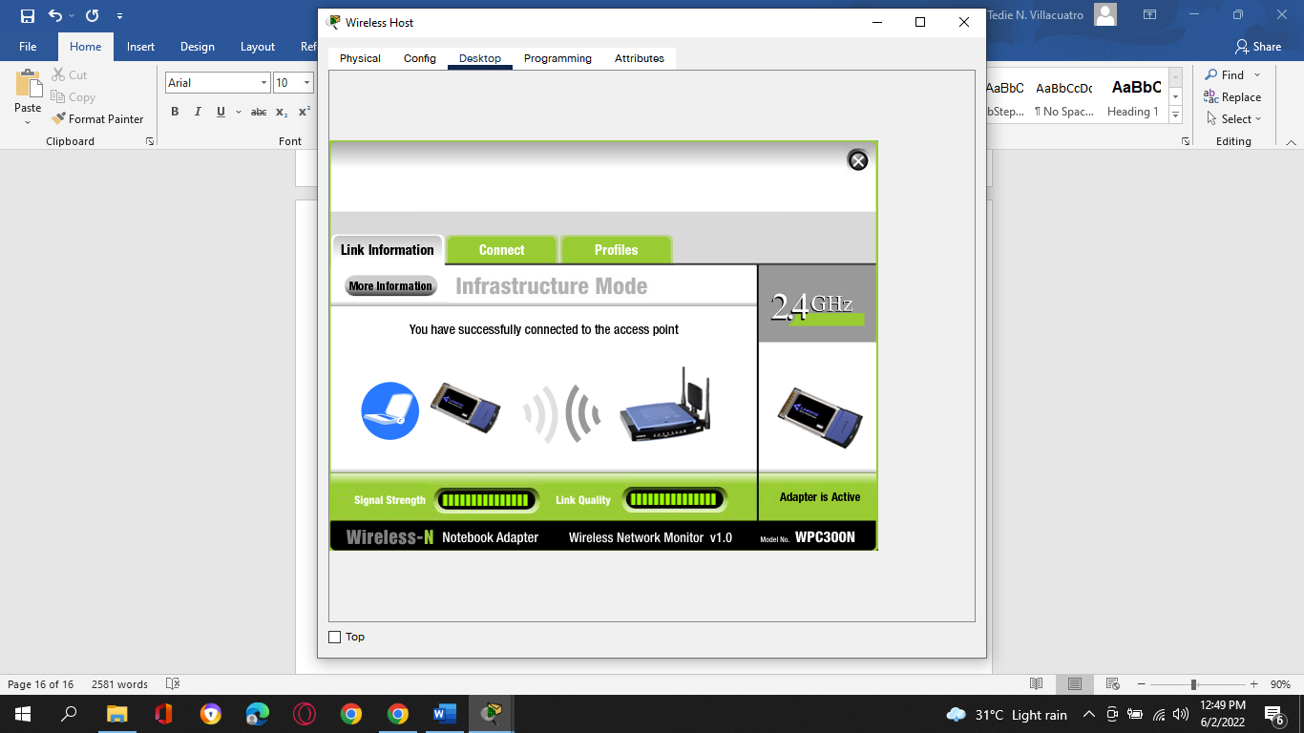

e.     Click the **More Information** button to see details about the connection.

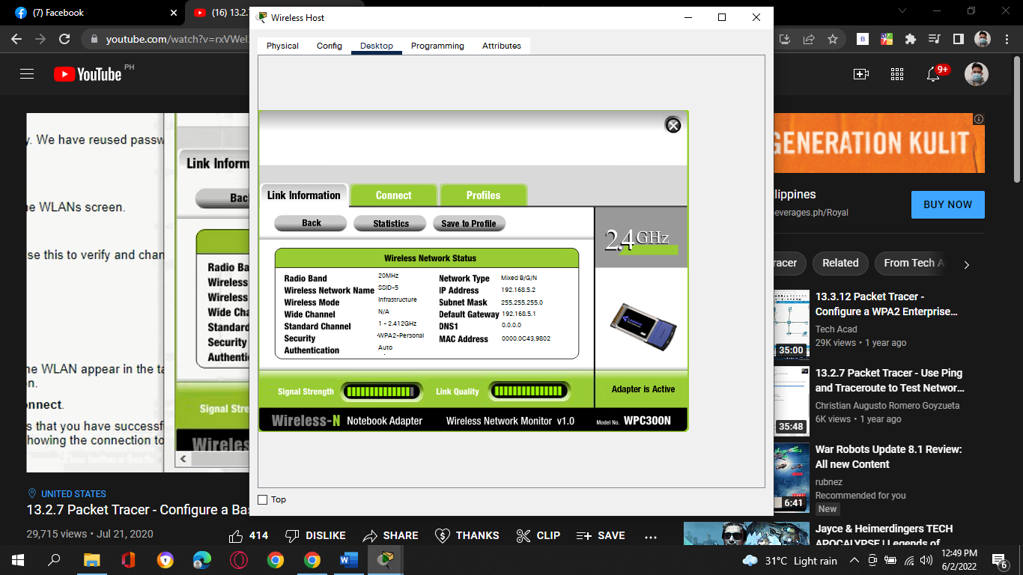

f.      Close the PC Wireless app and open the IP Configuration app. Verify that Wireless Host has received a non-APIPA IP address over DHCP. If not, click the Fast Forward Time button a few times.

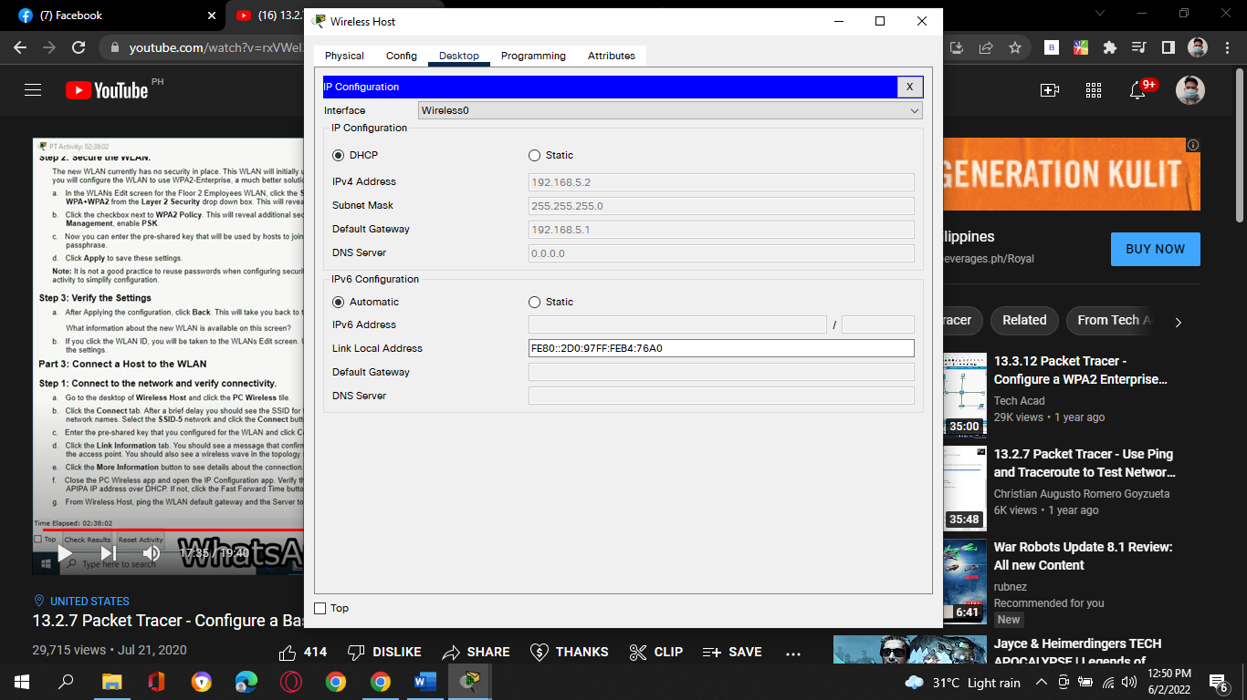

g.     From Wireless Host, ping the WLAN default gateway and the Server to verify that the laptop has full connectivity.

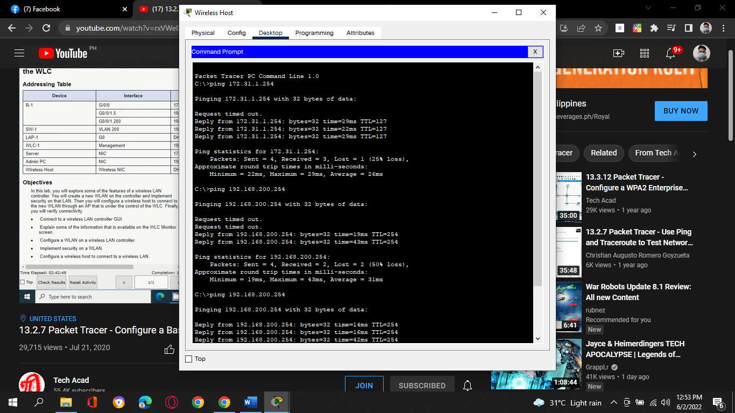

**Configure a Basic WLAN on the WLC Activity Completion:**

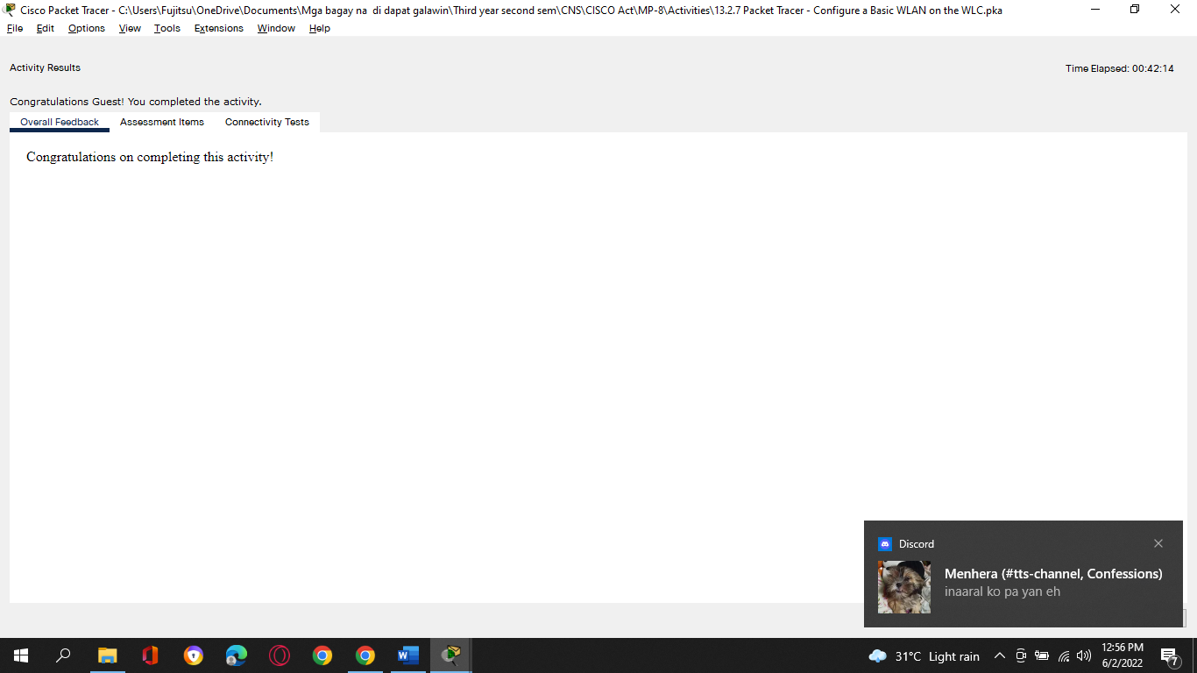

**Assessment Items:**

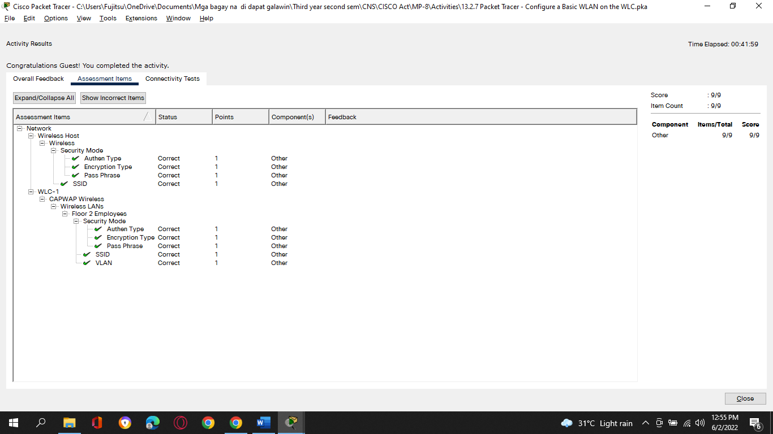

**Tedie N Villacuatro**

**BSCOE 3-3**

1. **13.5.1 Packet Tracer - WLAN Configuration**
2. **Addressing Table**

| **Device** | **Interface** | **IP Address** |
| --- | --- | --- |
| Home Wireless Router | Internet | DHCP |
| 1. *Home Wireless Router* | LAN | 192.168.6.1/27 |
| RTR-1 | G0/0/0.2 | 192.168.2.1/24 |
| RTR-1 | G0/0/0.5 | 192.168.5.1/24 |
| RTR-1 | G0/0/0.100 | 192.168.100.1/24 |
| RTR-1 | G0/0/1 | 10.6.0.1/24 |
| SW1 | VLAN 200 | 192.168.100.100/24 |
| LAP-1 | G0 | DHCP |
| WLC-1 | Management | 192.168.100.254/24 |
| RADIUS Server | NIC | 10.6.0.254/24 |
| Home Admin | NIC | DHCP |
| Enterprise Admin | NIC | 192.168.100.200/24 |
| Web Server | NIC | 203.0.113.78/24 |
| DNS Server | NIC | 10.100.100.252 |
| Laptop | NIC | DHCP |
| Tablet PC | Wireless0 | DHCP |
| Smartphone | Wireless0 | DHCP |
| Wireless Host 1 | Wireless0 | DHCP |
| Wireless Host 2 | Wireless0 | DHCP |

1. **WLAN Information**

| **WLAN** | **SSID** | **Authentication** | **Username** | **Password** |
| --- | --- | --- | --- | --- |
| 1. Home Network | 1. HomeSSID | 1. WPA2-Personal | 1. N/A | 1. Cisco123 |
| 1. WLAN VLAN 2 | 1. SSID-2 | 1. WPA-2 Personal | 1. N/A | 1. Cisco123 |
| 1. WLAN VLAN 5 | 1. SSID-5 | 1. WPA-2 Enterprise | 1. userWLAN5 | 1. userW5pass |

1. **Note:** It is not a good practice to reuse passwords as is done in this activity. Passwords have been reused to make it easier to work through the tasks.
2. **Objectives**
3. In this activity, you will configure both a wireless home router and a WLC-based network. You will implement both WPA2-PSK and WPA2-Enterprise security.
4. ·         Configure a home router to provide Wi-Fi connectivity to a variety of devices.
5. ·         Configure WPA2-PSK security on a home router.
6. ·         Configure interfaces on a WLC.
7. ·         Configure WLANs on a WLC.
8. ·         Configure WPA2-PSK security on a WLAN and connect hosts to WLAN.
9. ·         Configure WPA2-Enteprise on a WLAN and connect hosts to the WLAN.
10. ·         Verify connectivity WLAN connectivity.
11. **Background / Scenario**

You will apply your WLAN skills and knowledge by configuring a home wireless router and an enterprise WLC. You will implement both WPA2-PSK and WPA2-Enterprise security. Finally, you will connect hosts to each WLAN and verify connectivity.

1. **Instructions**
2. **Part 1: Configure a Home Wireless Router.**
3. You are installing a new home wireless router at a friend’s house. You will need to change settings on the router to enhance security and meet your friend’s requirements.
4. **Step 1: Change DHCP settings.**

a.     Open the Home Wireless Router GUI and change the router IP and DHCP settings according to the information in the Addressing Table.

b.     Permit a maximum of **20** addresses to be issued by the router.

c.     Configure the DHCP server to start with IP address .**3**of the LAN network.

d.     Configure the internet interface of the router to receive its IP address over DHCP.

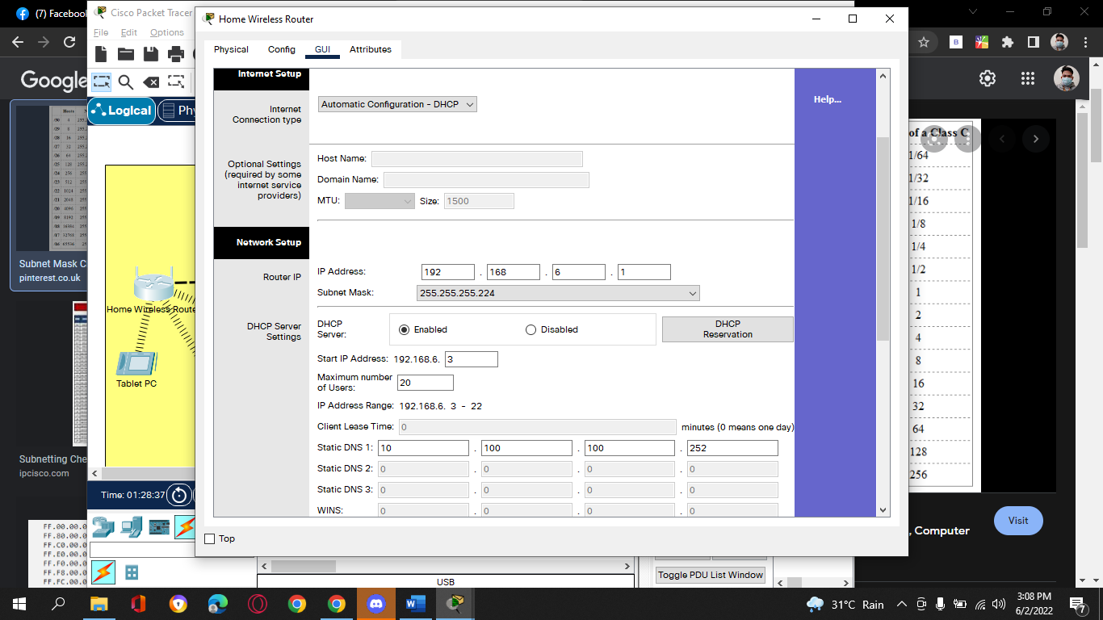

Question:

Verify the address. What address did it receive? **10.100.200.2**

e.     Configure the static DNS server to the address in the Addressing Table.

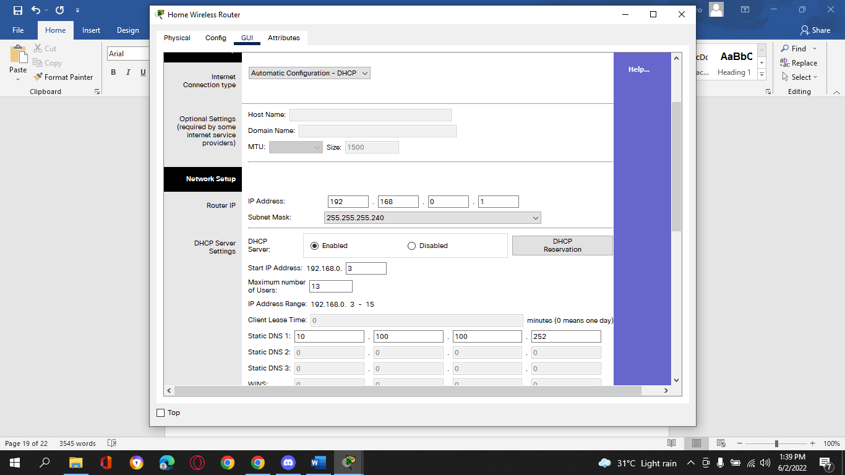

1. **Step 2: Configure the Wireless LAN.**

a.     The network will use the 2.4GHz Wireless LAN interface. Configure the interface with the SSID shown in the Wireless LAN information table.

b.     Use **channel 6**.

c.     Be sure that all wireless hosts in the home will be able to see the SSID.

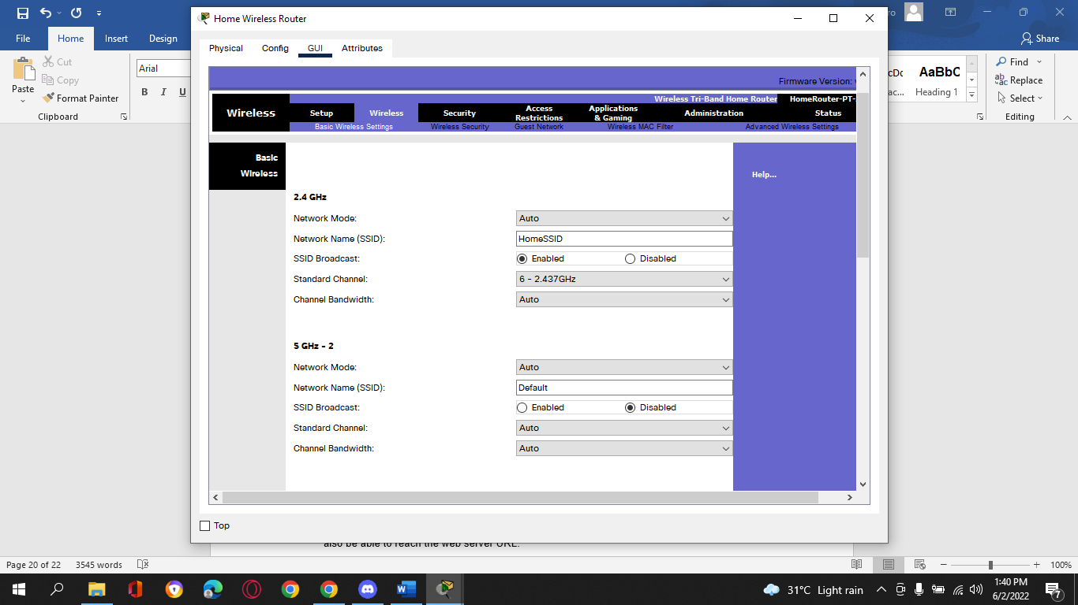

1. **Step 3: Configure security.**
   * + 1. Configure wireless LAN security. Use WPA2 Personal and the passphrase shown in the Wireless LAN information table.

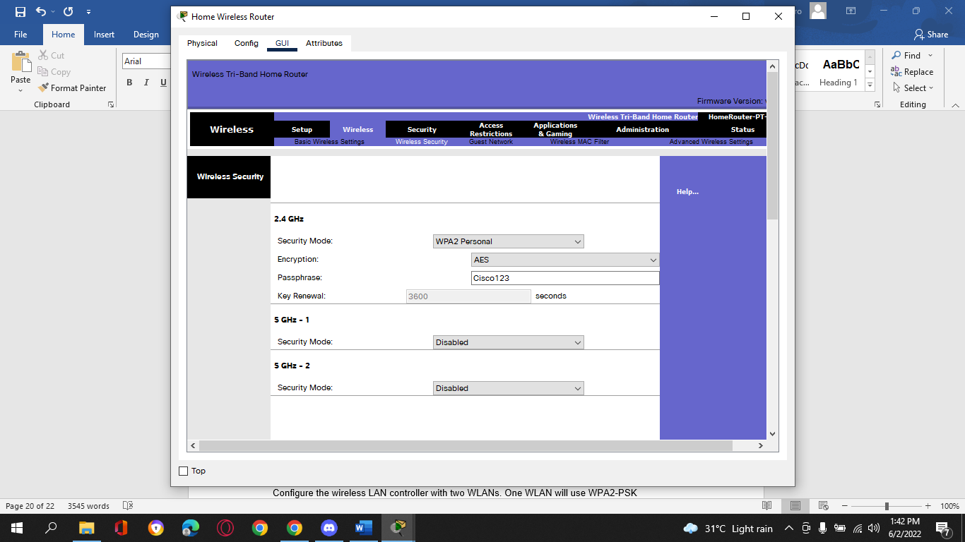

b.     Secure the router by changing the default password to the value shown in the Wireless LAN information table.

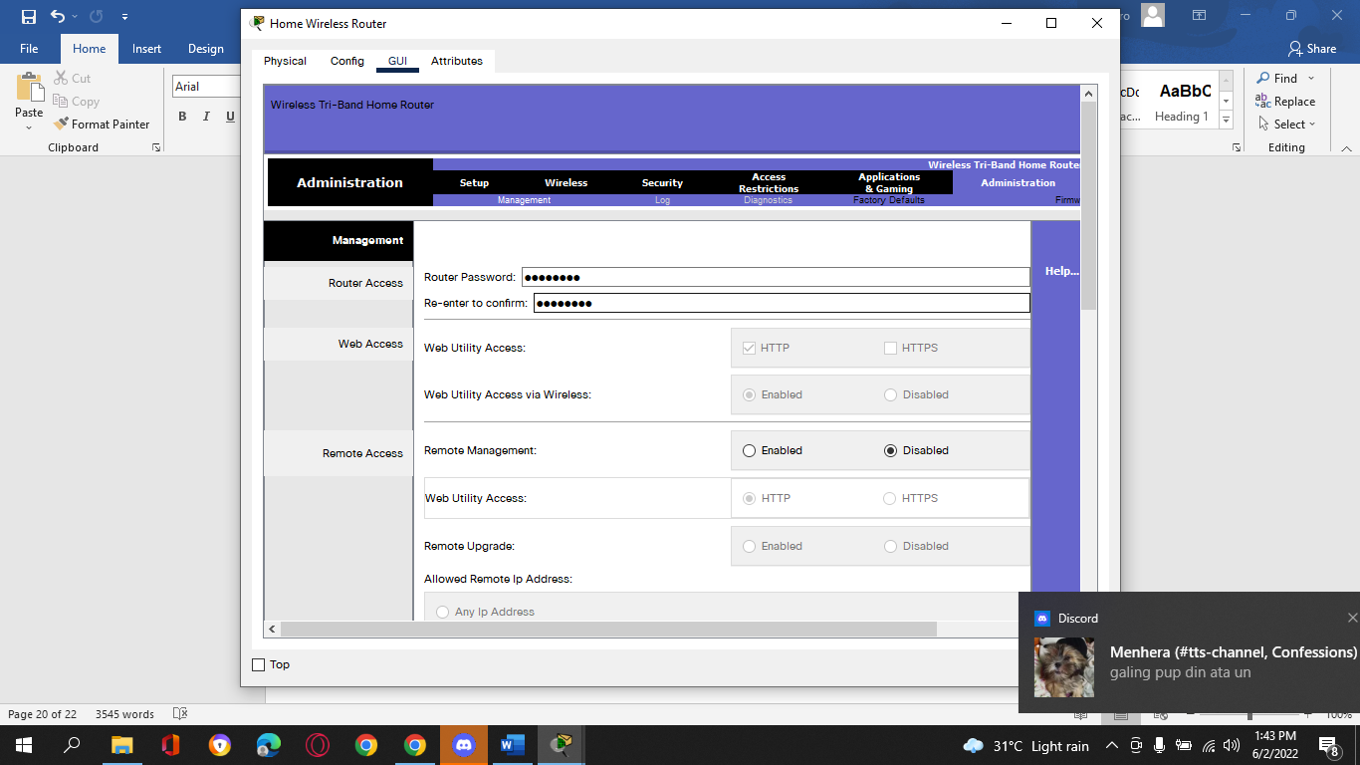

1. **Step 4: Connect clients to the network.**
   * + 1. Open the PC Wireless app on the desktop of the laptop and configure the client to connect to the network.

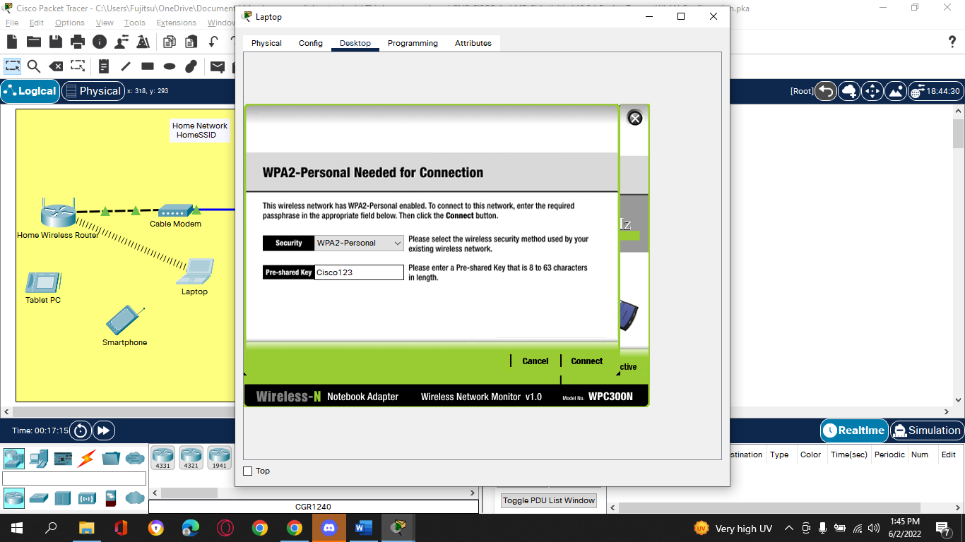

* + - 1. Open the Config tab on the Tablet PC and Smartphone and configure the wireless interfaces to connect to the wireless network.

**Smartphone wireless connection:**

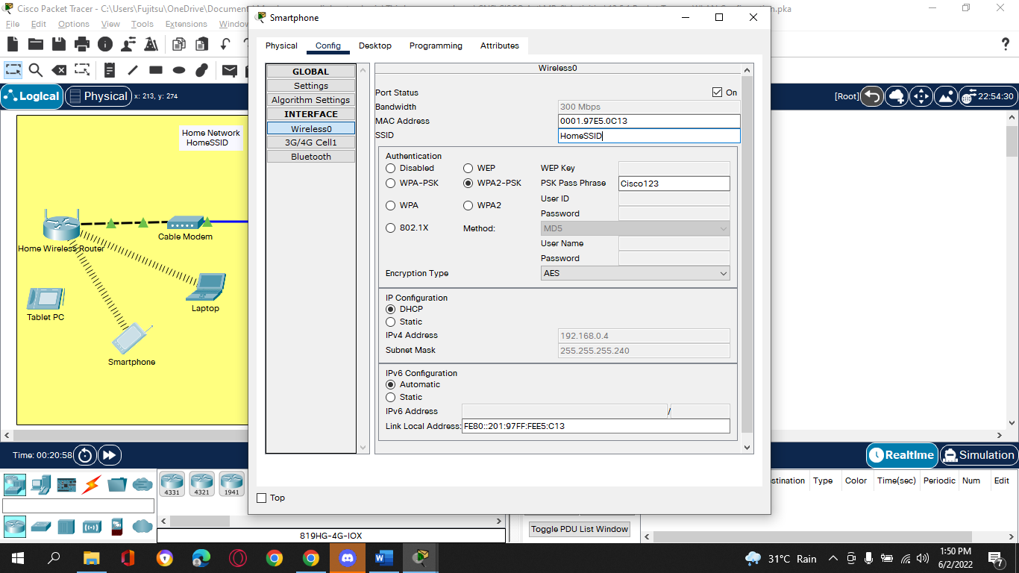

**Tablet Pc:**

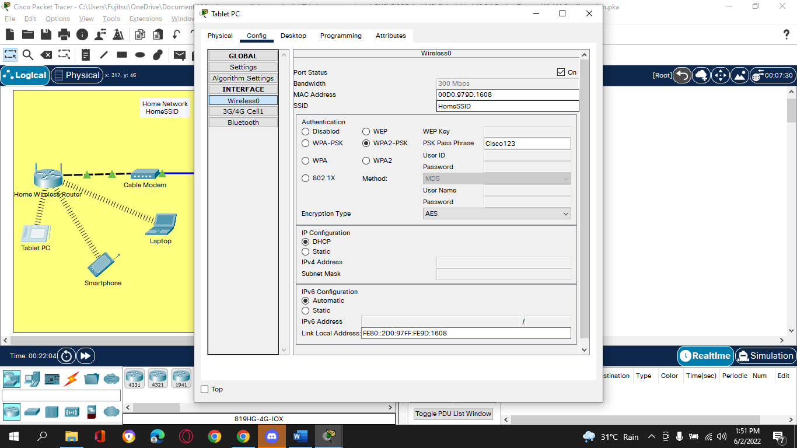

* + - 1. Verify connectivity. The hosts should be able to ping each other and the web server. They should also be able to reach the web server URL.

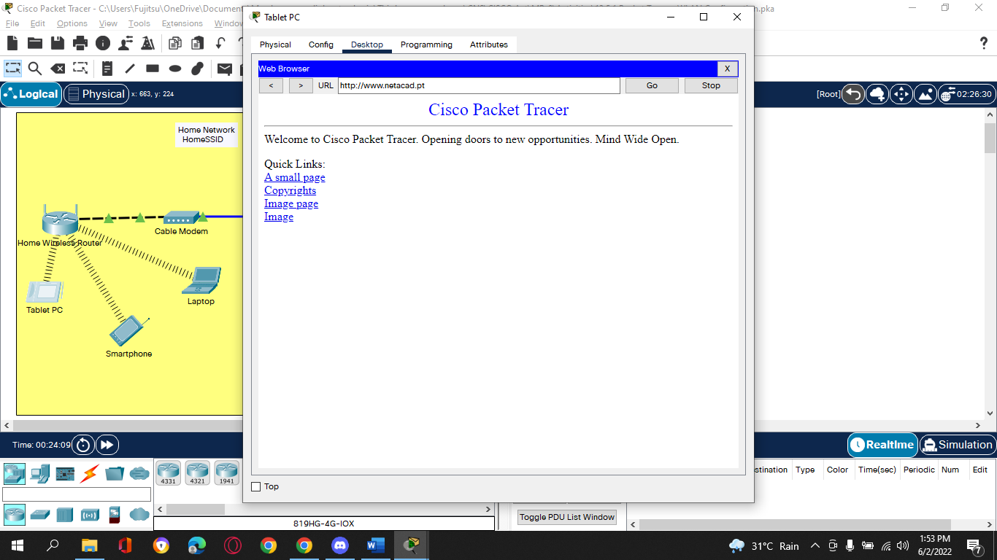

1. **Part 2: Configure a WLC Controller Network**
2. Configure the wireless LAN controller with two WLANs. One WLAN will use WPA2-PSK authentication. The other WLAN will use WPA2-Enterprise authentication. You will also configure the WLC to use an SNMP server and configure a DHCP scope that will be used by the wireless management network.
3. **Step 1: Configure VLAN interfaces.**
   * + 1. From the Enterprise Admin, navigate to the WLC-1 management interface via a web browser. To log into WLC-1, use **admin** as the username and **Cisco123** as the password.

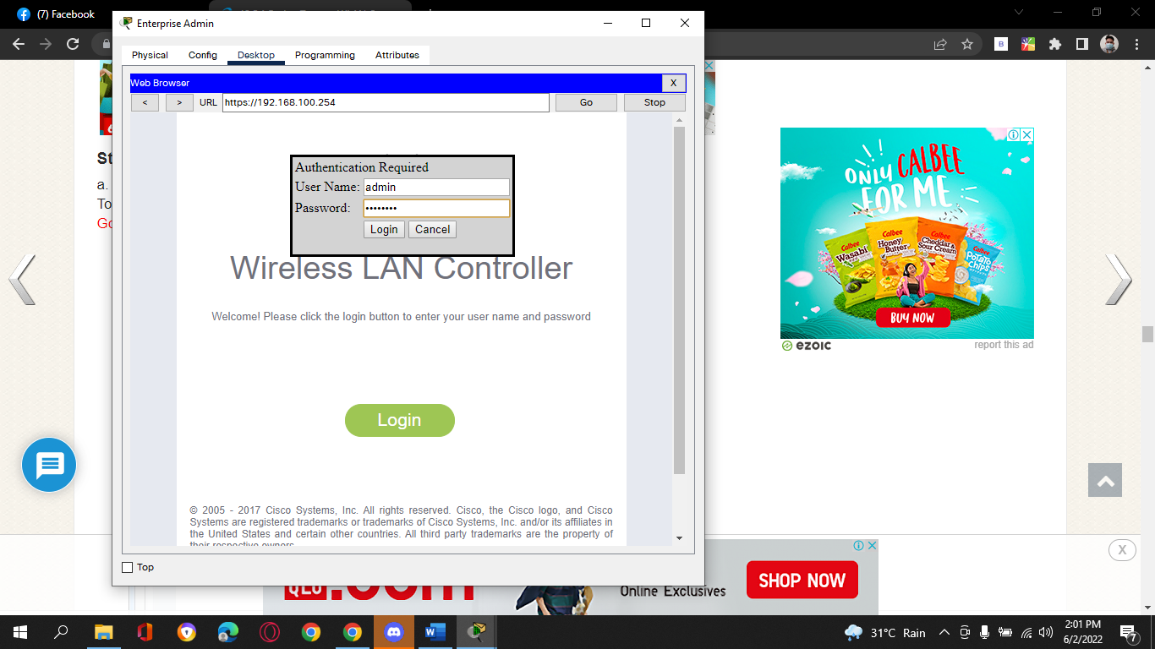

b.     Configure an interface for the first WLAN.

Name: **WLAN 2**

VLAN Identifier: **2**

Port Number: **1**

Interface IP Address: **192.168.2.254**

Netmask: **255.255.255.0**

Gateway: **RTR-1 G0/0/0.2 address**

Primary DHCP Server: **Gateway address**

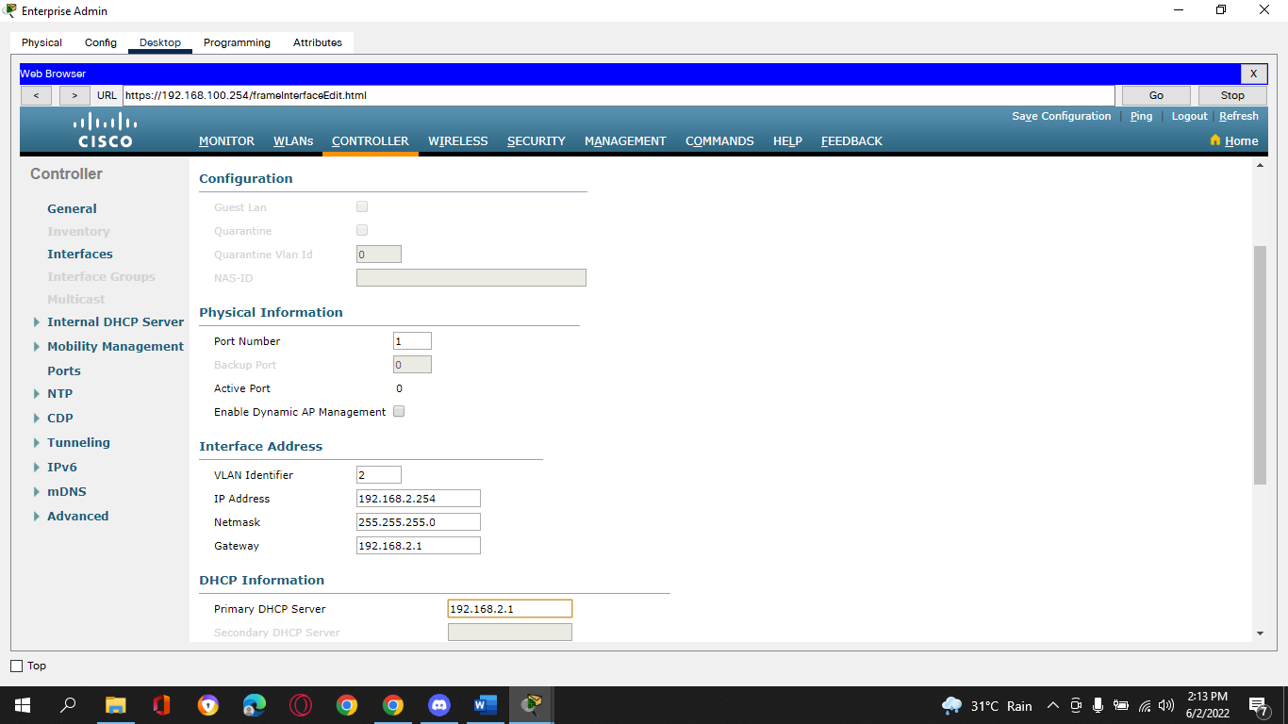

c.     Configure an interface for the second WLAN.

Name: **WLAN 5**

VLAN Identifier: **5**

Port Number: **1**

Interface IP Address: **192.168.5.254**

Netmask: **255.255.255.0**

Gateway: **RTR-1 interface G0/0/0.5 address**

Primary DHCP Server: **Gateway address**

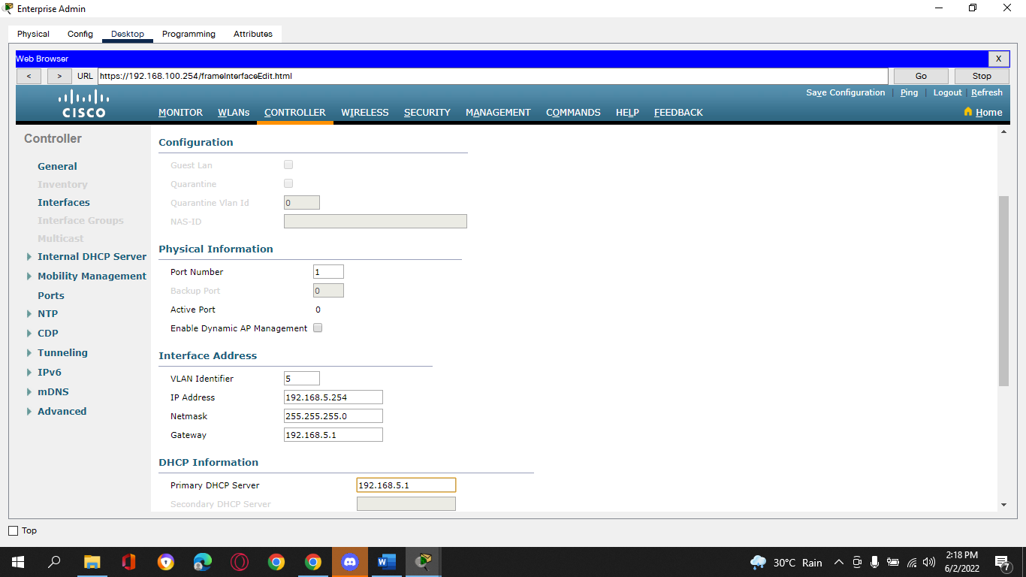

1. **Step 2: Configure a DHCP scope for the wireless management network.**
2. Configure and enable an internal DHCP scope as follows:

Scope Name: **management**

Pool Start Address: **192.168.100.235**

Pool End Address: **192.168.100.245**

Network: **192.168.100.0**

Netmask: **255.255.255.0**

Default Routers: **192.168.100.1**

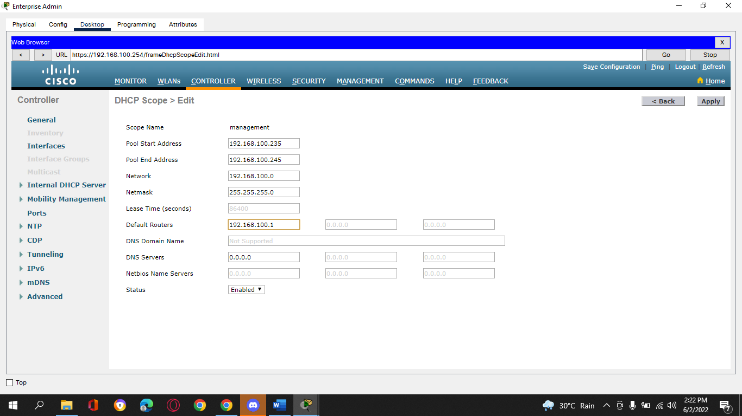

1. **Step 3: Configure the WLC with external server addresses.**

a.     Configure the RADIUS server information as follows:

Sever Index: **1**

Sever Address: **10.6.0.254**

Shared Secret: **RadiusPW**

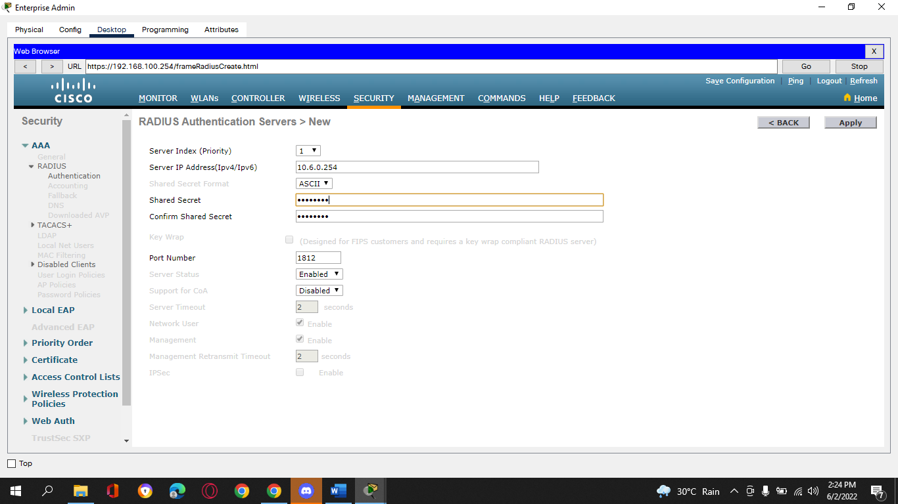

b.     Configure the WLC to send logs information to an SNMP server.

Community Name: **WLAN**

IP Address: **10.6.0.254**

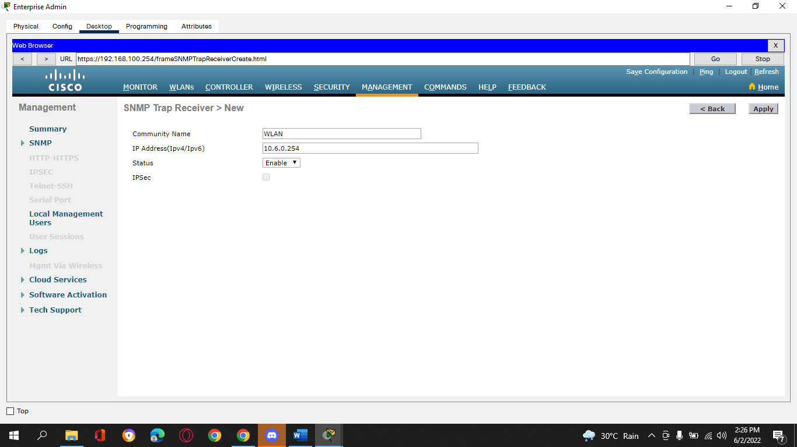

1. **Step 4: Create the WLANs.**

a.     Create the first WLAN:

Profile Name: **Wireless VLAN 2**

WLAN SSID: **SSID-2**

ID: **2**

Interface: **WLAN 2**

Security: **WPA2-PSK**

Passphrase: **Cisco123**

**Wireless VLAN 2:**

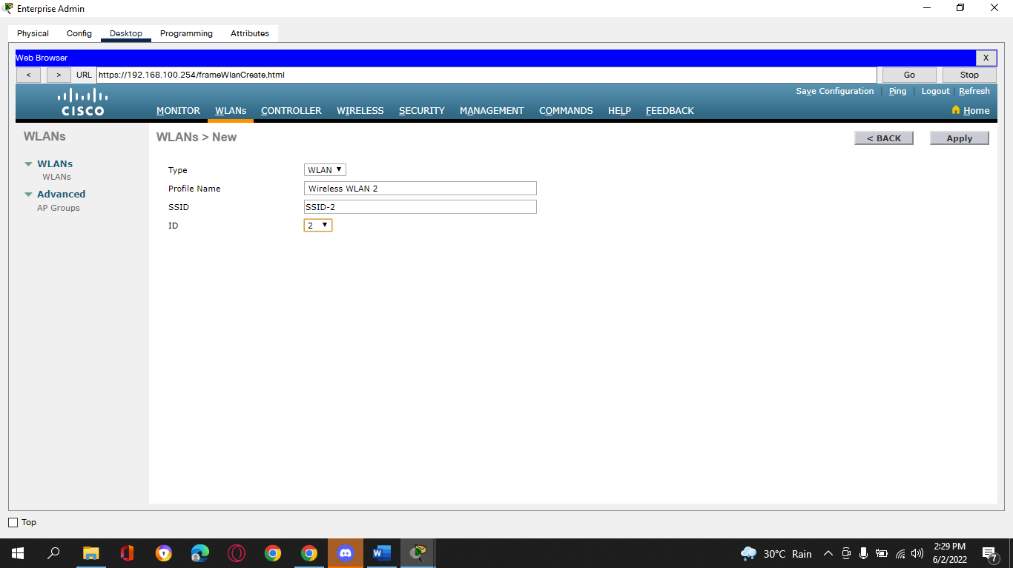

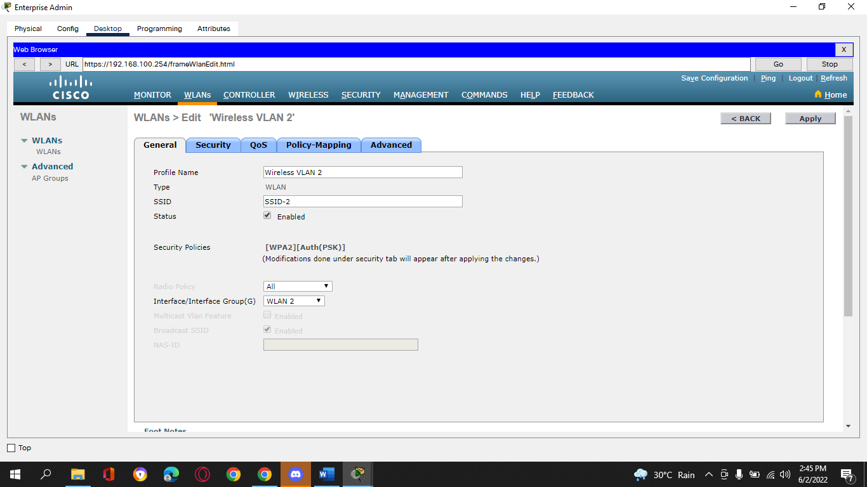

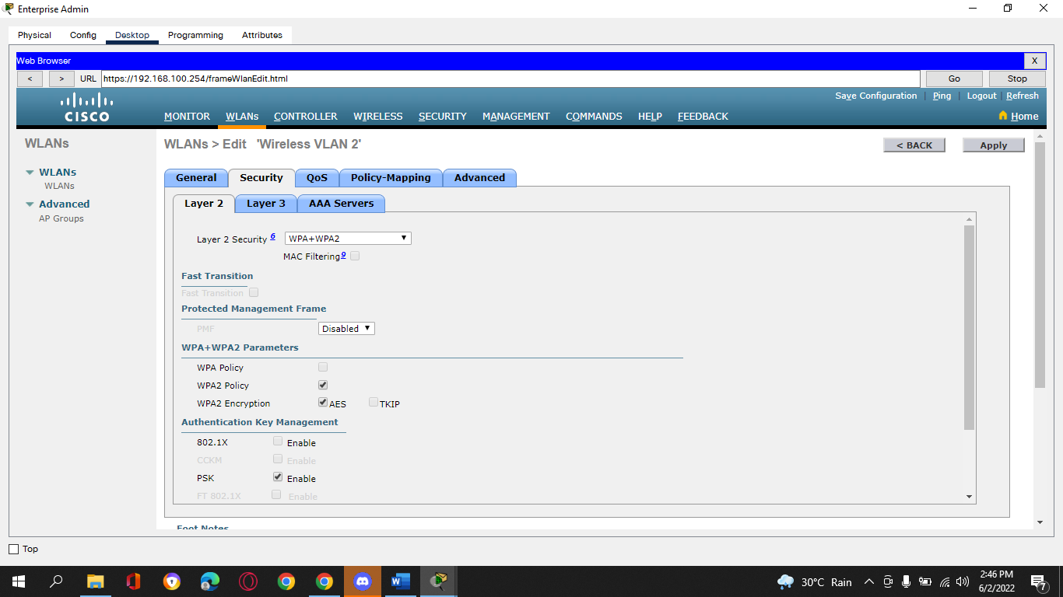

Under the Advanced tab, go to the FlexConnect section. Enable **FlexConnect Local Switching** and **FlexConnect Local Auth**.

**Wireless VLAN 2:**

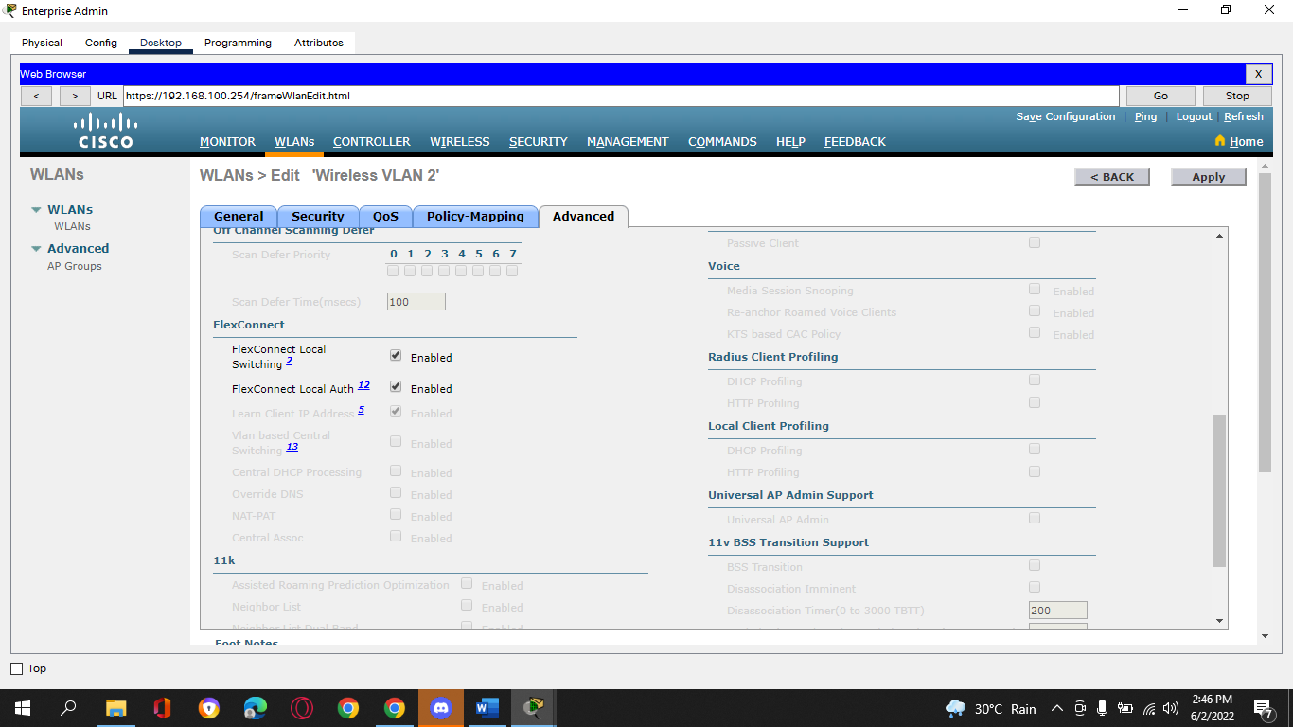

b.     Create the second WLAN:

Profile Name: **Wireless VLAN 5**

WLAN SSID: **SSID-5**

Interface: **WLAN 5**

ID: **5**

Security: **802.1x - WPA2-Enterprise**

Configure the WLAN to use the RADIUS server for authentication.

Make the **FlexConnect**settings as was done in Step 4a.

**Wireless VLAN 5:**

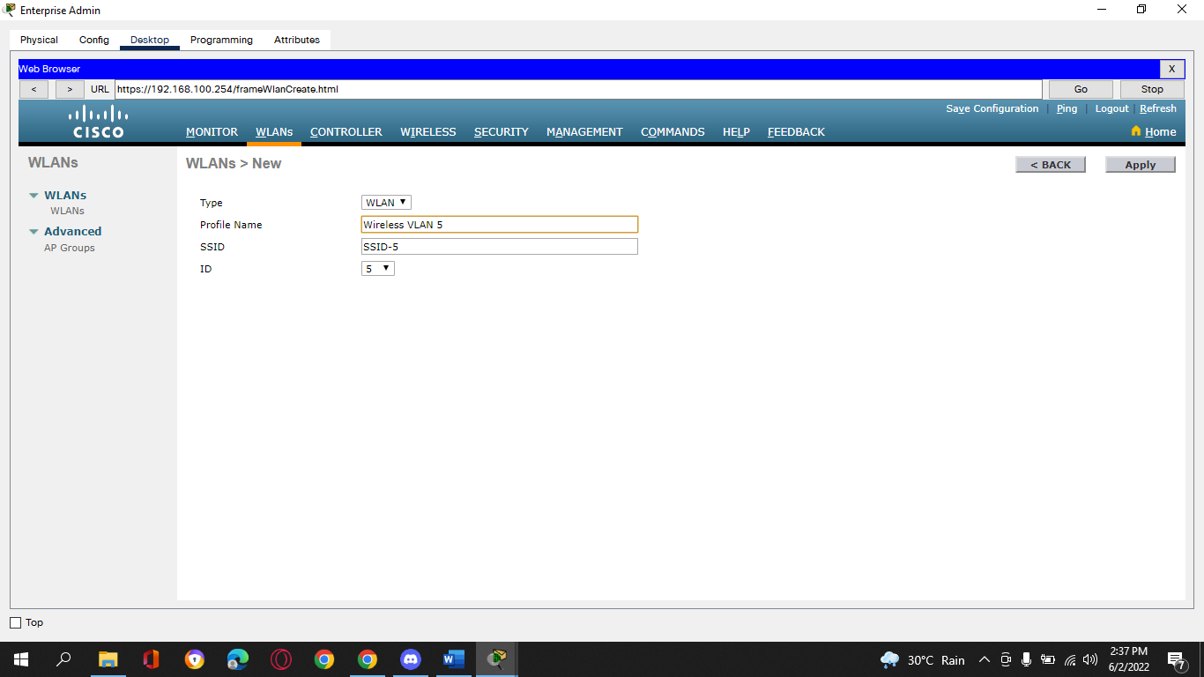

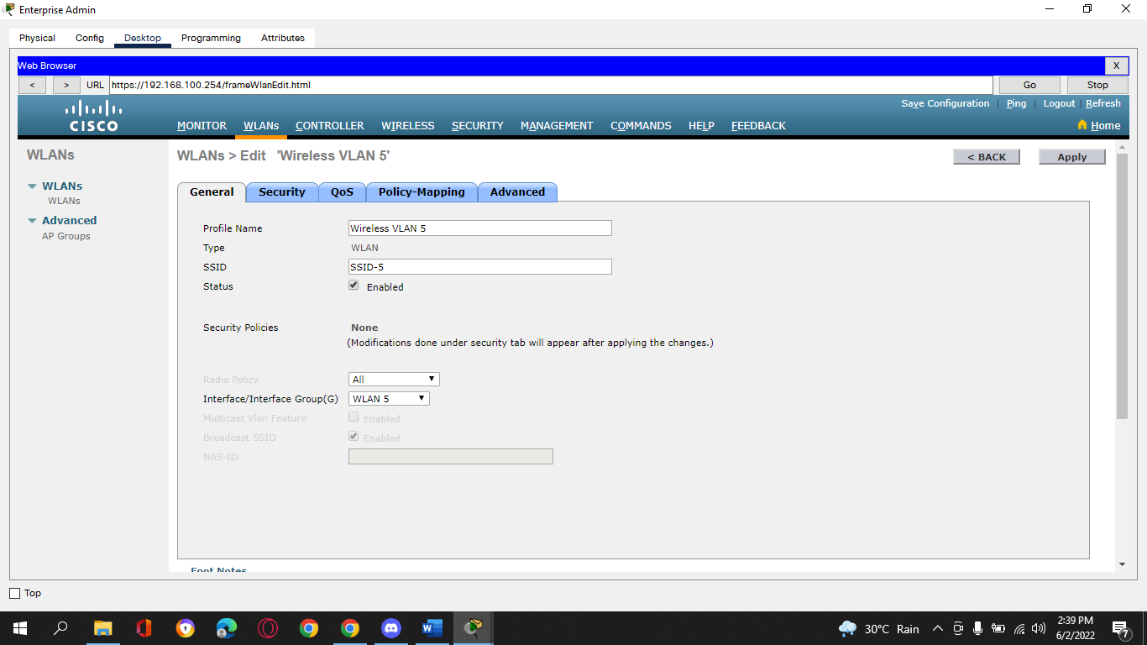

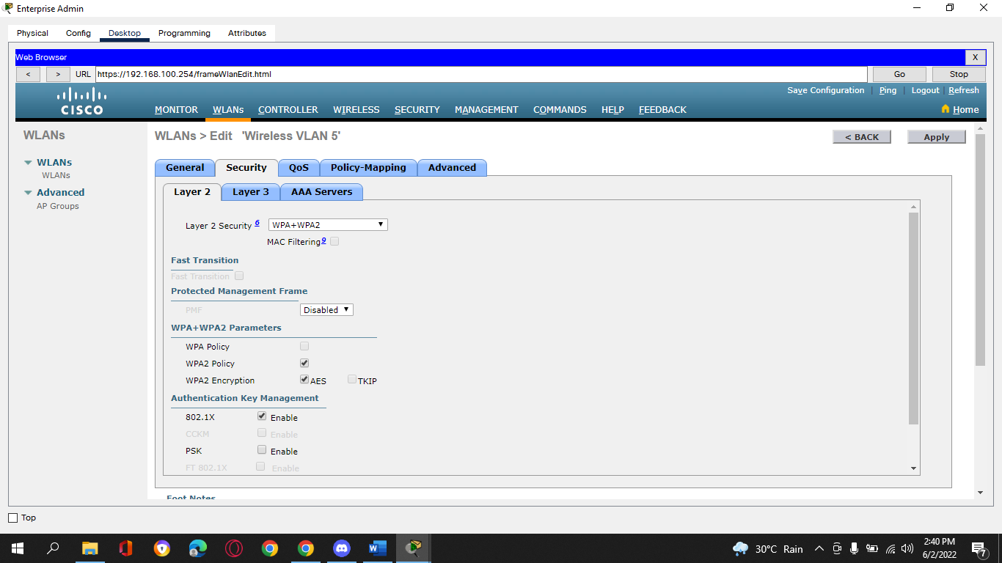

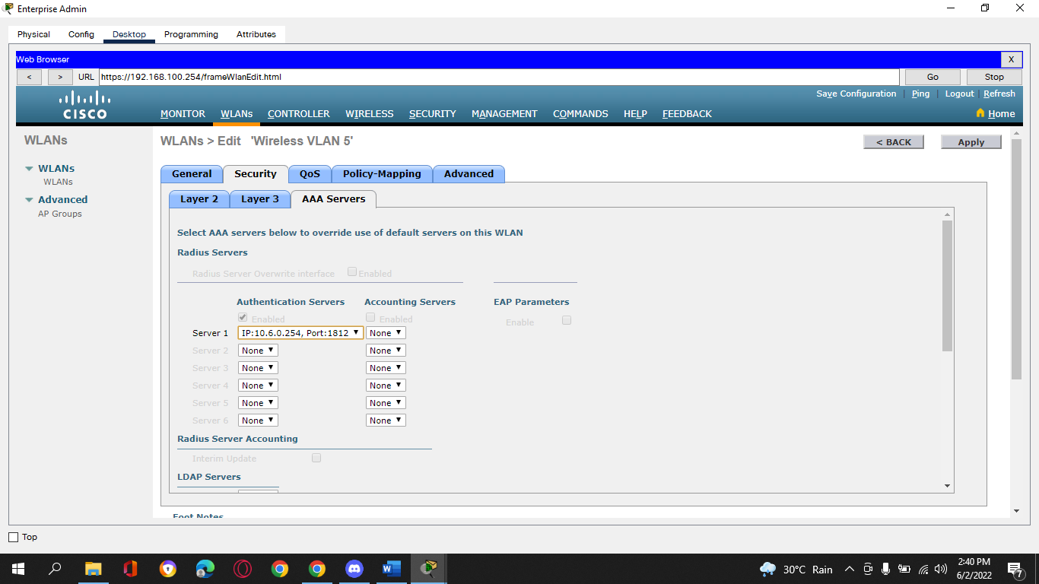

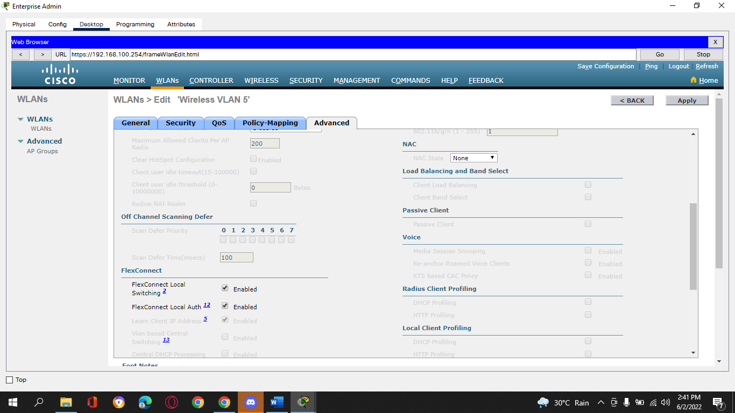

1. **Step 5: Configure the hosts to connect to the WLANs.**
2. Use the desktop PC Wireless app to configure the hosts as follows:
   * + 1. Wireless Host 1 should connect to Wireless VLAN 2.

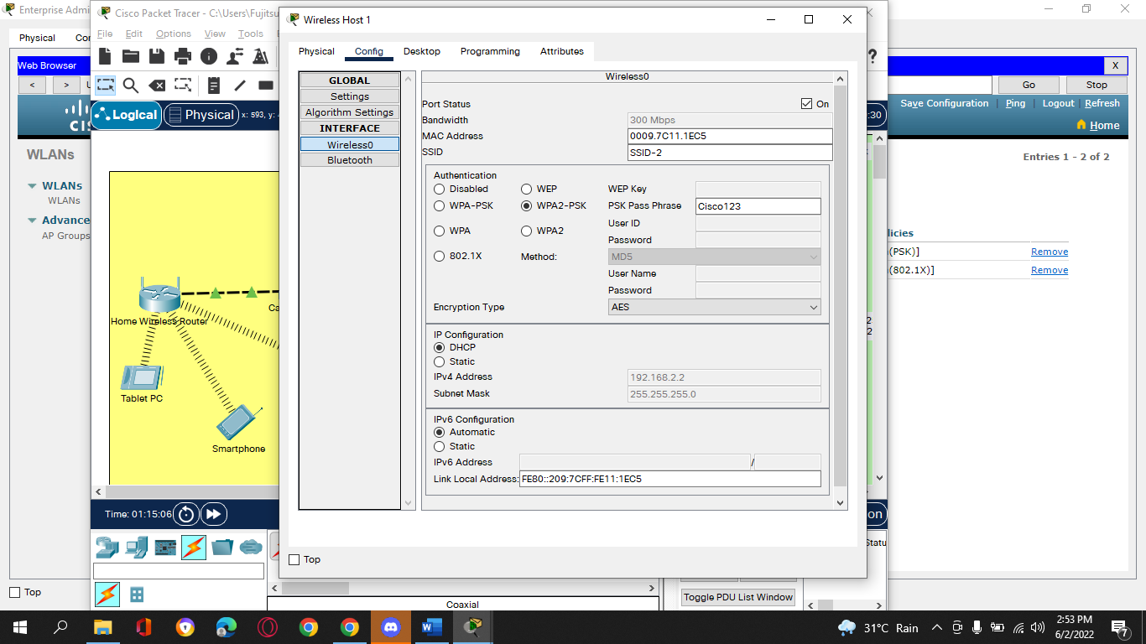

* + - 1. Wireless Host 2 should connect to Wireless VLAN 5 using the credentials in the WLAN information table.

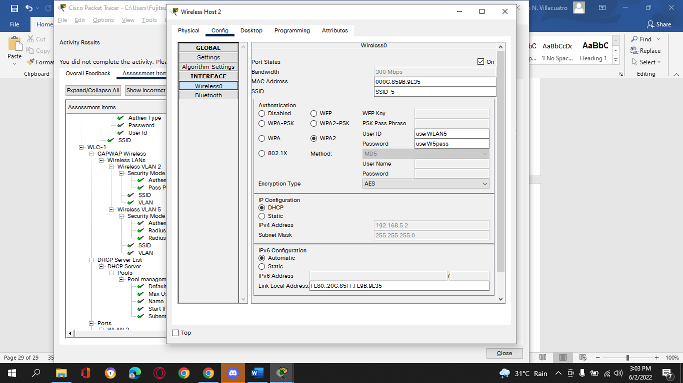

1. **Step 6: Test connectivity.**

Test connectivity between the wireless hosts and the Web Server by ping and URL.

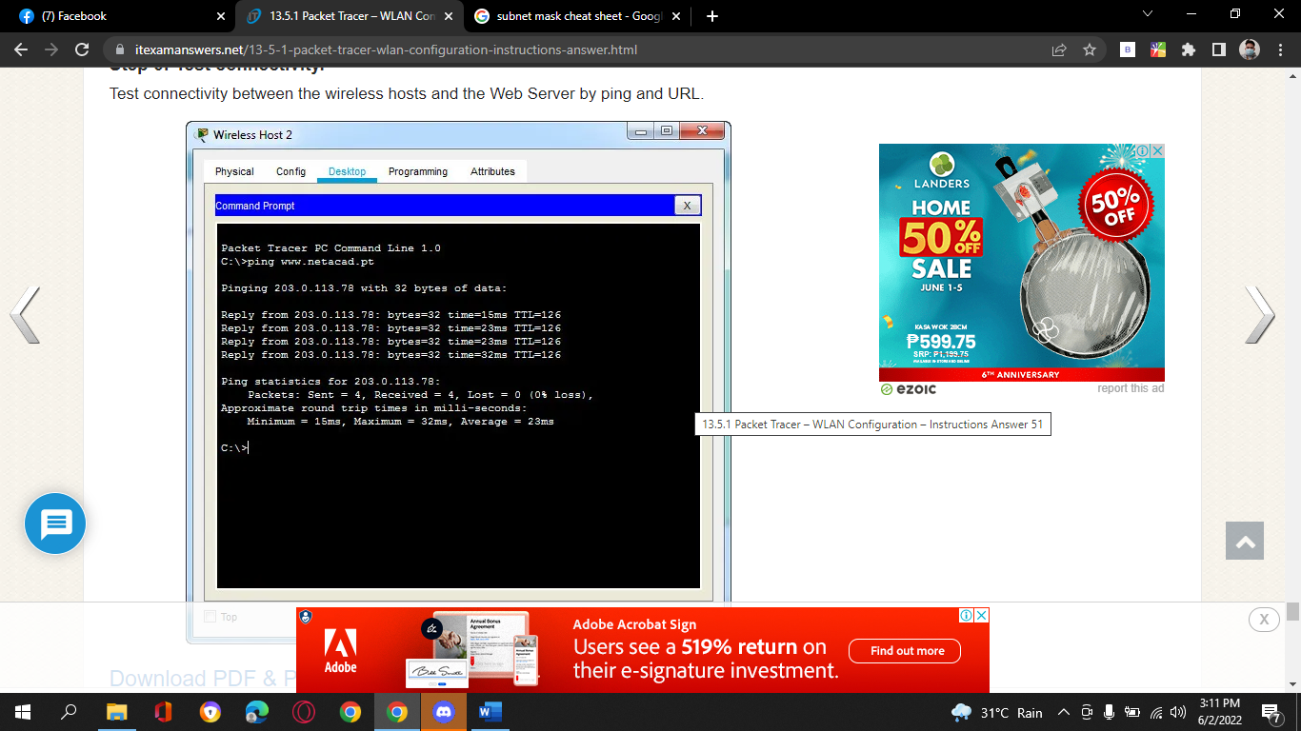

**WLAN Configuration Activity Completion:**

1. *End of document*

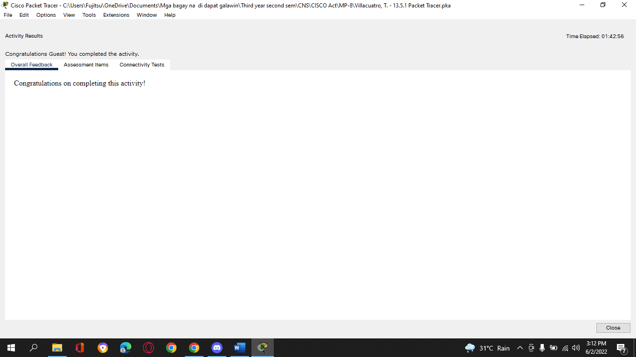

**Assessment Items:**

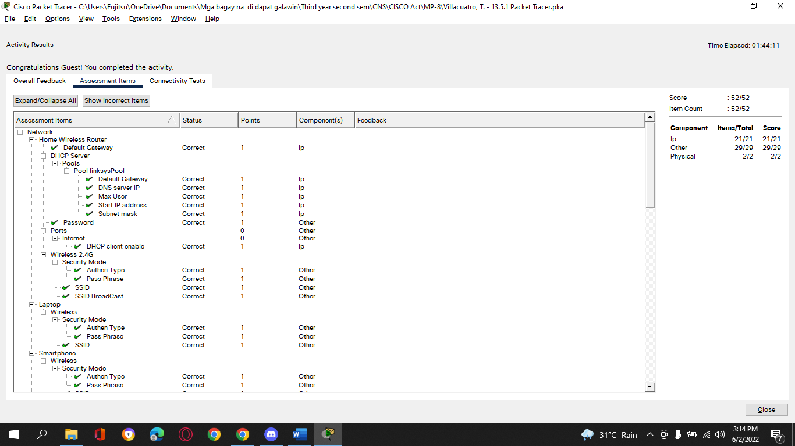

1. **Tedie N. Villacuatro**
2. **BSCOE 3-3**
3. **13.3.2 Packet Tracer - Configure a WPA2 Enterprise WLAN on the WLC**
4. **Addressing Table**

| **Device** | **Interface** | **IP Address** |
| --- | --- | --- |
| R1 | G0/0/0.5 | 192.168.5.1/24 |
| 1. *R1* | G0/0/0.200 | 192.168.200.1/24 |
| 1. *R1* | G0/0/1 | 172.31.1.1/24 |
| SW1 | VLAN 200 | 192.168.200.100/24 |
| LAP-1 | G0 | DHCP |
| WLC-1 | Management | 192.168.200.254/24 |
| RADIUS/SNMP Server | NIC | 172.31.1.254/24 |
| Admin PC | NIC | 192.168.200.200/24 |

1. **Objectives**
2. In this activity, you will configure a new WLAN on a wireless LAN controller (WLC), including the VLAN interface that it will use. You will configure the WLAN to use a RADIUS server and WPA2-Enterprise to authenticate users. You will also configure the WLC to use an SNMP server.
3. ·         Configure a new VLAN interface on a WLC.
4. ·         Configure a new WLAN on a WLC.
5. ·         Configure a new scope on the WLC internal DHCP server.
6. ·         Configure the WLC with SNMP settings.
7. ·         Configure the WLC to user a RADIUS server to authenticate WLAN users.
8. ·         Secure a WLAN with WPA2-Enterprise.
9. ·         Connect hosts to the new WLC.
10. **Background / Scenario**
11. You have already configured and tested the WLC with an existing WLAN. You configured WPA2-PSK for that WLAN because it was to be used in a smaller business. You have been asked to configure and test a WLC topology that will be used in a larger enterprise. You know that WPA2-PSK does not scale well and is not appropriate to use in an enterprise network. This new topology will use a RADIUS server and WPA2-Enterprise to authenticate WLAN users. This allows administration of the user accounts from a central location and provides enhanced security and transparency because each account has its own username and password. In addition, user activity is logged on the server.
12. In this lab, you will create a new VLAN interface, use that interface to create a new WLAN, and secure that WLAN with WPA2-Enterprise. You will also configure the WLC to use the enterprise RADIUS server to authenticate users. In addition, you will configure the WLC to use a SNMP server.
13. **Instructions**
14. **Part 1: Create a new WLAN**
15. **Step 1: Create a new VLAN interface.**
16. Each WLAN requires a virtual interface on the WLC. These interfaces are known as dynamic interfaces. The virtual interface is assigned a VLAN ID and traffic that uses the interface will be tagged as VLAN traffic. This is why connections between the APs, the WLC, and the router are over trunk ports. For the traffic from multiple WLANs to be transported through the network, traffic for the WLAN VLANs must be trunked.

a.     Open the browser from the desktop of Admin PC. Connect to the IP address of the WLC over HTTPS.

b.     Login with the username **admin** and password **Cisco123**.

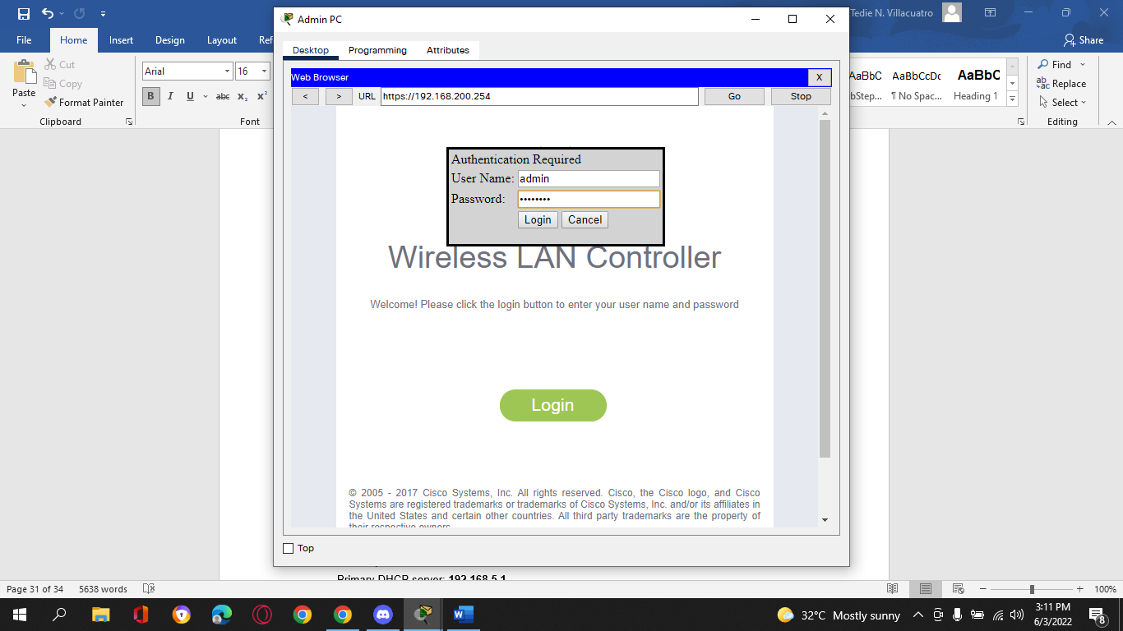

c.     Click the **Controller** menu and then click **Interfaces** from the menu on the left. You will see the default virtual interface and the management interface to which you are connected.

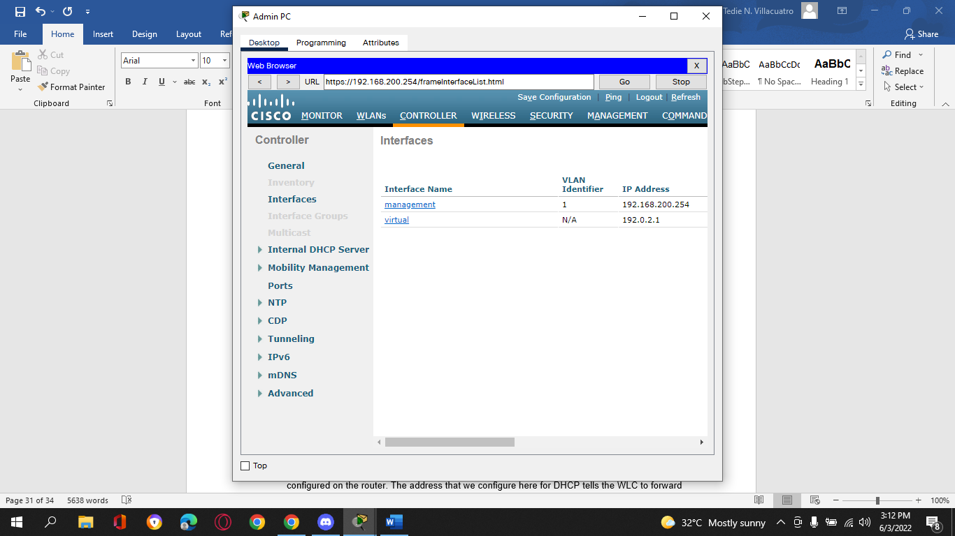

d.     Click the **New** button in the upper right-hand corner of the page. You may need to scroll the page to the right to see it.

e.     Enter the name of the new interface. We will call it **WLAN-5**. Configure the VLAN ID as **5**. This is the VLAN that will carry traffic for the WLAN that we create later. Click **Apply**. This leads to a configuration screen for the VLAN interface.

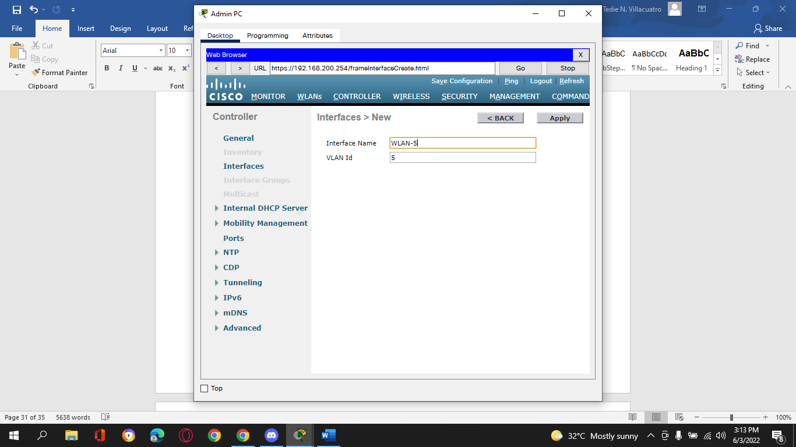

f.      First, configure the interface to use physical port number **1**. Multiple VLAN interfaces can use the same physical port because the physical interfaces are like dedicated trunk ports.

g.     Address the interface as follows:

IP Address: **192.168.5.254**

Netmask: **255.255.255.0**

Gateway: **192.168.5.1**

Primary DHCP server: **192.168.5.1**

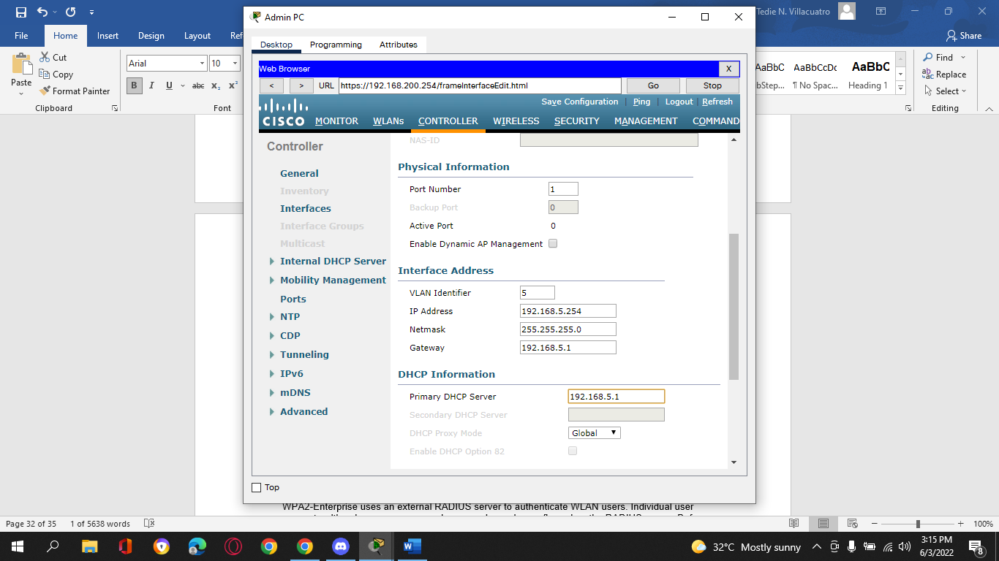

User traffic for the WLAN that uses this VLAN interface will be on the 192.168.5.0/24 network. The default gateway is the address of an interface on router R-1. A DHCP pool has been configured on the router. The address that we configure here for DHCP tells the WLC to forward all DHCP requests that it receives from hosts on the WLAN to the DHCP server on the router.

h.     Be sure to click **Apply** to enact your changes and click **OK** to respond to the warning message. Click **Save Configuration** so that your configuration will be in effect when the WLC restarts.

1. **Step 2: Configure the WLC to use a RADIUS server.**
2. WPA2-Enterprise uses an external RADIUS server to authenticate WLAN users. Individual user accounts with unique usernames and passwords can be configured on the RADIUS server. Before the WLC can use the services of the RADIUS server, the WLC must be configured with the server address.

a.     Click the **Security** menu on the WLC.

b.     Click the **New** button and enter the IP address of the RADIUS server in the Server IP Address field.

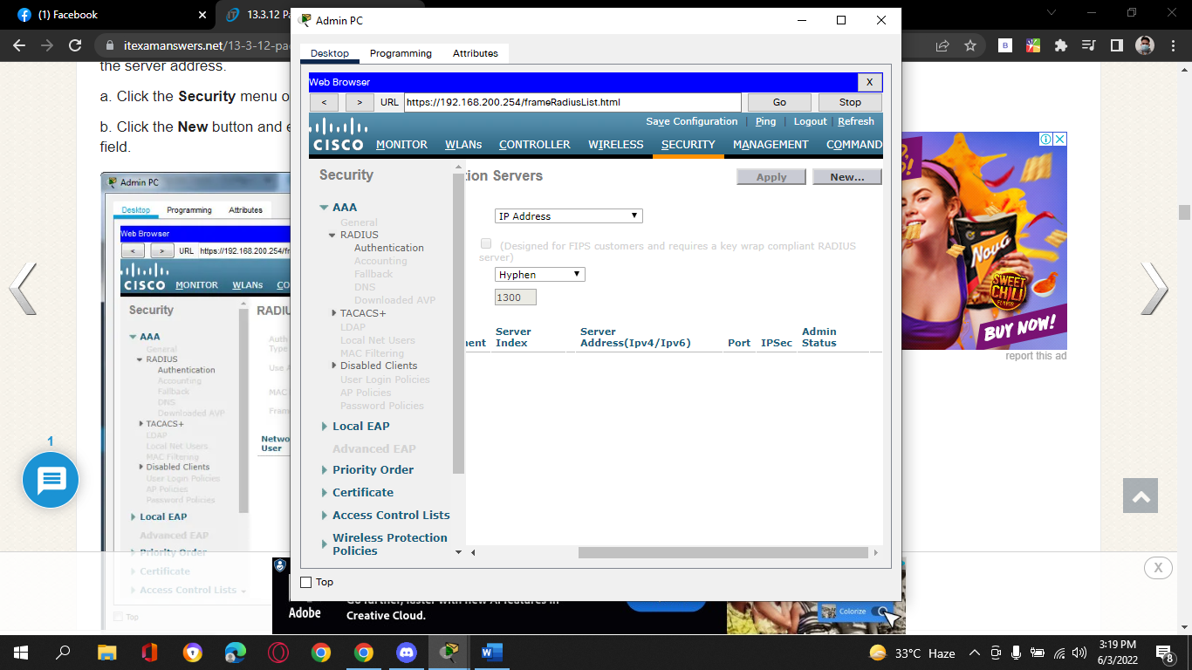

c.     The RADIUS server will authenticate the WLC before it will allow the WLC to access the user account information that is on the server. This requires a shared secret value. Use **Cisco123**. Confirm the shared secret and click **Apply**.

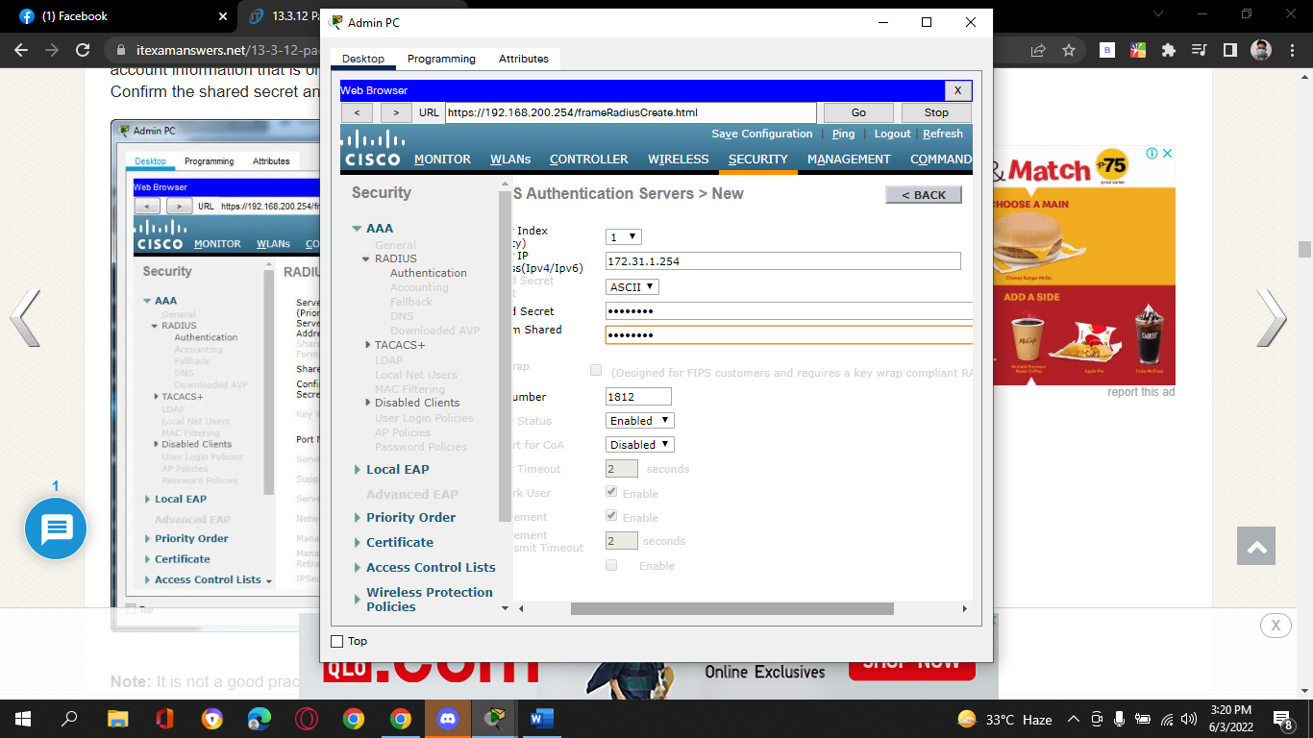

**Note**: It is not a good practice to reuse passwords. This activity reuses passwords only to make the activity easier for you to complete and review.

1. **Step 3: Create a new WLAN.**
2. Create a New WLAN. Use the newly created VLAN interface for the new WLAN.

a.     Click the **WLANs** entry in the menu bar. Locate the dropdown box in the upper right-had corner of the WLANs screen. It will say **Create New**. Click **Go** to create a new WLAN.

b.     Enter the **Profile Name** of the new WLAN. Use the profile name **Floor 2 Employees**. Assign an SSID of **SSID-5** to the WLAN. Change the ID drop down to **5**. Hosts will need to use this SSID to join the network. When you are done, click **Apply** to accept your settings.

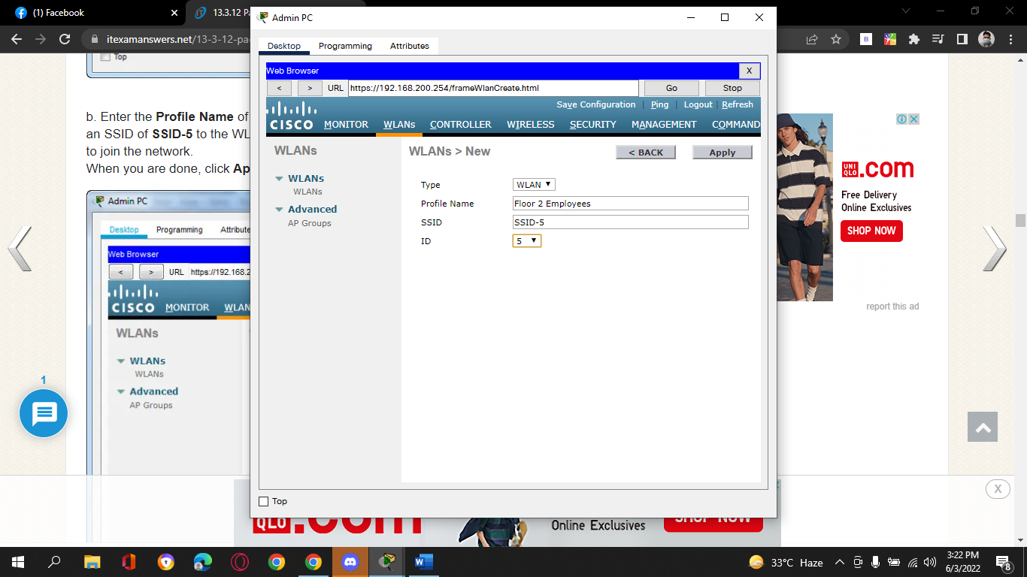

**Note:** The ID is an arbitrary value that is used as a label for the WLAN. In this case, we configured it as 5 to be consistent with VLAN for the WLAN. It could be any available value.

c.     Click **Apply** so that the settings go into effect.

d.     Now that the WLAN has been created you can configure features of the network. Click **Enabled** to make the WLAN functional. It is a common mistake to accidentally skip this step.

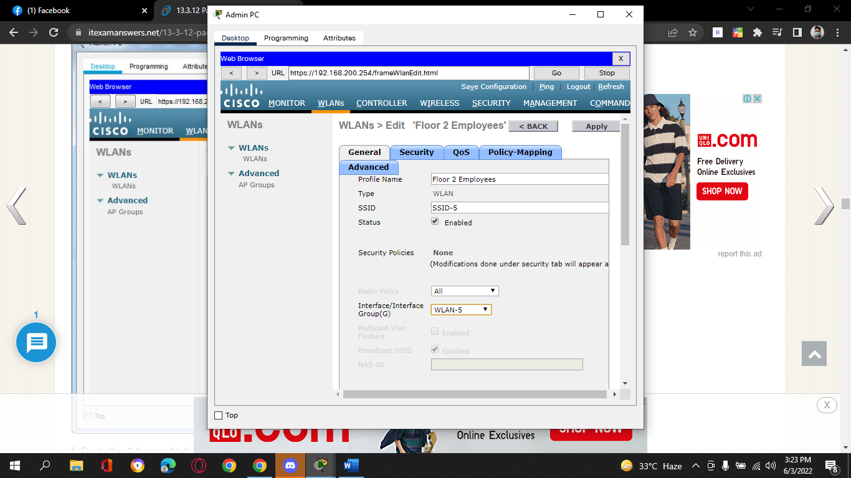

e.     Choose the VLAN interface that will be used for the new WLAN. The WLC will use this interface for user traffic on the network. Click the drop-down box for Interface/Interface Group (G). Select the interface that we created in Step 1.



f.      Go to the Advanced tab. Scroll to **FlexConnect**section of the interface.

g.     Click to enable **FlexConnect Local Switching** and **FlexConnect Local Auth**.

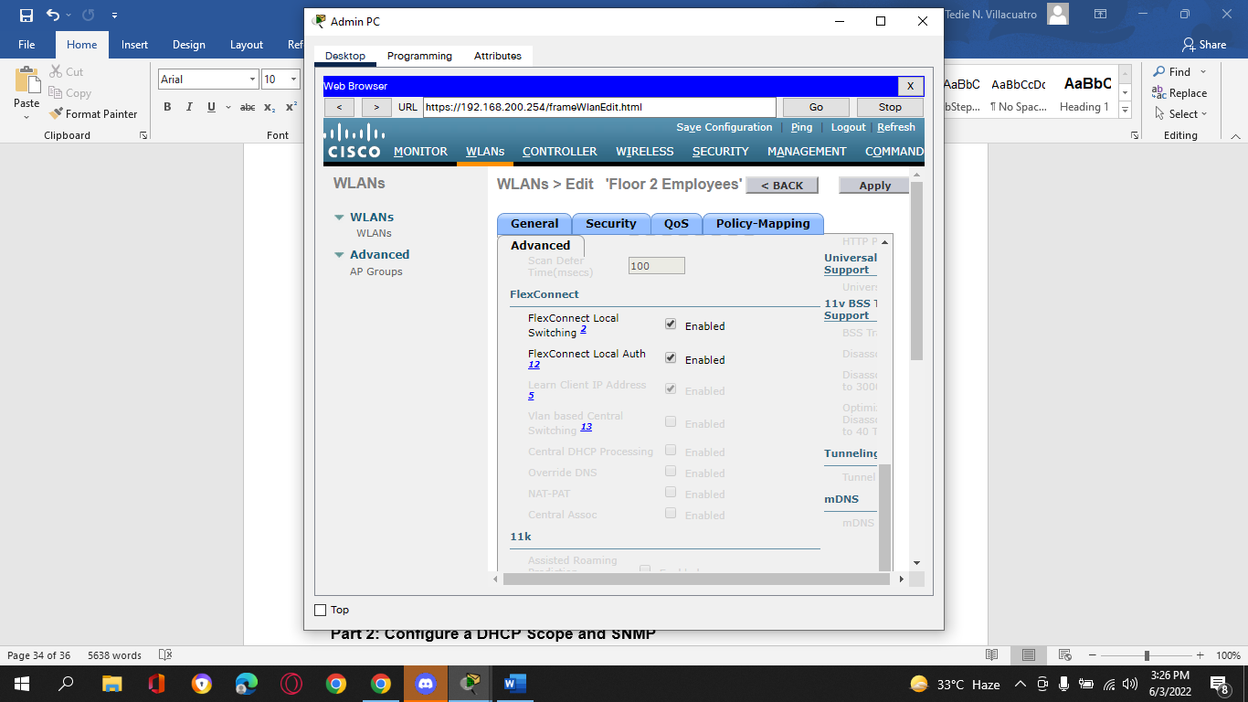

h.     Click **Apply** to enable the new WLAN. If you forget to do this, the WLAN will not operate.

1. **Step 4: Configure WLAN security.**
2. Instead of WPA2-PSK, we will configure the new WLAN to use WPA2-Enterprise.

a.     Click the WLAN ID of the newly created WLAN to continue configuring it, if necessary.

b.     Click the Security tab. Under the Layer 2 tab, select **WPA+WPA2** from the drop-down box.

c.     Under WPA+WPA2 Parameters, enable **WPA2 Policy**. Click **802.1X** under Authentication Key Management. This tells the WLC to use the 802.1X protocol to authenticate users externally

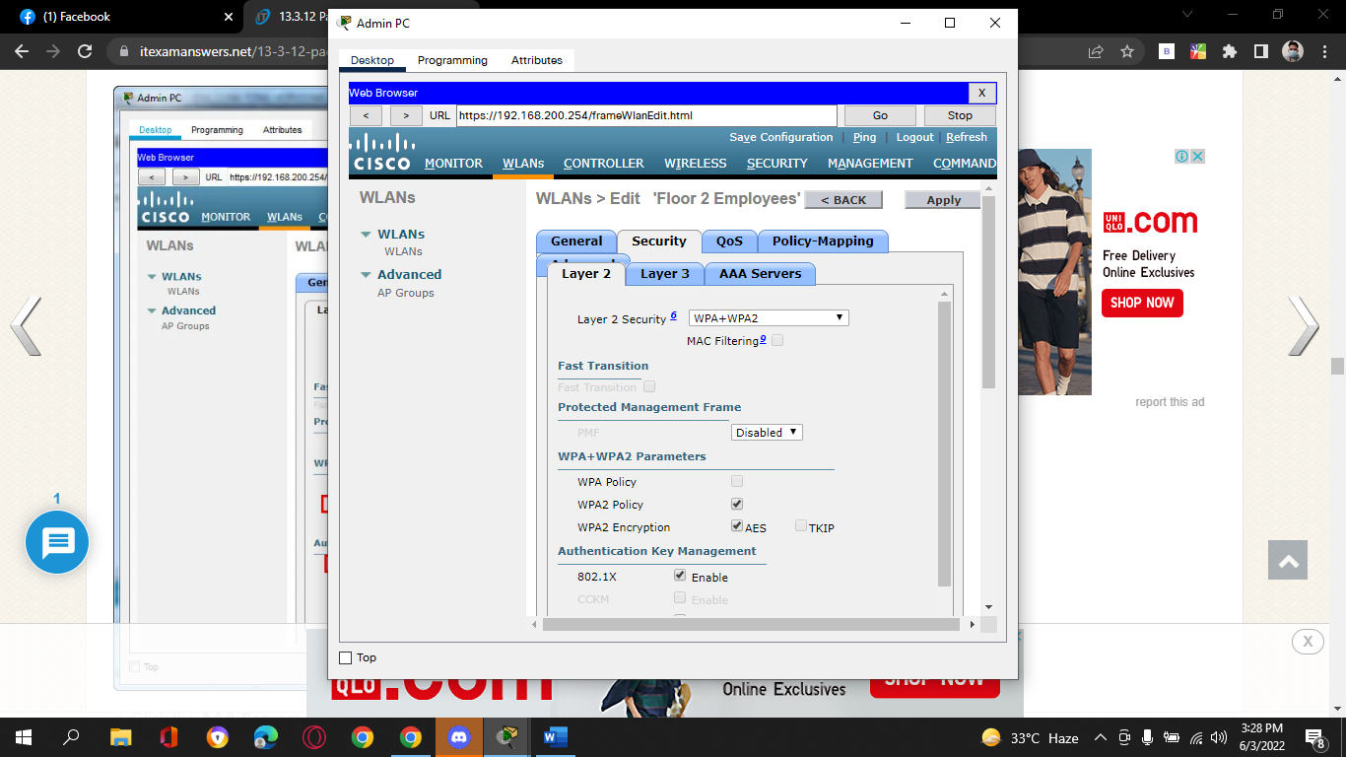.

d.     Click the **AAA Servers** tab. Open the drop-down next to Server 1 in the Authentication Servers column and select the server that we configured in Step 2.

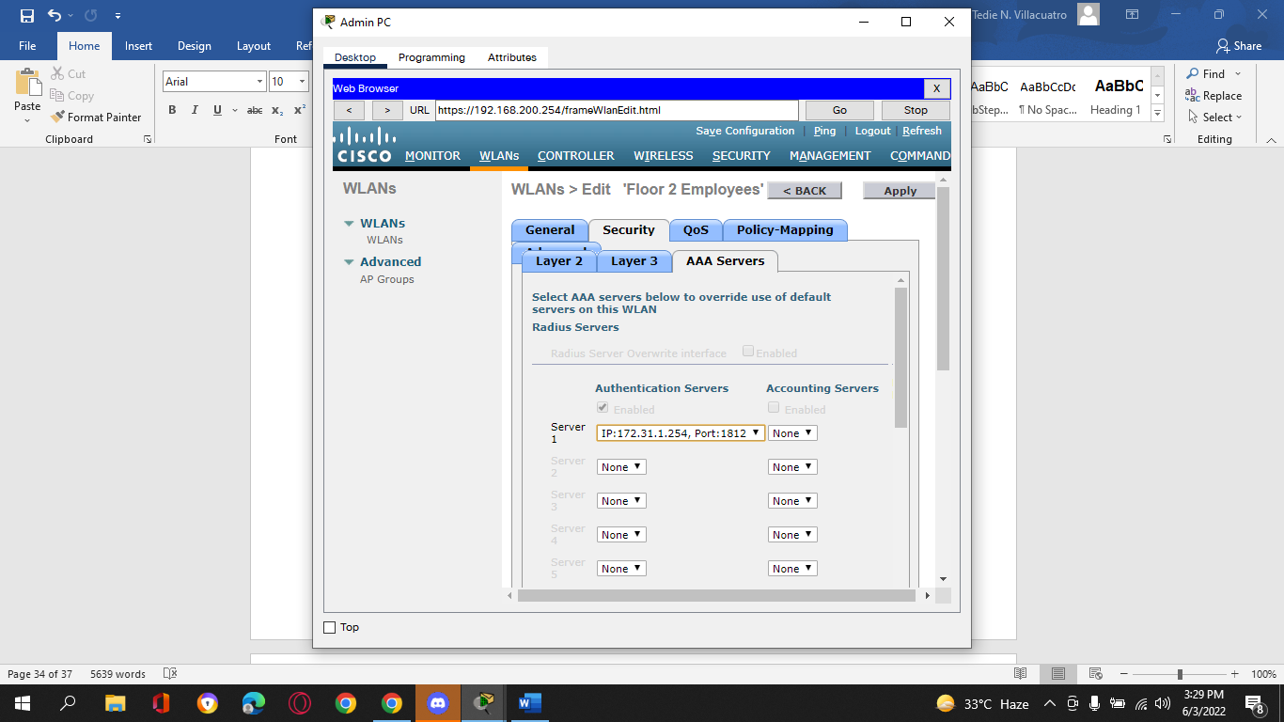

e.     Click **Apply** to enact this configuration. You have now configured the WLC to use the RADIUS sever to authenticate users that attempt to connect to the WLAN.

1. **Part 2: Configure a DHCP Scope and SNMP**
2. **Step 1: Configure a DHCP Scope.**
3. The WLC offers its own internal DHCP server. Cisco recommends that the WLAN DHCP server not be used for high-volume DHCP services, such as that required by larger user WLANs. However, in smaller networks, the DHCP server can be used to provide IP addresses to LAPs that are connected to the wired management network. In this step, we will configure a DHCP scope on the WLC and use it to address LAP-1.

a.     Should be connected to the WLC GUI from Admin PC.

b.     Click the **Controller** menu and then click **Interfaces**.

Question:

What interfaces are present? **WLAN-5, management, and virtual.**

c.     Click the **management** Interface. Record its addressing information here.

Questions:

IP address: **192.168.200.254**

Netmask: **255.255.255.0**

Gateway: **192.168.200.1**

Primary DHCP server: **none specified**

d.     We want the WLC to use its own DHCP sever to provide addressing to devices on the wireless management network, such as lightweight APs. For this reason, enter the IP address of the WLC management interface as the primary DHCP server address. Click **Apply**. Click **OK** to acknowledge any warning messages that appear.

e.     In the left-hand menu, expand the **Internal** **DHCP Server** section. Click **DHCP Scope**.

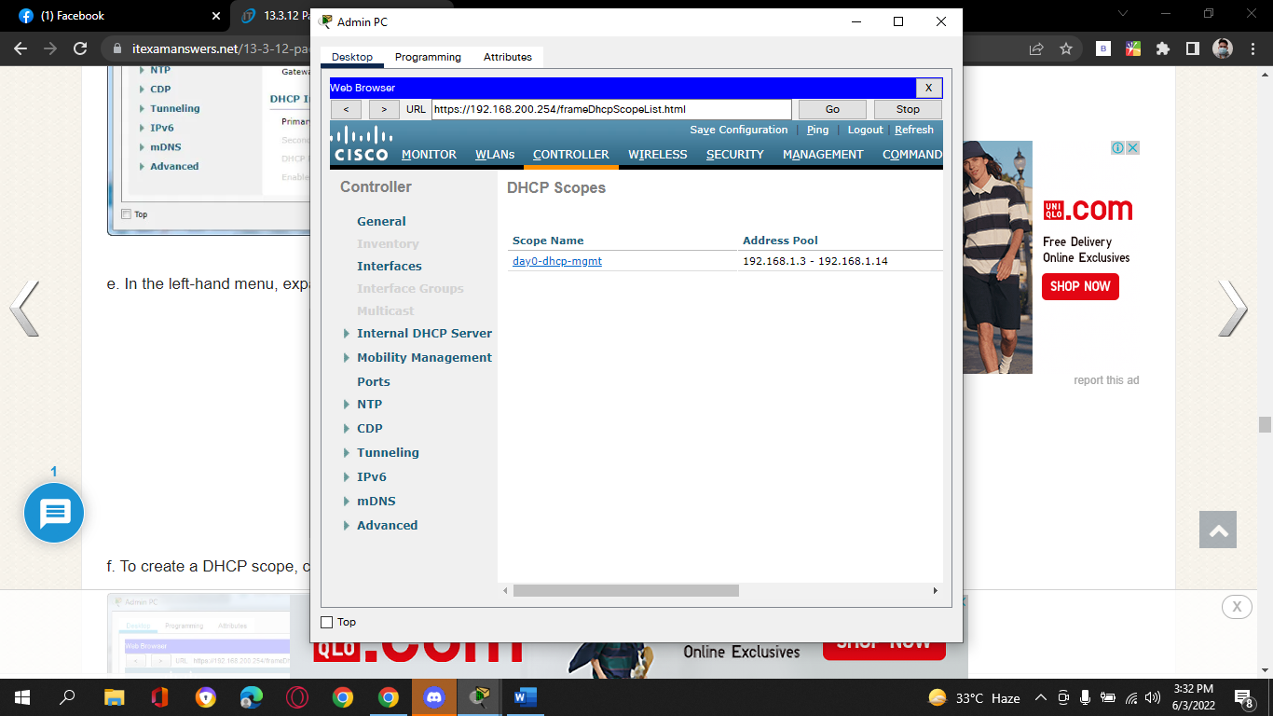

f.      To create a DHCP scope, click the **New…** button.

g.     Name the scope **Wired Management**. You will configure this DHCP scope to provide addresses to the wired infrastructure network that connects the Admin PC, WLC-1, and LAP-1.

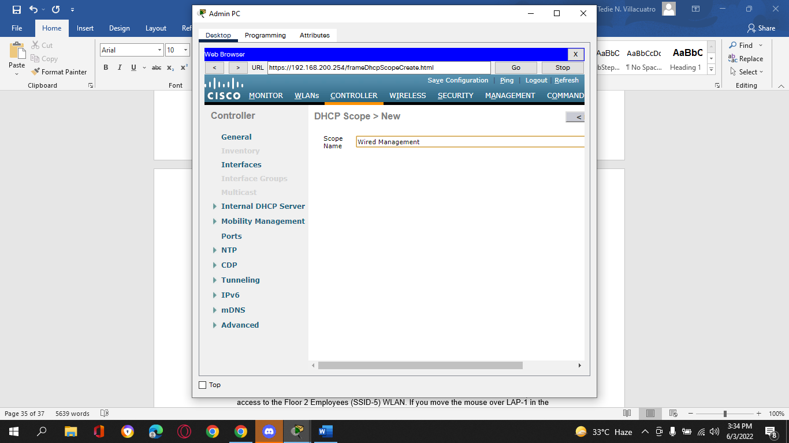

h.     Click **Apply** to create the new DHCP scope.

i.      Click the new scope in the DHCP Scopes table to configure addressing information for the scope. Enter the following information.

Pool Start Address: **192.168.200.240**

Pool End Address: **192.168.200.249**

Status: **Enabled**

Provide the values for **Network**, **Netmask**, and **Default Routers** from the information you gathered in Step 1c.

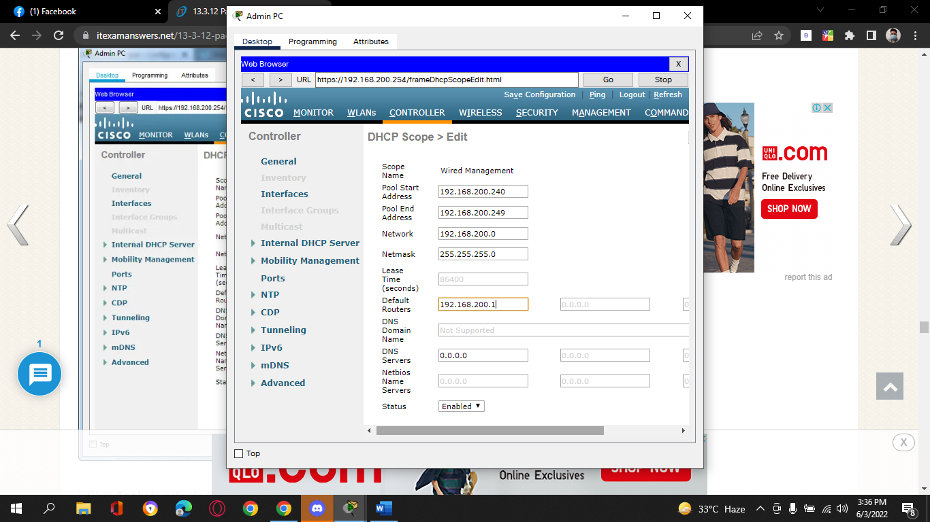

j.      Click **Apply** to activate the configuration. Click **Save Configuration** in the upper-right-hand corner of the WLC interface to save your work so that it is available when the WLC restarts.

The internal DHCP server will now provide an address to LAP-1 after a brief delay. When LAP-1 has its IP address, the CAPWAP tunnel will be established and LAP-1 will be able to provide access to the Floor 2 Employees (SSID-5) WLAN. If you move the mouse over LAP-1 in the topology, you should see its IP address, the status of the CAPWAP tunnel, and the WLAN that LAP-1 is providing access to.

1. **Step 2: Configure SNMP**

a.     Click the **Management** menu in the WLC GUI and expand the entry for **SNMP** in the left-hand menu.

b.     Click **Trap Receivers** and then **New…**

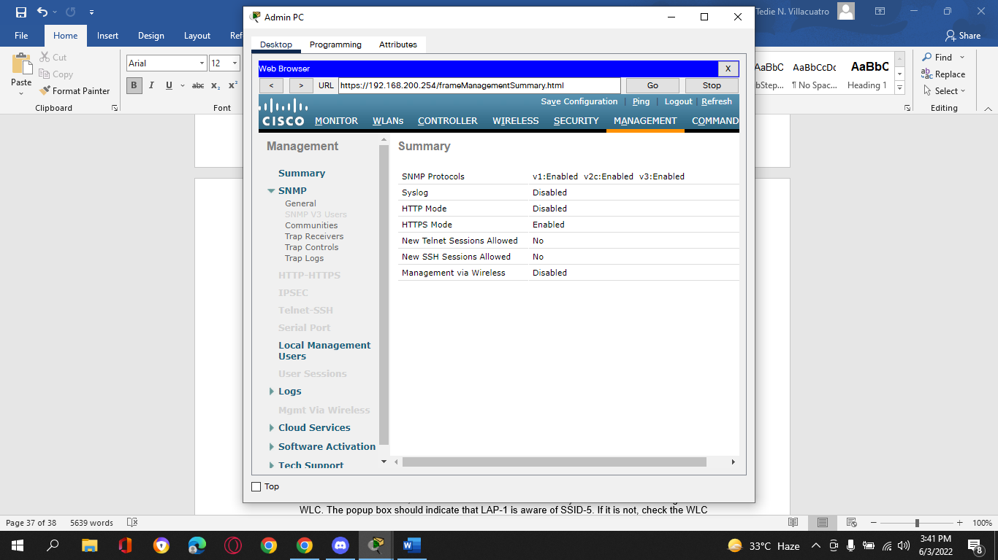

c.     Enter the community string as **WLAN_SNMP** and the IP address of the server at **172.31.1.254**.

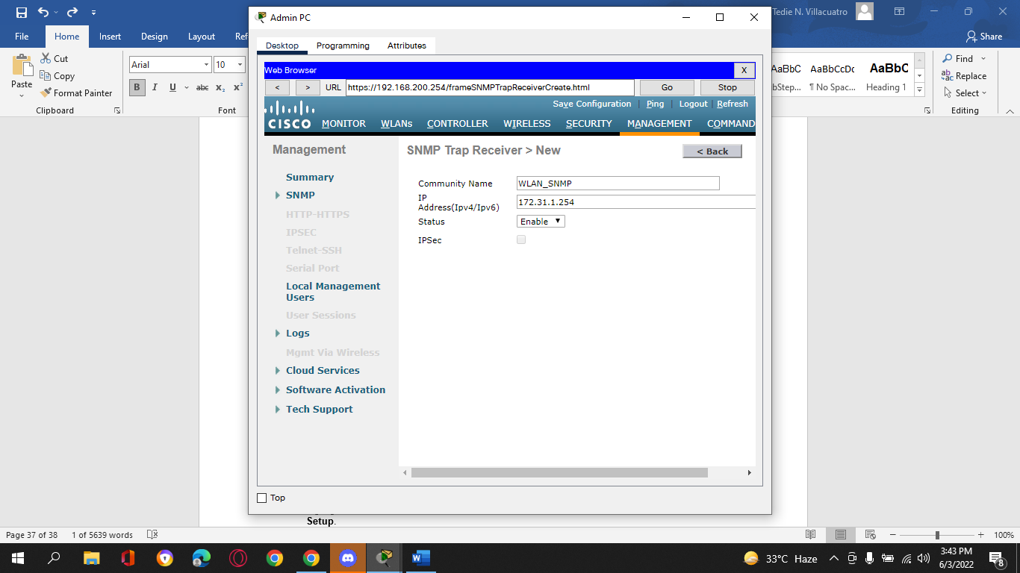

d.     Click **Apply** to finish the configuration.

1. **Part 3: Connect Hosts to the Network**
2. **Step 1: Configure a host to connect to the enterprise network.**
3. In the Packet Tracer PC Wireless client app, you must configure a WLAN Profile in order to attach to a WPA2-Enterprise WLAN.

a.     Click Wireless Host and open the **PC Wireless** app.

b.     Click the **Profiles**tab and then click **New** to create a new profile. Name the profile **WLC NET**.

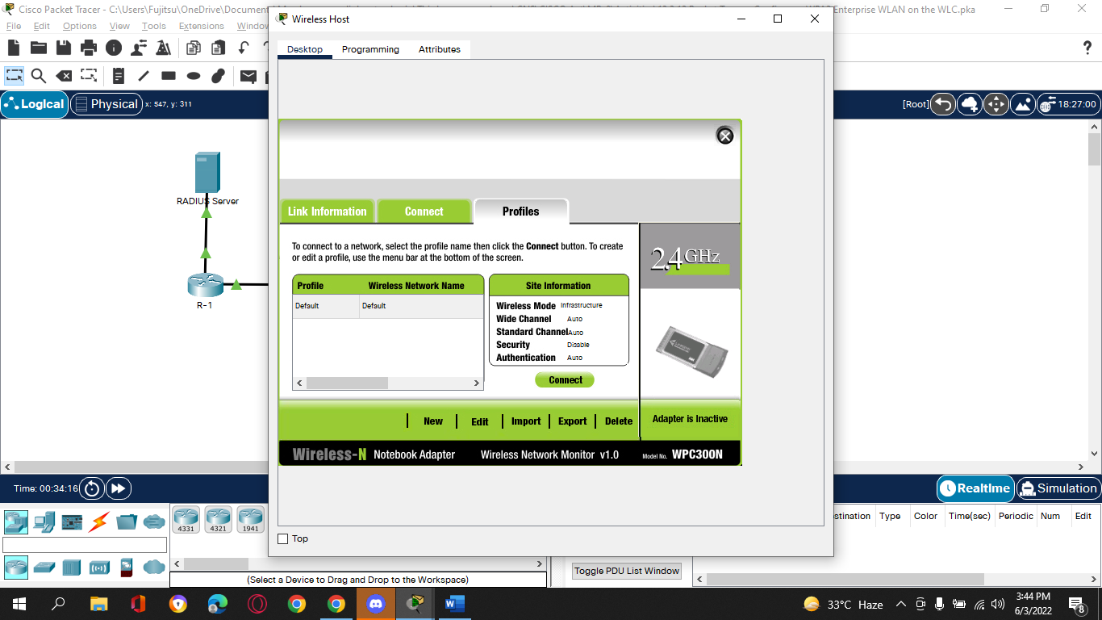

c.     Highlight the Wireless Network Name for the WLAN that we created earlier and click **Advanced Setup**.

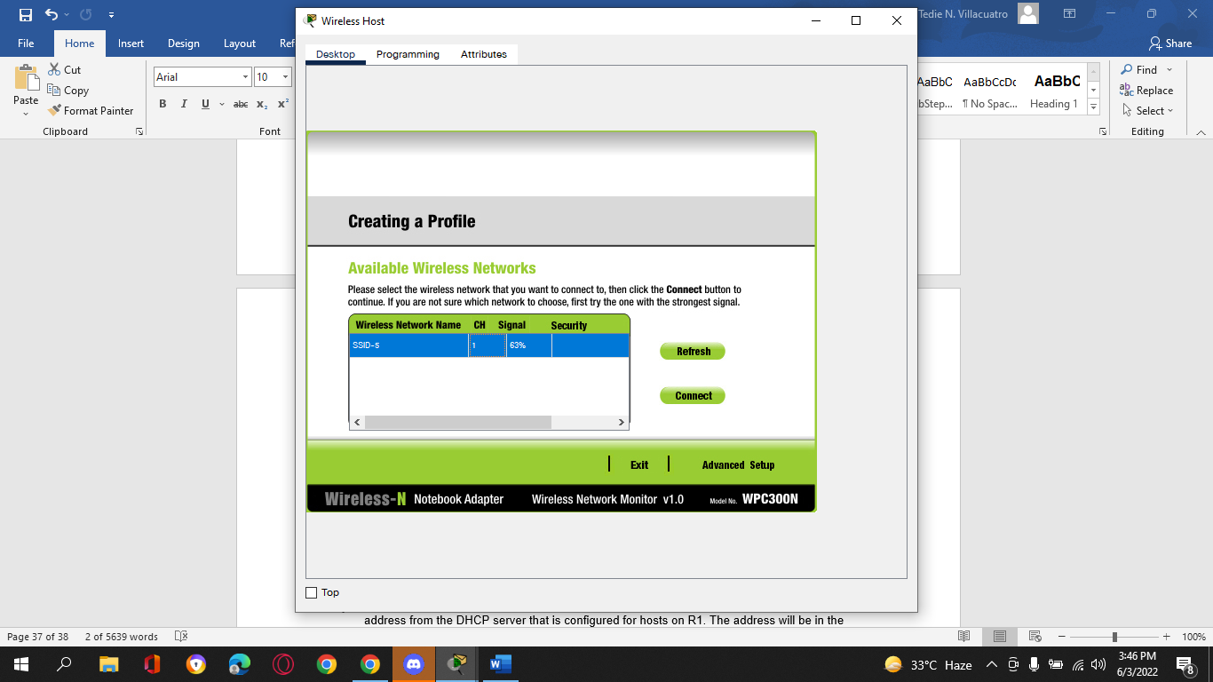

d.     Verify that the SSID for the wireless LAN is present and then click **Next**. Wireless Host should see SSID-5. If it does not, move the mouse over LAP-1 to verify that it is communicating with the WLC. The popup box should indicate that LAP-1 is aware of SSID-5. If it is not, check the WLC configuration. You can also manually enter the SSID.

e.     Verify that the DHCP network setting is selected and click **Next**.

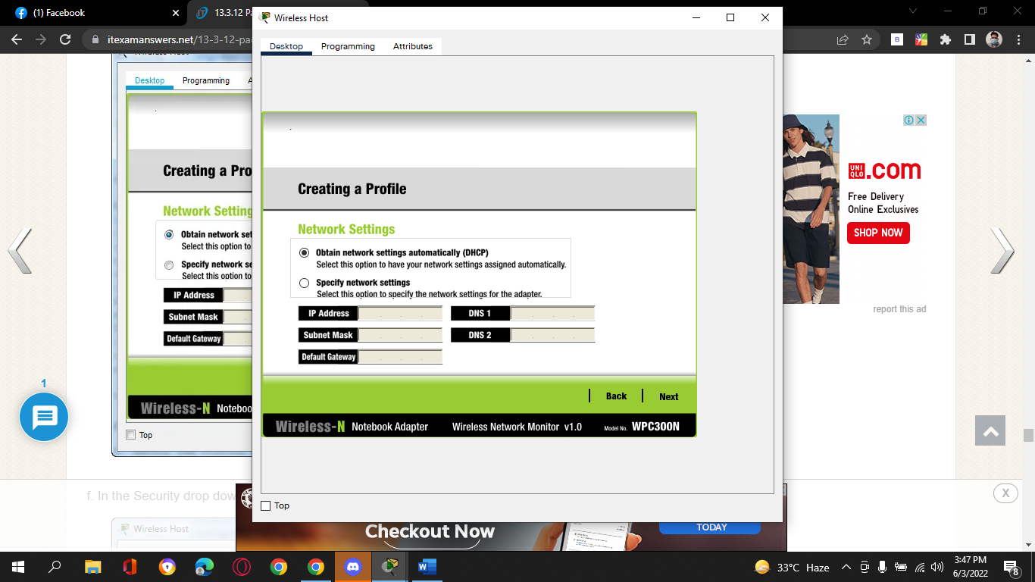

f.      In the Security drop down box, select **WPA2-Enterprise**. Click **Next**.

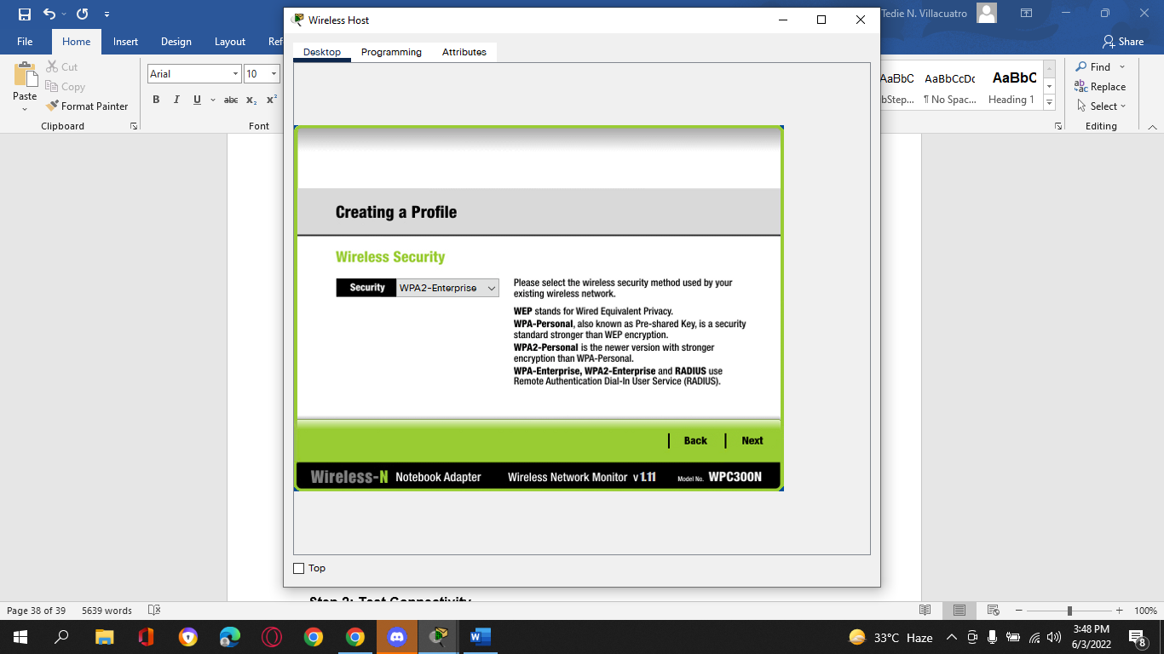

g.     Enter login name **user1** and the password **User1Pass** and click **Next**.

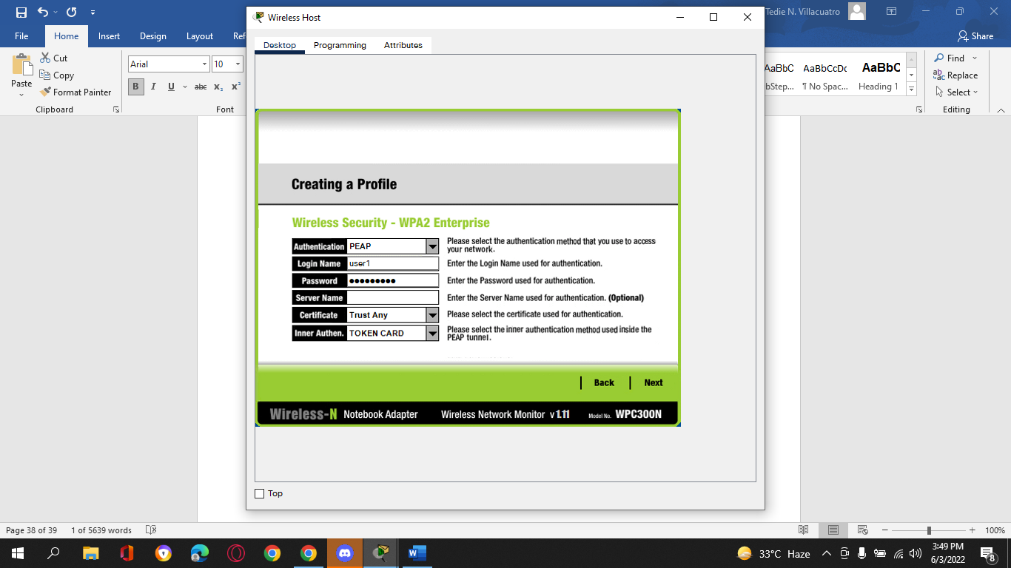

h.     Verify the Profile Settings and click **Save**.

i.      Select the **WLC NET** profile and click the **Connect** **to Network** button. After a brief delay, you should see the Wireless Host connect to LAP-1. You can click the Fast Forward Time button to speed up the process if it seems to be taking too long.

j.      Confirm that Wireless Host has connected to the WLAN. Wireless Host should receive an IP address from the DHCP server that is configured for hosts on R1. The address will be in the 192.168.5.0/24 network. You may need to click the Fast Forward Time button speed up the process.

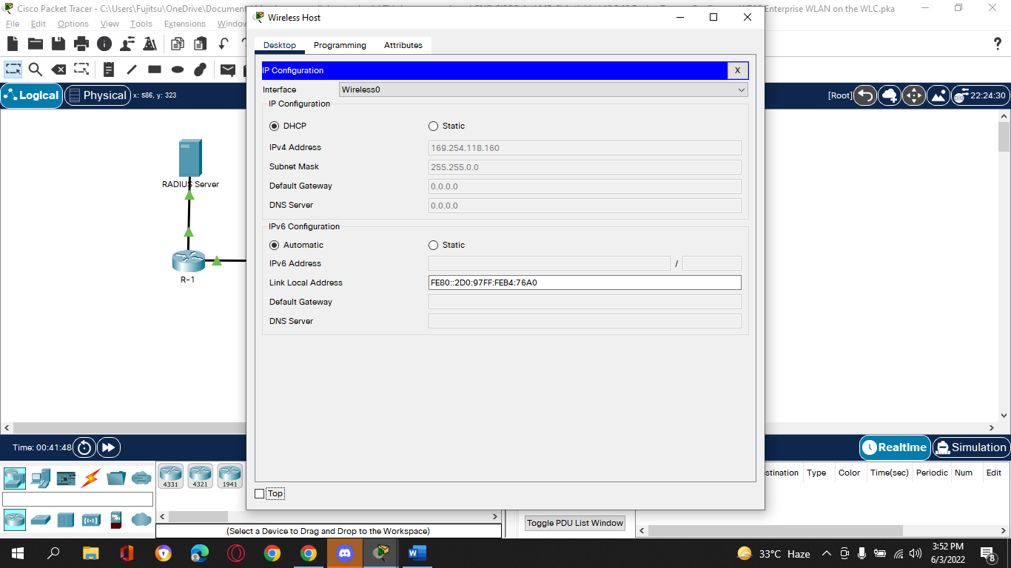

1. **Step 2: Test Connectivity.**

a.     Close the PC Wireless app.

b.     Open a command prompt and confirm that Wireless Host laptop has obtained an IP address from the WLAN network.

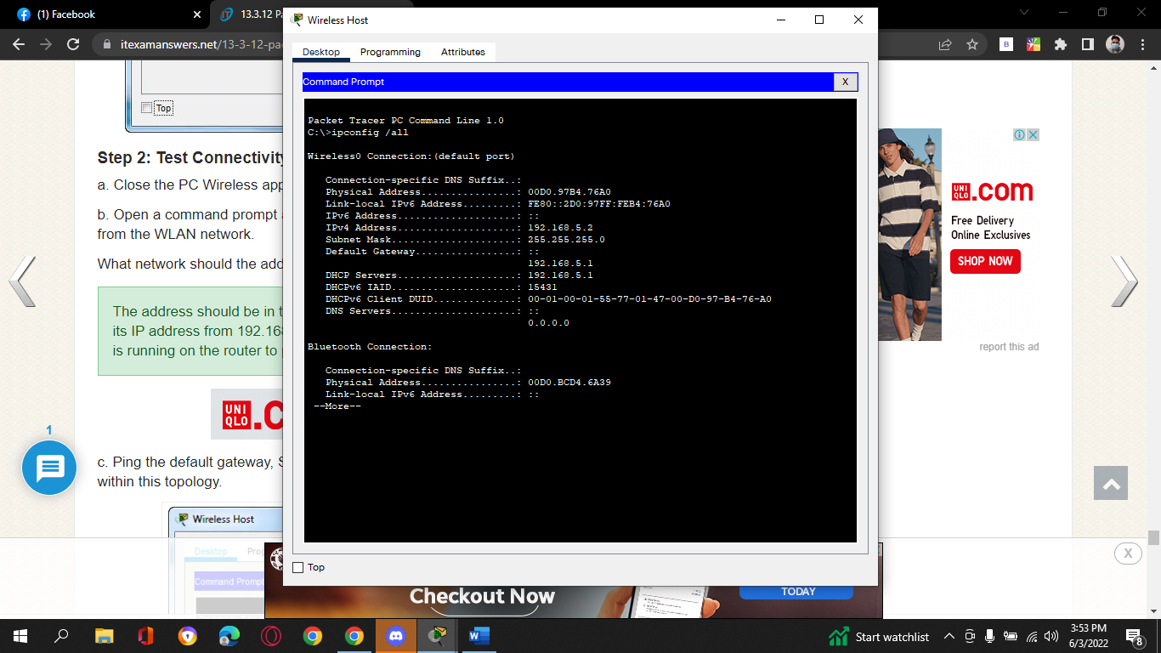

Question:

What network should the address be in? Explain.

* **The address should be in the 192.168.5.0/24 network. The interface was configured to get its IP address from 192.168.5.1. That is the router subinterface address for VLAN 5. DHCP is running on the router to provide addresses to wireless hosts.**

c.     Ping the default gateway, SW1, and the RADIUS server. Success indicates full connectivity within this topology.

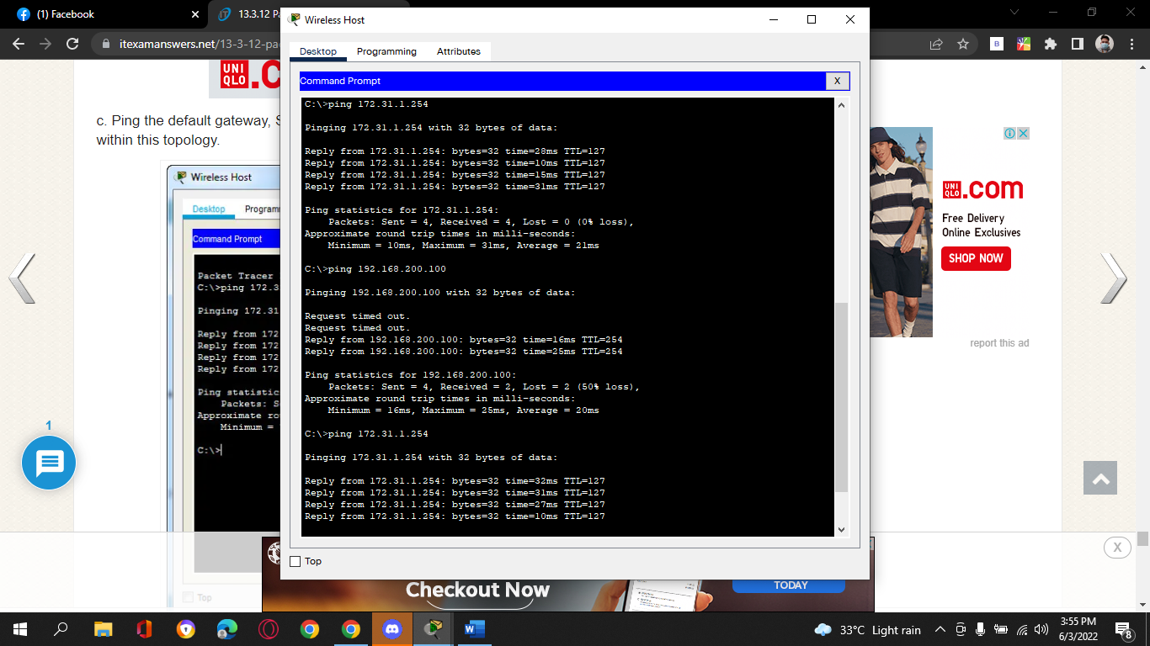

1. **Reflection Questions**

1.     The RADIUS server uses a dual authentication mechanism. What two things are authenticated by the RADIUS server? Why do think this is necessary?

* **Both the WLC and the wireless host are authenticated by the RADIUS server. On behalf of the wireless host, the WLC sends an authentication request. The WLC must be authenticated because it is critical to safeguard the RADIUS server tables of usernames and passwords from unauthorized breaches. This is why, when configuring the WLC to use the RADIUS server, a shared secret is required.**

2.     What are the advantages of WPA2-Enterprise over WPA2-PSK?

* **All hosts must use the same password when using WPA2-PSK. Furthermore, no username is required. This makes it more difficult to keep track of when users join and leave the network. Finally, if the PSK password needs to be updated, the new password must be sent to all users. This also increases the likelihood of the password being stolen. Multiple distinct user accounts can be created and managed using WPA2-Enterprise and RADIUS. The RADIUS server's logs may simply be audited for user behavior. Furthermore, users can readily be deleted or added as staffing in the enterprise changes.**

1. *End of document*

**Configure a WPA Enterprise WLAN on the WLC Activity Completion:**

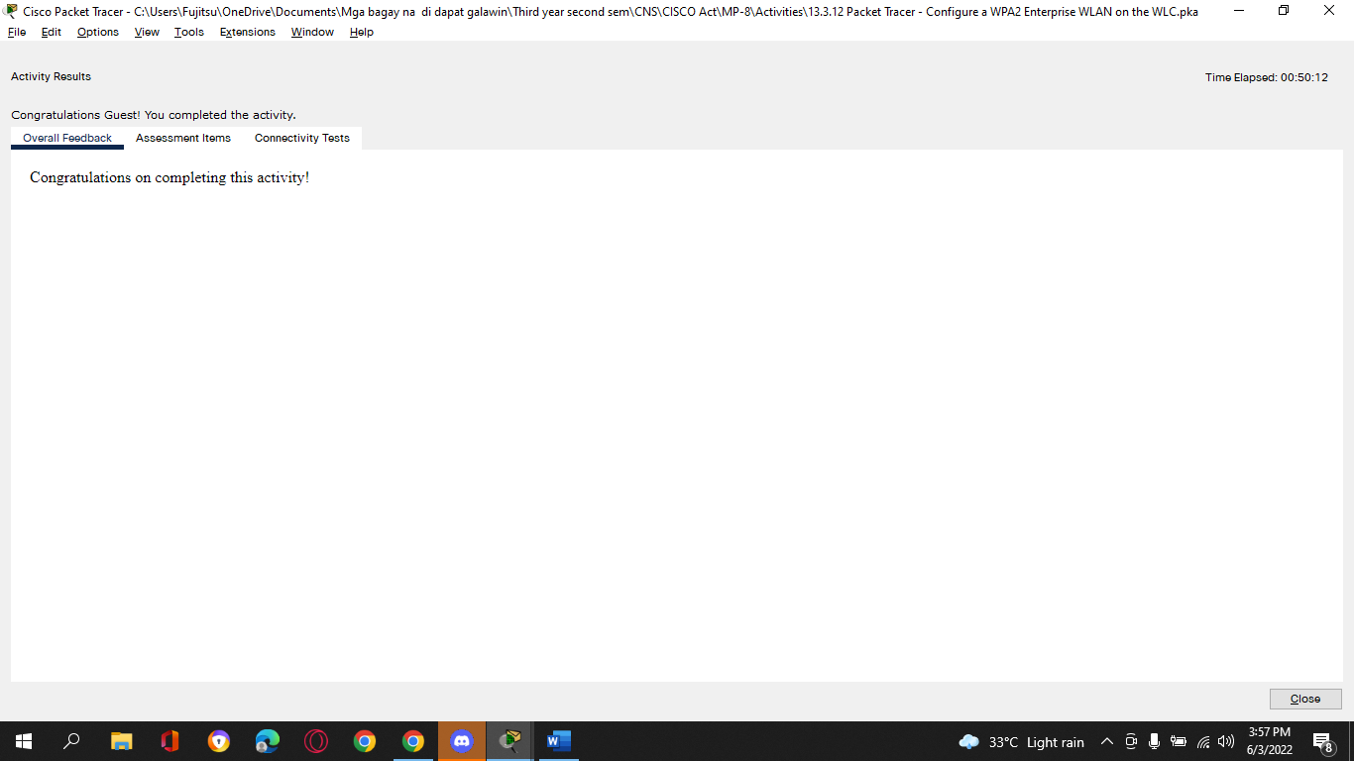

**Assessment Items:**

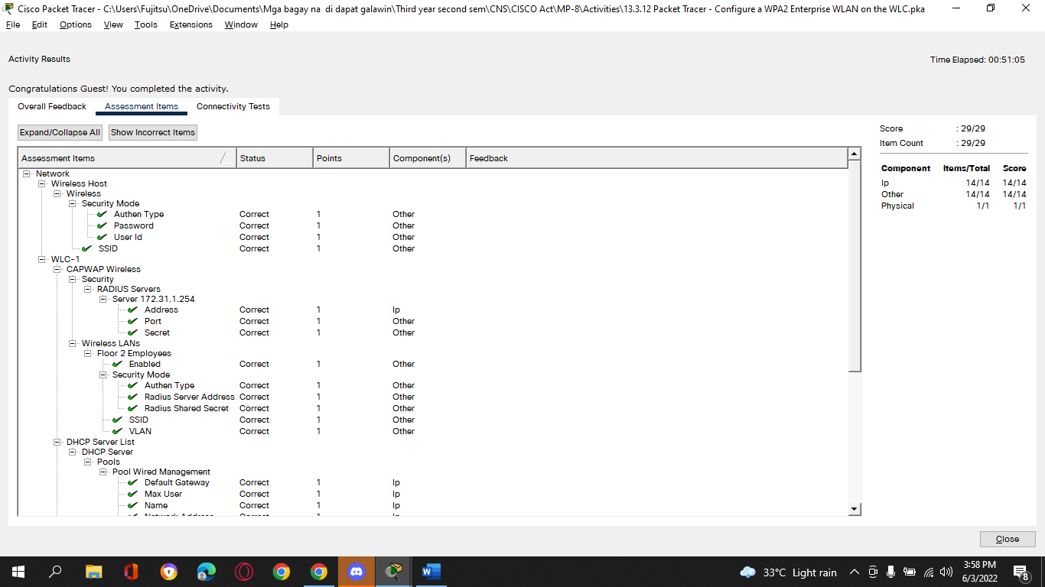

**Tedie N. Villacuatro**

**BSCOE 3-3**

**13.4.5 Packet Tracer - Troubleshoot WLAN Issues**

# Addressing Table

| **Device** | **Interface** | **IP Address** |
| --- | --- | --- |
| Home Wireless Router | Internet | DHCP |
| *Home Wireless Router* | LAN | 192.168.0.1 |
| R1 | G0/0/0.10 | 192.168.10.1/24 |
| *R1* | G0/0/0.20 | 192.168.20.1/24 |
| *R1* | G0/0/0.200 | 192.168.200.1/24 |
| *R1* | G0/0/1 | 172.31.1.1/24 |
| SW1 | VLAN 200 | 192.168.200.100/24 |
| LAP-1 | G0 | DHCP |
| WLC-1 | Management | 192.168.200.254/24 |
| RADIUS Server | NIC | 172.31.1.254/24 |
| Admin PC | NIC | 192.168.200.200/24 |
| Web Server | NIC | 203.0.113.78/24 |
| DNS Server | NIC | 10.100.100.254 |
| Home Admin | NIC | DHCP |
| Laptop | NIC | DHCP |
| Laptop1 | Wireless0 | DHCP |
| Laptop2 | Wireless0 | DHCP |
| Tablet PC | Wireless0 | DHCP |
| Smartphone | Wireless0 | DHCP |

# WLAN Information

| **WLAN** | **SSID** | **Authentication** | **Username** | **Password** |
| --- | --- | --- | --- | --- |
| Home Network | HomeSSID | WPA2-Personal | N/A | Cisco123 |
| WLAN VLAN10 | SSID-10 | WPA-2 PSK/Personal | N/A | Cisco123 |
| WLAN VLAN 20 | SSID-20 | WPA-2 802.1x/Enterprise | user2 | User2Pass |

# Objectives

In this activity, you will troubleshoot various issues in home wireless and enterprise wireless networks.

·         Troubleshoot wireless LAN connectivity issues in a home network.

·         Troubleshoot wireless LAN connectivity issues in an enterprise network.

# Background / Scenario

Now that you have learned how to configure wireless in home and enterprise networks, you need to learn how to troubleshoot in both wireless environments. Your goal is to enable connectivity between hosts on the networks to the web server by both IP address and URL. Connectivity between the home and enterprise networks is not required.

To access the Home Wireless Router, the username and password is **admin**.

The WLC management interface username is **admin**and the password is **Cisco123**.

# Instructions

## Part 1: Troubleshoot the Network

**Note**: You will only be troubleshooting the Home Wireless Router, WLC and wireless host devices in this activity.

### Step 1: Test connectivity.

* + - 1. Test connectivity between the various wireless hosts and the web server by both IP and URL [**www.netacad.pt**](http://www.netacad.pt).

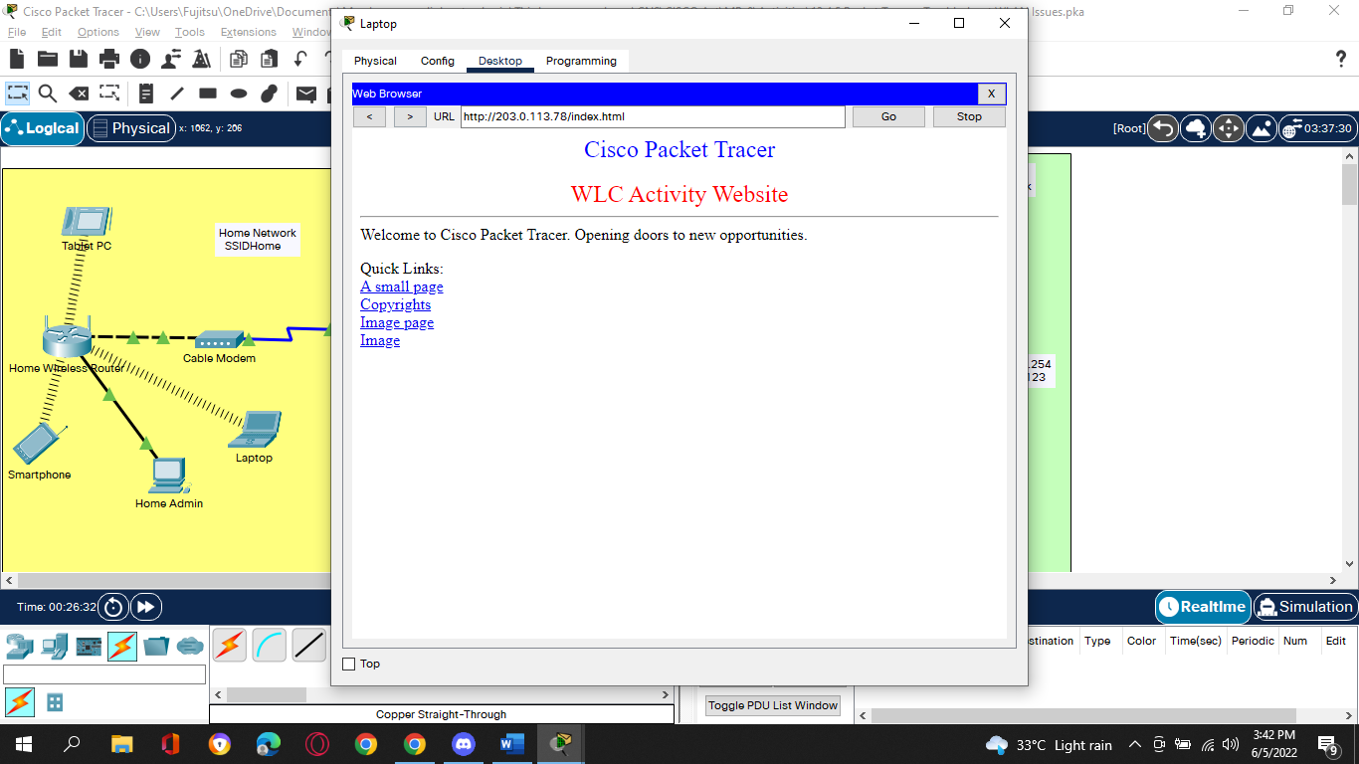

b.     Record the hosts that cannot access the web server in the table in Step 2.

### Step 2: Investigate issues and record findings.

a.     Investigate the connectivity issues with each host. Issues may be with the host configuration, or with other wireless network components.

b.     Complete the table.

| **Device** | **Network**  **Home/Enterprise** | **Issue** | **Remedy** |
| --- | --- | --- | --- |
| Smartphone, Tablet PC, Laptop | Home | Unable to access URL of server by name. The DNS server address misconfigured on Home Wireless Router DHCP server. | Change static address on Home Wireless router DHCP server to 10.100.100.254 |
| Tablet PC | Home | Client set to static addressing | Should be set to DHCP. |
| Wireless router | Home | Internet interface is set to static. | Set internet interface to DHCP |
| WLC | Enterprise | WLAN Wireless VLAN 20 is not enabled. | Enable WLAN and apply. |
| Laptop 2 | Enterprise | Laptop 2 won’t connect to Wireless VLAN 20. Incorrect username in client profile. | Change username to user2. |
| WLC | Enterprise | Laptop 1 cannot connect to the WLAN. On the WLC, WLAN-Wireless VLAN 10 has Authentication Key Management set to 802.1x rather than PSK, which is the configuration required for WPA2 PSK security. | Change Authentication Key Management to PSK, enter the PSK value from the WLAN table. |

## Part 2: Fix Issues

Make changes to the device configurations so hosts can achieve connectivity with the network. Test to ensure all hosts can reach the communication goal of connecting to the web server by both IP address and URL.

**Login to WLC1:**

*End of document*

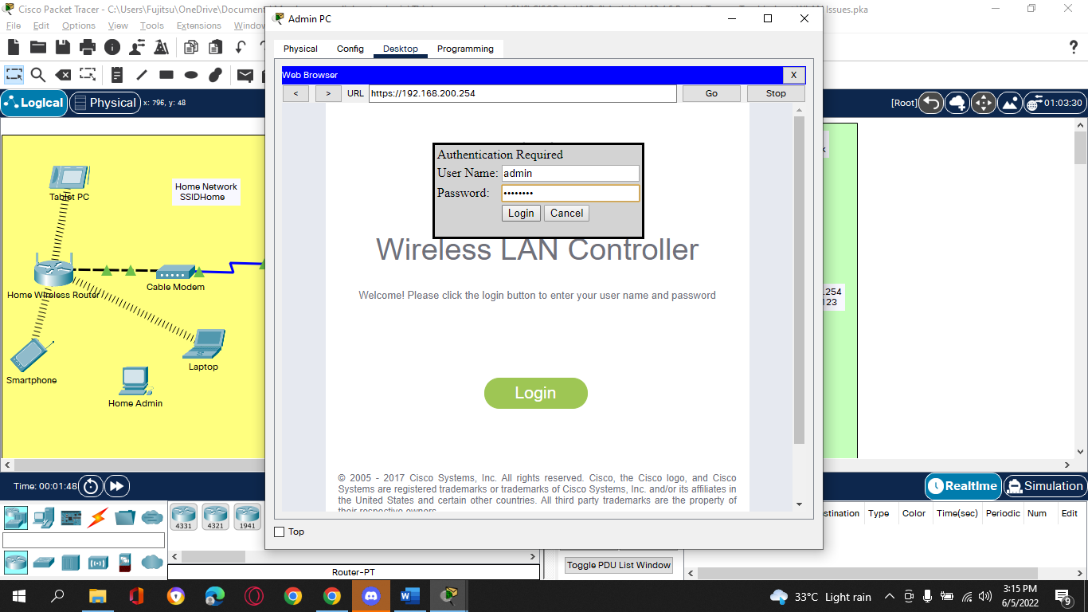

**Enabled Wireless VLAN 20:**

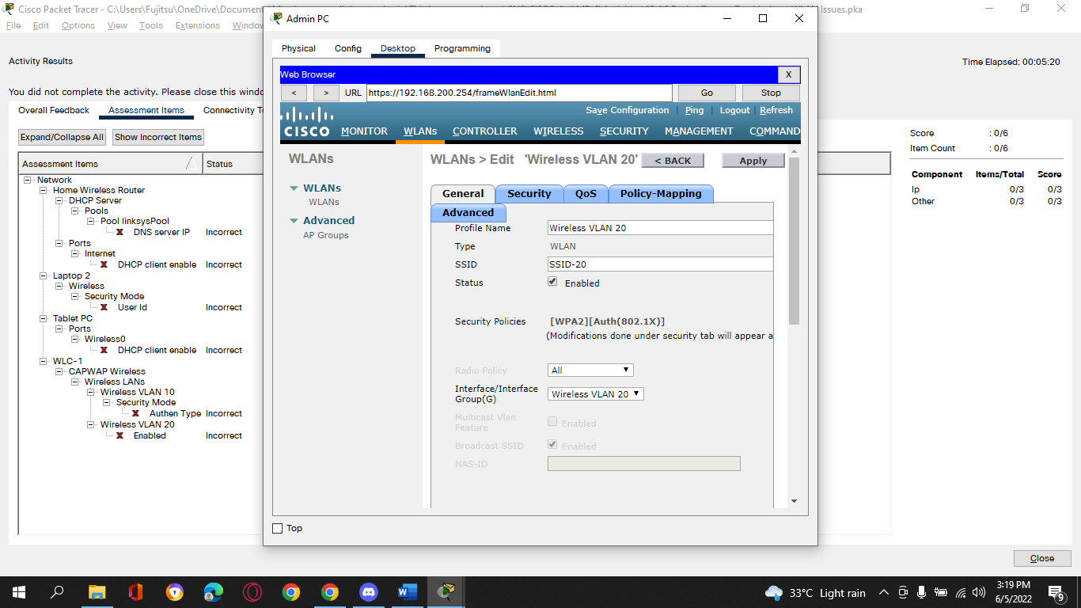

**Enable PSK on Wireless VLAN 10:**

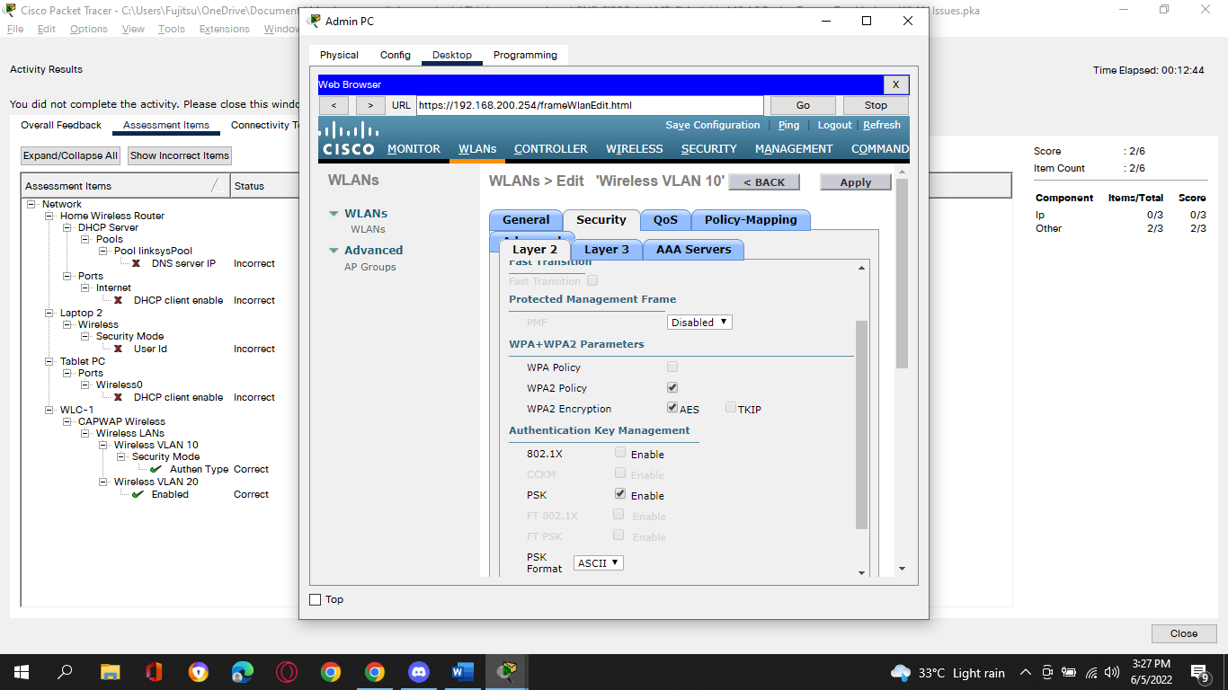

**Enable DHCP on Tablet PC:**

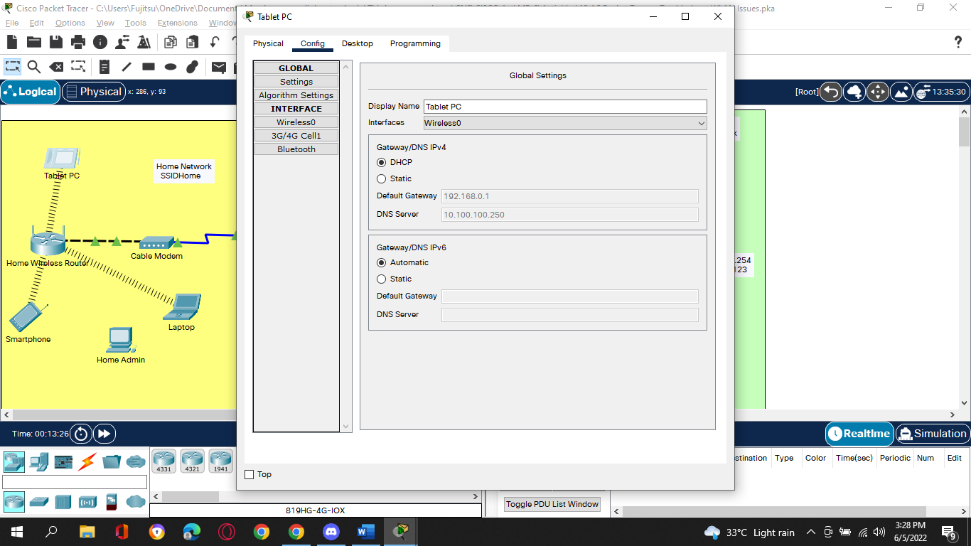

**Change Static Ip to DHCP and Change DNS IP Address to Match DNS Server IP**

**Address:**

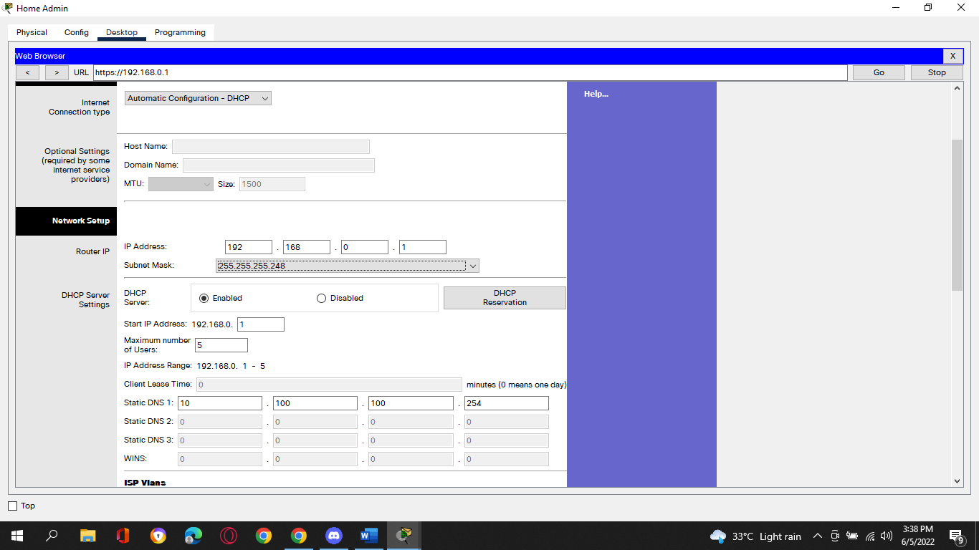

**Change Laptop2’s user ID:**

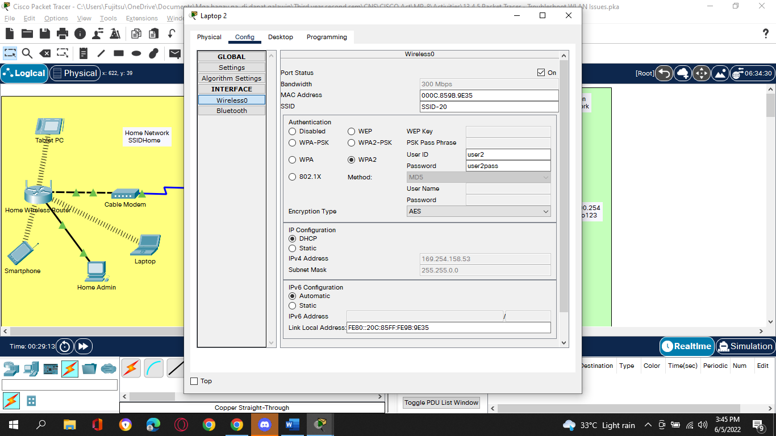

**Troubleshoot WLAN Issues Activity Completion:**

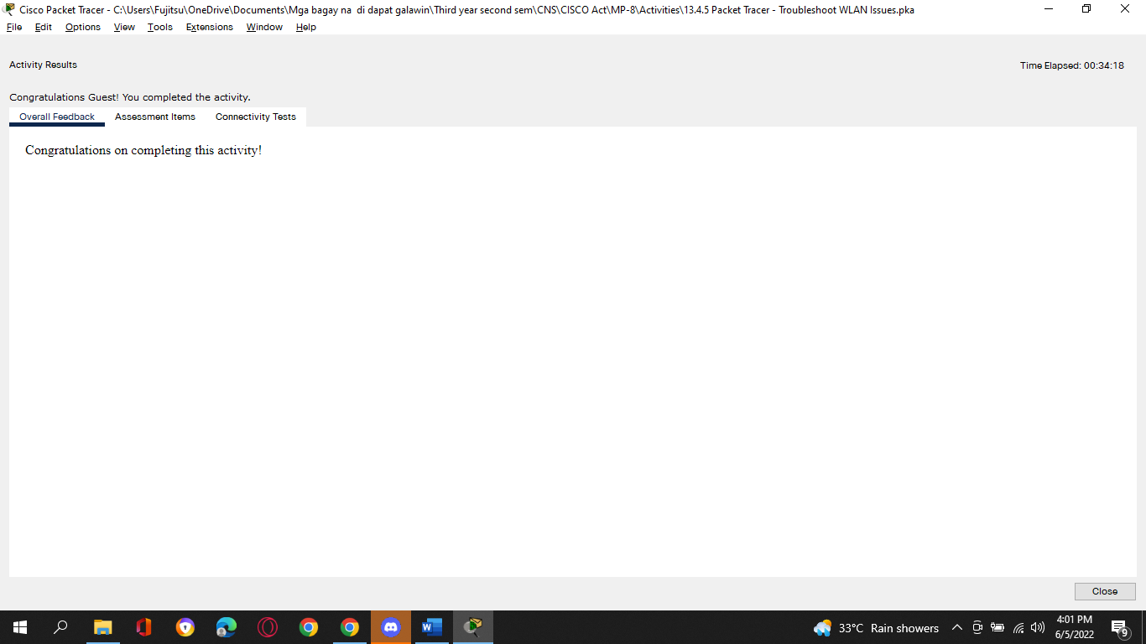

**Assessment Items:**

